React Notes:

Act 1:

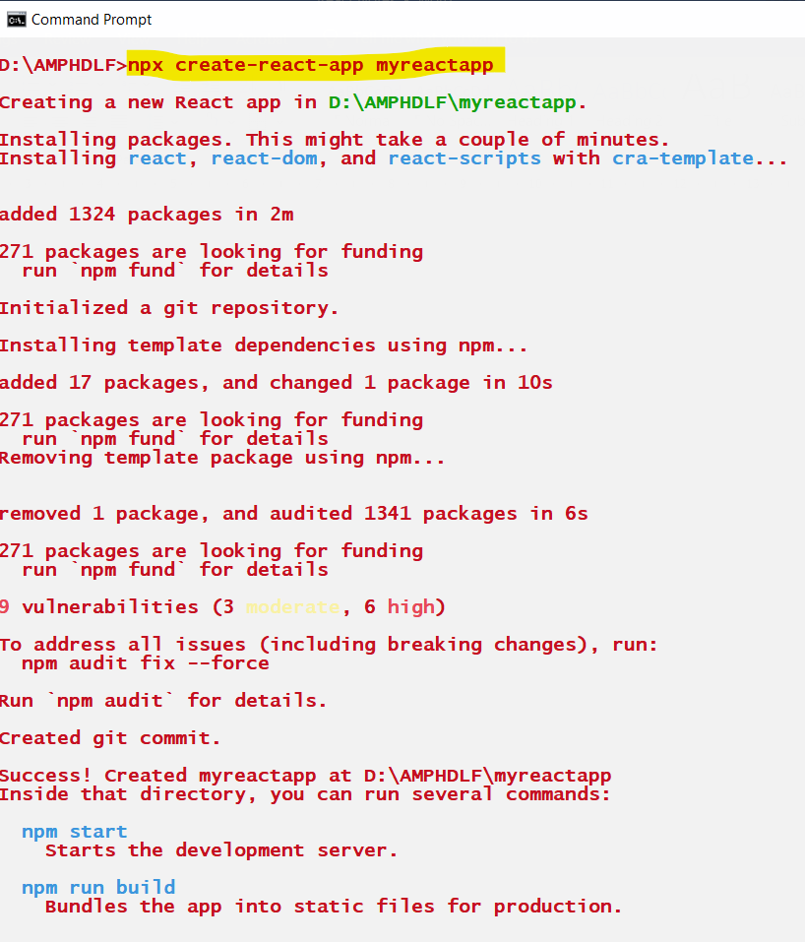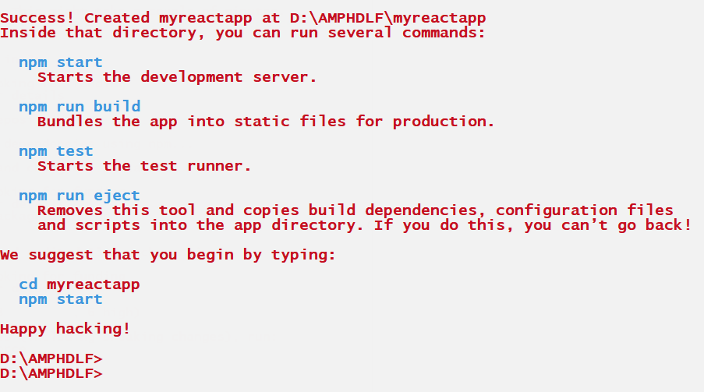

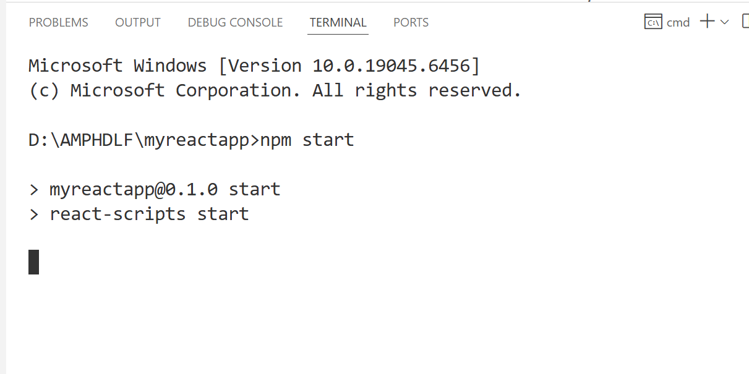

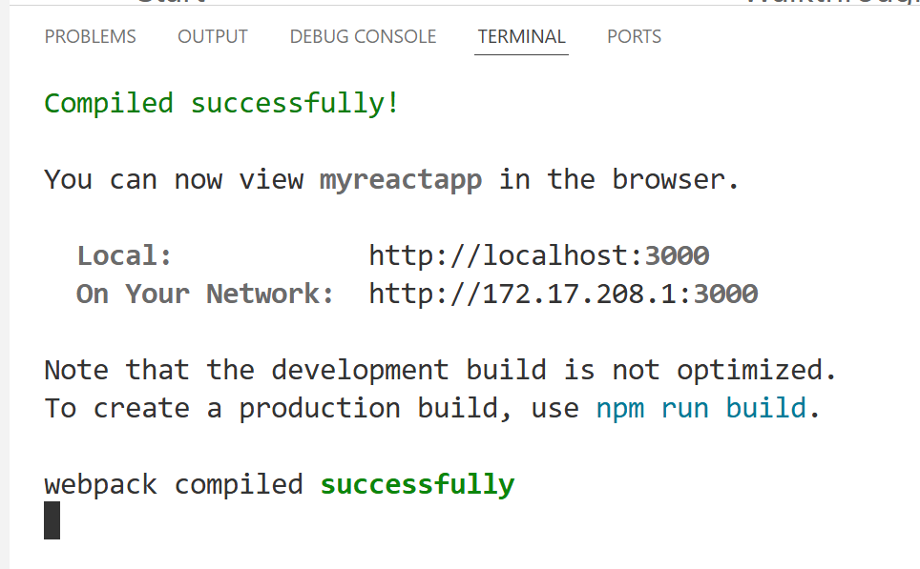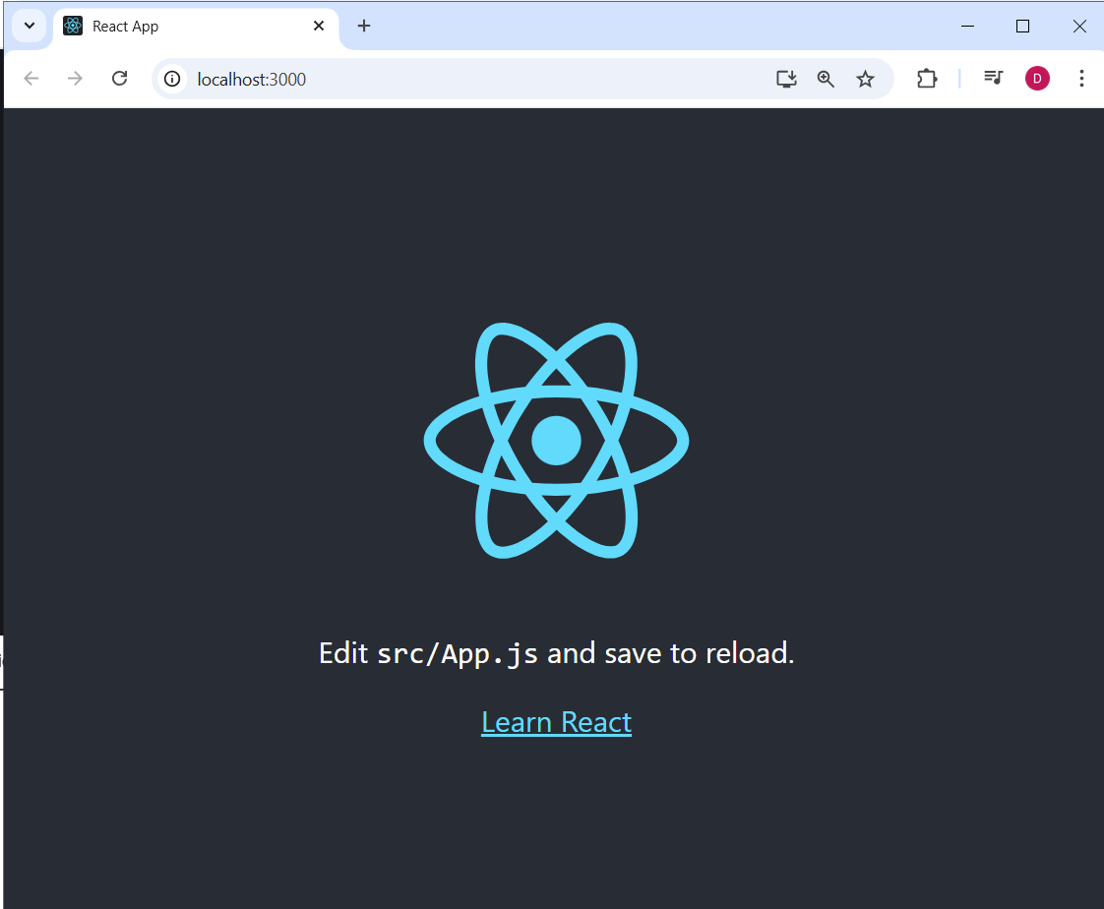

After creating the App, remove few files and edit few codes

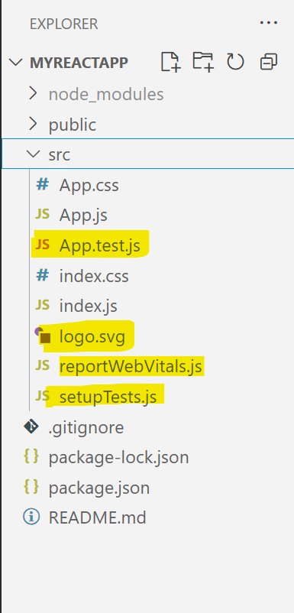

Index.js

|  |
| --- |
| **import React from "react";**  **import ReactDOM from "react-dom/client";**  **import "./index.css";**  **import App from "./App";**  **const root = ReactDOM.createRoot(document.getElementById("root"));**  **root.render(**  **<React.StrictMode>**  **<App />**  **</React.StrictMode>**  **);** |

Index.css

|  |
| --- |
| **body {**  **margin: 0;**  **font-family: -apple-system, BlinkMacSystemFont, 'Segoe UI', 'Roboto', 'Oxygen',**  **'Ubuntu', 'Cantarell', 'Fira Sans', 'Droid Sans', 'Helvetica Neue',**  **sans-serif;**  **-webkit-font-smoothing: antialiased;**  **-moz-osx-font-smoothing: grayscale;**  **}**  **code {**  **font-family: source-code-pro, Menlo, Monaco, Consolas, 'Courier New',**  **monospace;**  **}** |

App.css

|  |
| --- |
| **.App {**  **text-align: center;**  **}**  **.App-logo {**  **height: 40vmin;**  **pointer-events: none;**  **}**  **@media (prefers-reduced-motion: no-preference) {**  **.App-logo {**  **animation: App-logo-spin infinite 20s linear;**  **}**  **}**  **.App-header {**  **background-color: #282c34;**  **min-height: 100vh;**  **display: flex;**  **flex-direction: column;**  **align-items: center;**  **justify-content: center;**  **font-size: calc(10px + 2vmin);**  **color: white;**  **}**  **.App-link {**  **color: #61dafb;**  **}**  **@keyframes App-logo-spin {**  **from {**  **transform: rotate(0deg);**  **}**  **to {**  **transform: rotate(360deg);**  **}**  **}** |

App.js

|  |
| --- |
| **import "./App.css";**  **function App() {**  **return (**  **<div className="App">**  **<h1>Hello React !!!</h1>**  **</div>**  **);**  **}**  **export default App;** |

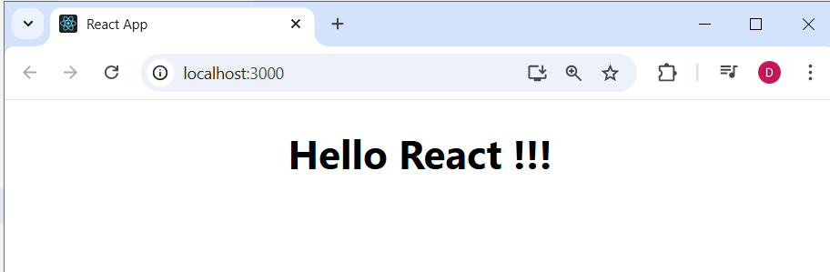

|  |
| --- |
| -- **All JSX elements shd be wrapped with one/single parent element**  **-- In html tag, we use the attribute as class, but here it shd be className**  function App(){  const element =<h1>Hello ... </h1>  return(  <div>  <h1 className="">Hello, world!"</h1>  <p>Hi</p>  {element}  {10+2}  </div>  )  }  -- **you can embed any valid JS expression inside curly brackets{} in jSX**  **-- JSX attributes use camelCase Syntax** |

Act 2:

|  |
| --- |
| **import "./App.css";**  **function App() {**  **const name ="E-Commerce App"**  **return (**  **<div className="App">**  **<h1>Welcome to {name} !!!</h1>**  **</div>**  **);**  **}**  **export default App;** |

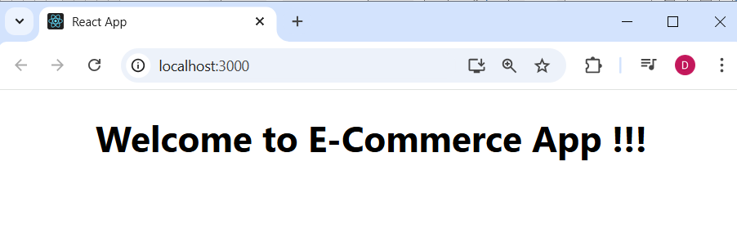

Act 3:

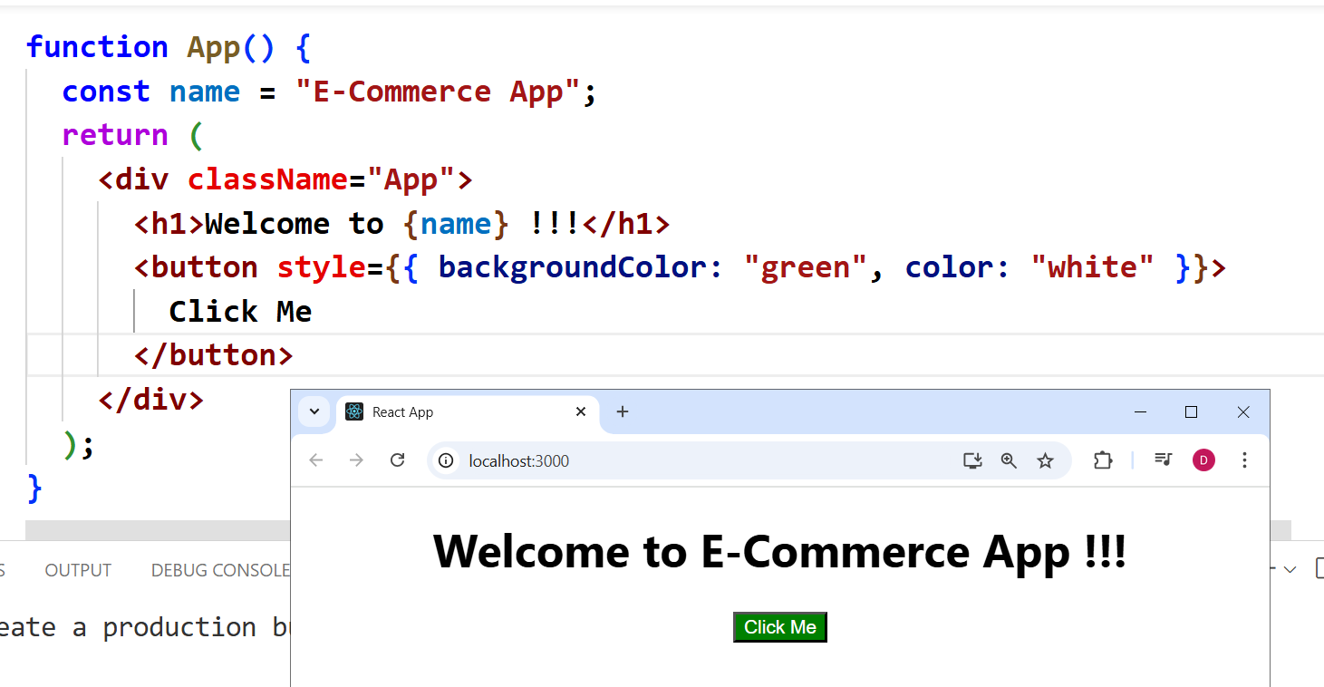

|  |
| --- |
| **import "./App.css";**  **function App() {**  **const name = "E-Commerce App";**  **return (**  **<div className="App">**  **<h1>Welcome to {name} !!!</h1>**  **<button style={{ backgroundColor: "green", color: "white" }}>**  **Click Me**  **</button>**  **</div>**  **);**  **}**  **export default App;** |

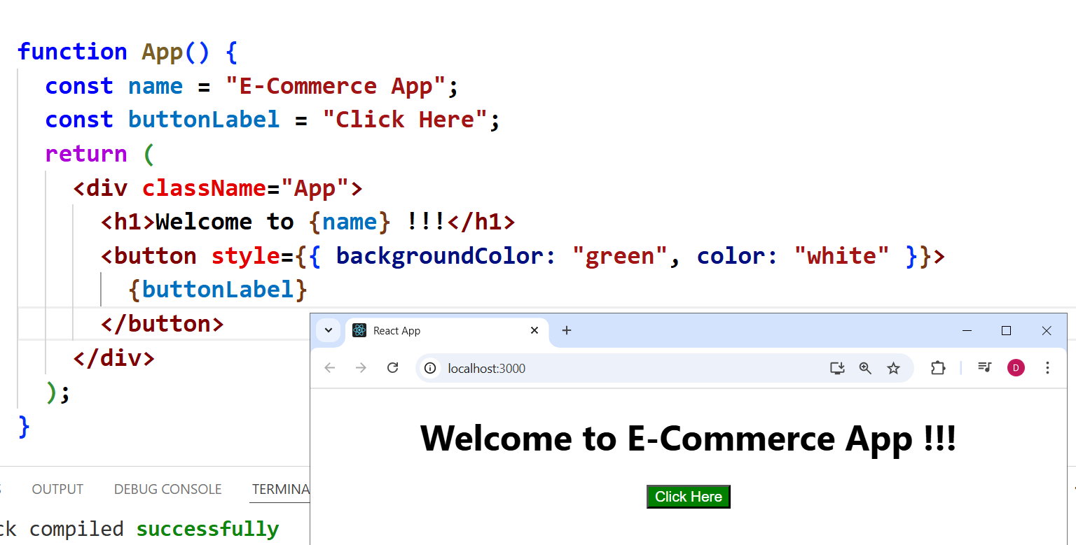

Act 4:.

|  |
| --- |
| **import "./App.css";**  **function App() {**  **const name = "E-Commerce App";**  **const buttonLabel = "Click Here";**  **return (**  **<div className="App">**  **<h1>Welcome to {name} !!!</h1>**  **<button style={{ backgroundColor: "green", color: "white" }}>**  **{buttonLabel}**  **</button>**  **<button onClick={()=>{ alert(`Button Clicked !!!`)}}>Get Alert</button>**  **</div>**  **);**  **}**  **export default App;** |

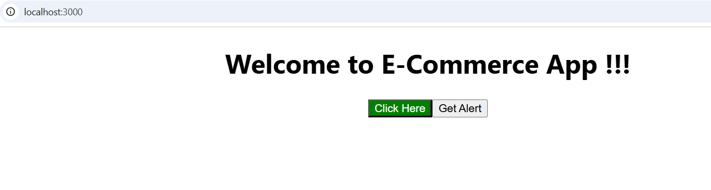 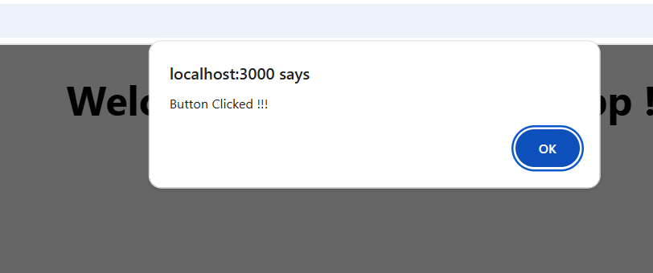

Act 5:

|  |
| --- |
| **import "./App.css";**  **function App() {**  **const name = "E-Commerce App";**  **const buttonLabel = "Click Here";**  **const imageUrl = "https://placehold.co/100x100";**  **return (**  **<div className="App">**  **<h1>Welcome to {name} !!!</h1>**  **<button style={{ backgroundColor: "green", color: "white" }}>{buttonLabel}</button>**  **<button**  **onClick={() => {**  **alert(`Button Clicked !!!`);**  **}}**  **>**  **Get Alert**  **</button>**  **<img src={imageUrl} alt="Dynamic Click" />**  **</div>**  **);**  **}**  **export default App;** |

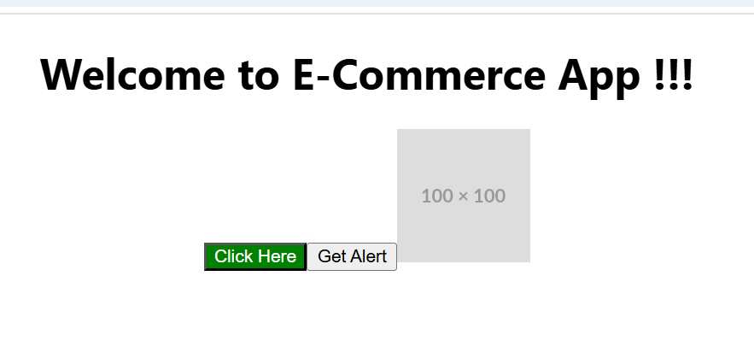

**Conditional Rendering:**

**Done in 3 ways**

1. **If-else block**
2. **Ternary operator**
3. **Short circuiting operator**

**Act 6: IF-ELSE**

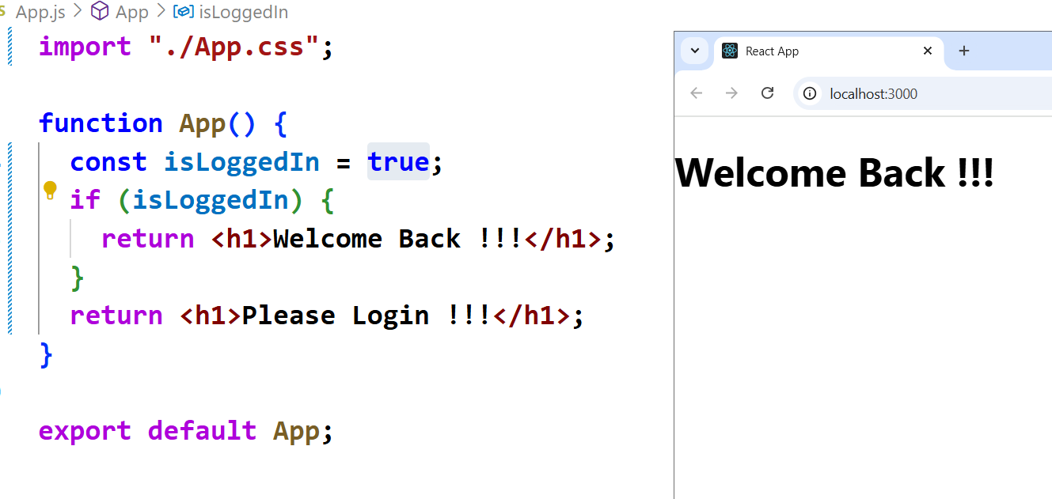

|  |
| --- |
| **import "./App.css";**  **function App() {**  **const isLoggedIn = true;**  **if (isLoggedIn) {**  **return <h1>Welcome Back !!!</h1>;**  **}**  **return <h1>Please Login !!!</h1>;**  **}**  **export default App;** |

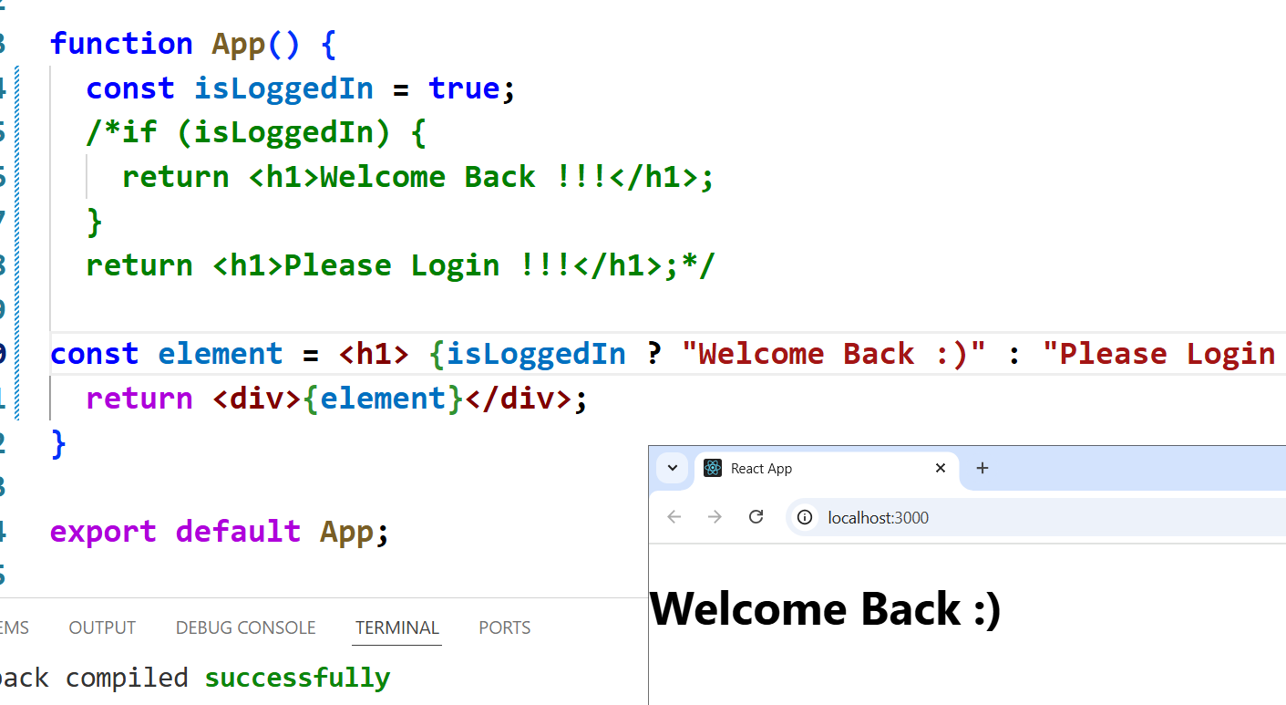

|  |
| --- |
| **import "./App.css";**  **function App() {**  **const isLoggedIn = true;**  **/*if (isLoggedIn) {**  **return <h1>Welcome Back !!!</h1>;**  **}**  **return <h1>Please Login !!!</h1>;*/**  **const element = <h1> {isLoggedIn ? "Welcome Back :)" : "Please Login !!!"}</h1>;**  **return <div>{element}</div>;**  **}**  **export default App;** |

Act 7: && operator -- SHORT CIRCUITING

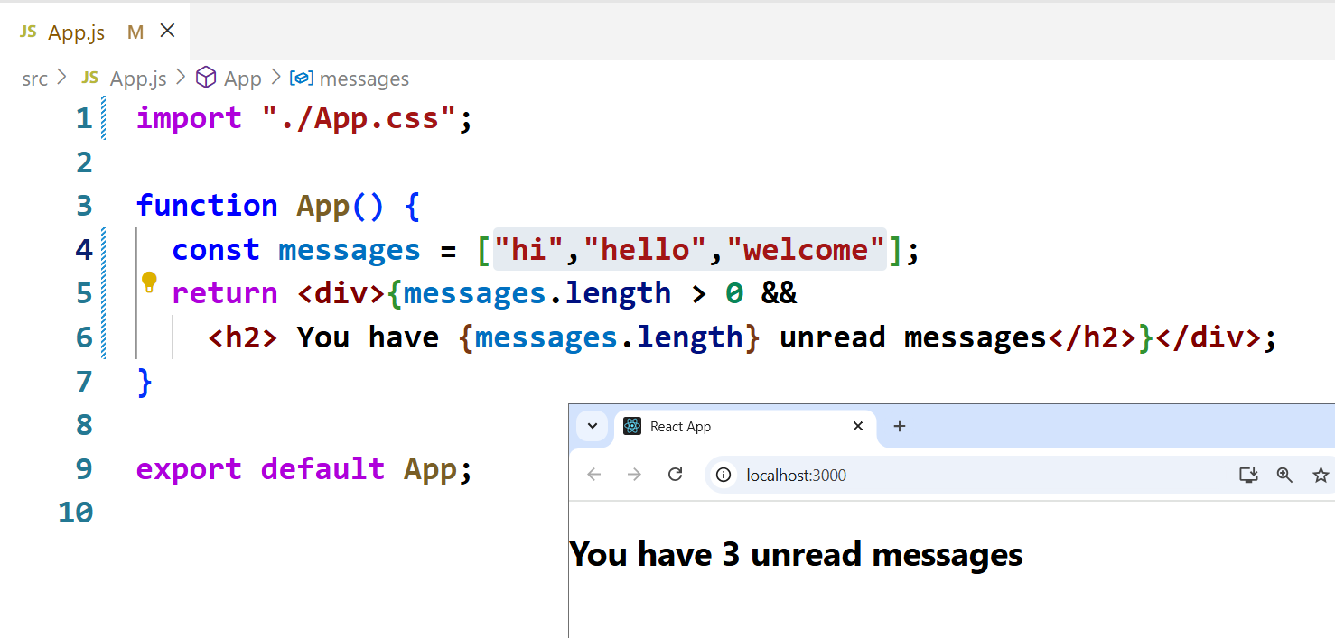

|  |
| --- |
| How && operator in this syntax works?  If you are familiar with JavaScript, uh, you must be aware of logical and operator. &&  There the left hand side is being evaluated first. So this is the expression on the left hand side.  **{messages.length} > 0 is** evaluated .  **If this expression is true it evaluates and returns the right side.**  **And if this is false ,it does not return the right hand side**. And this is known as short circuiting |

WHEN TO USE TERNARY OPERATOR , AND WHEN TO USE SHORT CIRCUITING OPERATOR

|  |
| --- |
| NOTE:  ternary operator actually is useful if you want to have a failure message as well. But short circuiting operator returns only one message, if the expression returns true. |

**Act 8: JSX FUNCTIONS**:

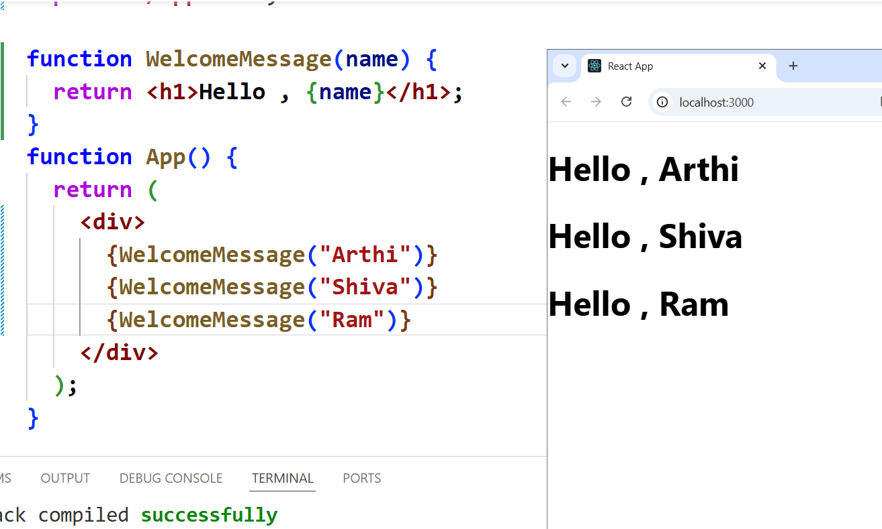

|  |
| --- |
| **import "./App.css";**  **function WelcomeMessage(name) {**  **return <h1>Hello , {name}</h1>;**  **}**  **function App() {**  **return (**  **<div>**  **{WelcomeMessage("Arthi")}**  **{WelcomeMessage("Shiva")}**  **{WelcomeMessage("Ram")}**  **</div>**  **);**  **}**  **export default App;** |

Act 9:

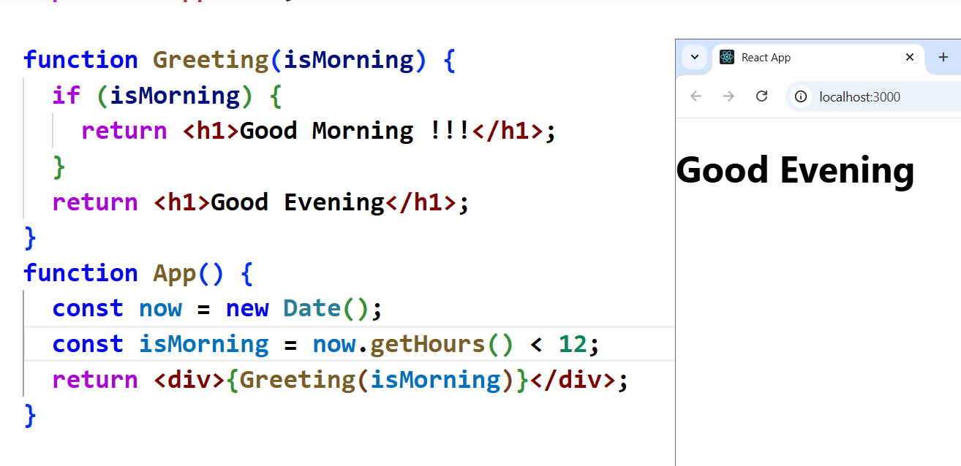

|  |
| --- |
| **import "./App.css";**  **function Greeting(isMorning) {**  **if (isMorning) {**  **return <h1>Good Morning !!!</h1>;**  **}**  **return <h1>Good Evening</h1>;**  **}**  **function App() {**  **const now = new Date();**  **const isMorning = now.getHours() < 12;**  **return <div>{Greeting(isMorning)}</div>;**  **}**  **export default App;** |

Act 10: Comment in JSX

|  |
| --- |
| **import "./App.css";**  **function App() {**  **//Adding Variable**  **/\***  **Multi-line Comment**  **\*/**  **const now = new Date();**  **return (**  **<div>**  **{/*Multi-line comment in JSX */}**  **<h1>Hello All !!! Today is {now.toString()}</h1>**  **</div>**  **);**  **}**  **export default App;** |

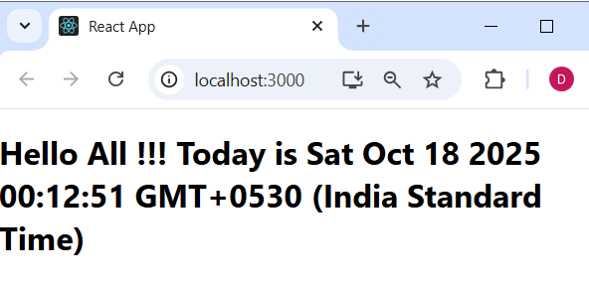

Act 10: C**omponents**

React apps are made out of *components***. A component is a piece of the UI (user interface) that has its own logic and appearance. A component can be as small as a button, or as large as an entire page.**

**React components are JavaScript functions that return markup**

**React component names must always start with a capital letter, while HTML tags must be lowercase.**

|  |
| --- |
| **import "./App.css";**  **function MyButton() {**  **return <button>I'm a button</button>;**  **}**  **function App() {**  **return (**  **<div>**  **<MyButton />**  **<MyButton />**  **<MyButton />**  **</div>**  **);**  **}**  **export default App;** |

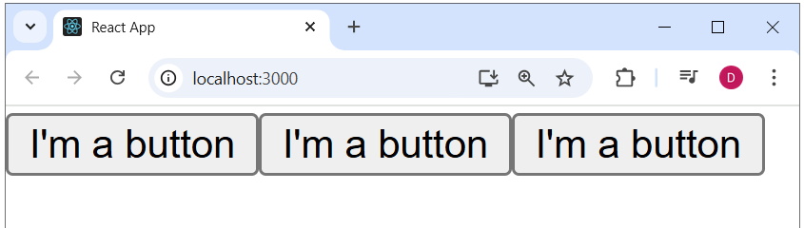

Portfolio Application using react:

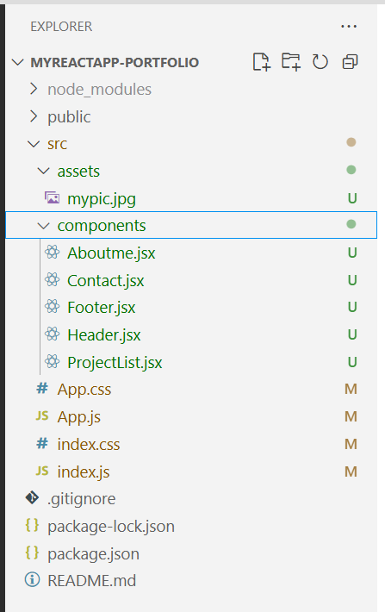 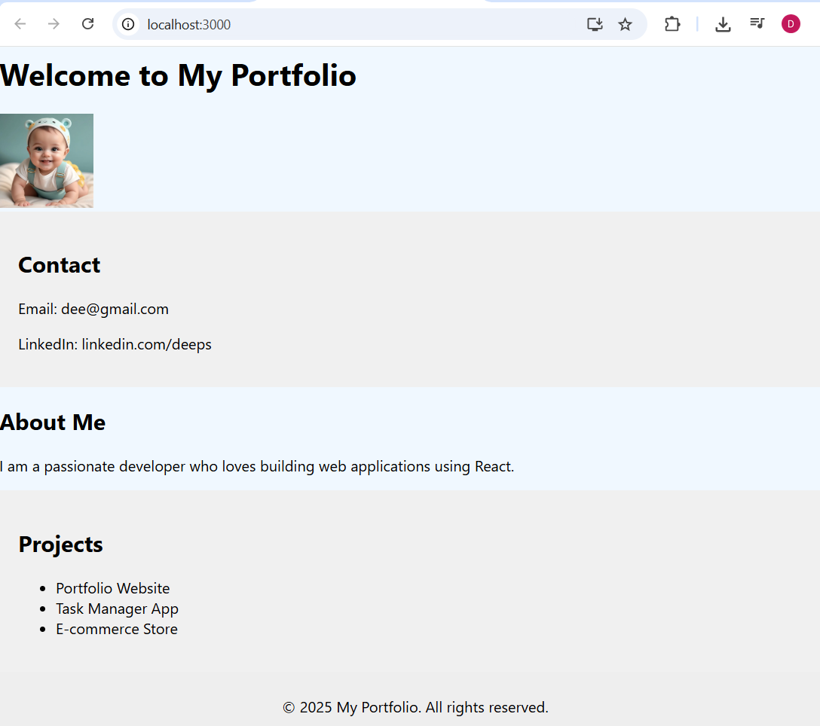

Index.js

|  |
| --- |
| **import React from "react";**  **import ReactDOM from "react-dom/client";**  **import "./index.css";**  **import App from "./App";**  **const root = ReactDOM.createRoot(document.getElementById("root"));**  **root.render(**  **<React.StrictMode>**  **<App />**  **</React.StrictMode>**  **);** |

Index.css

|  |
| --- |
| **body {**  **margin: 0;**  **font-family: -apple-system, BlinkMacSystemFont, "Segoe UI", "Roboto", "Oxygen", "Ubuntu", "Cantarell", "Fira Sans", "Droid Sans",**  **"Helvetica Neue", sans-serif;**  **-webkit-font-smoothing: antialiased;**  **-moz-osx-font-smoothing: grayscale;**  **background-color: aliceblue;**  **}**  **code {**  **font-family: source-code-pro, Menlo, Monaco, Consolas, "Courier New", monospace;**  **}** |

App.js

|  |
| --- |
| **import React from "react";**  **import Header from "./components/Header";**  **import AboutMe from "./components/Aboutme";**  **import Contact from "./components/Contact";**  **import Footer from "./components/Footer";**  **import ProjectsList from "./components/ProjectList";**  **function App() {**  **return (**  **<div>**  **<Header />**  **<Contact />**  **<AboutMe />**  **<ProjectsList />**  **<Footer />**  **</div>**  **);**  **}**  **export default App;** |

App.css

|  |
| --- |
| **.App {**  **text-align: center;**  **}**  **body {**  **margin: 0;**  **padding: 0;**  **font-family: "Segoe UI", Tahoma, Geneva, Verdana, sans-serif;**  **background-color: #ffffff;**  **color: #333;**  **}**  **.app-container {**  **display: flex;**  **flex-direction: column;**  **min-height: 100vh;**  **}**  **/* Header */**  **/* Header styles */**  **.header {**  **background-color: #282c34;**  **color: white;**  **padding: 20px;**  **}**  **/* Flex layout: title left, image right */**  **.header-content {**  **display: flex;**  **justify-content: space-between;**  **align-items: center;**  **}**  **/* Style the image */**  **.header-profile-pic {**  **width: 100px;**  **height: 100px;**  **object-fit: cover;**  **border-radius: 50%;**  **border: 3px solid white;**  **box-shadow: 0 0 8px rgba(255, 255, 255, 0.3);**  **}**  **/* Responsive tweak (optional) */**  **@media (max-width: 600px) {**  **.header-content {**  **flex-direction: column;**  **text-align: center;**  **}**  **.header-profile-pic {**  **margin-top: 15px;**  **}**  **}**  **/* Footer */**  **.footer {**  **background-color: #eee;**  **padding: 10px;**  **text-align: center;**  **margin-top: auto;**  **}**  **/* Section common styles */**  **.section {**  **padding: 20px;**  **}**  **.section-alt {**  **background-color: #f7f7f7;**  **}** |

Header.jsx

|  |
| --- |
| **import React from "react";**  **import profilePic from "../assets/mypic.jpg";**  **function Header() {**  **return (**  **<header className="header">**  **<div className="header-content">**  **<h1>Welcome to My Portfolio</h1>**  **<img src={profilePic} alt="Profile" className="header-profile-pic" width="100px" height="100px" />**  **</div>**  **</header>**  **);**  **}**  **export default Header;** |

Contact.jsx

|  |
| --- |
| **import React from "react";**  **function Contact() {**  **return (**  **<section style={{ padding: "20px", backgroundColor: "#f0f0f0" }}>**  **<h2>Contact</h2>**  **<p>Email: dee@gmail.com</p>**  **<p>LinkedIn: linkedin.com/deeps</p>**  **</section>**  **);**  **}**  **export default Contact;** |

Aboutme.jsx

|  |
| --- |
| **import React from "react";**  **function AboutMe() {**  **return (**  **<section className="section about-section">**    **<h2>About Me</h2>**  **<p>I am a passionate developer who loves building web applications using React.</p>**  **</section>**  **);**  **}**  **export default AboutMe;** |

ProjectList.jsx

|  |
| --- |
| import React from "react";  function ProjectsList() {  return (  <section style={{ padding: "20px", backgroundColor: "#f0f0f0" }}>  <h2>Projects</h2>  <ul>  <li>Portfolio Website</li>  <li>Task Manager App</li>  <li>E-commerce Store</li>  </ul>  </section>  );  }  export default ProjectsList; |

Footer.jsx

|  |
| --- |
| **import React from "react";**  **function Footer() {**  **return (**  **<footer style={{ padding: "10px", backgroundColor: "#eee", textAlign: "center" }}>**  **<p>© 2025 My Portfolio. All rights reserved.</p>**  **</footer>**  **);**  **}**  **export default Footer;** |

**Act 11: Properties (props)**

**Step 1: What are Props?**

**Props** (short for **Properties**) are like **parameters** in a function.

They are used to pass **data from a parent component to a child component** in React.

**Props are read only**. The function which is calling is **Parent** and the called function as tag is **Child**.

**Child CANT modify the data, instead the Parent control the data.**

**When you have a SINGLE product**

App.js

|  |
| --- |
| **import React from "react";**  **import AdminProducts from "./components/admin/products/AdminProducts";**  **function App() {**  **const products = {**  **productId: 1,**  **productName: "iPad Pro",**  **quantity: 30,**  **price: 40000.0,**  **};**  **return (**  **<div>**  **<div className="pt-6 pb-10 flex justify-end">**  **<AdminProducts prod={products} />**  **</div>**  **</div>**    **}**  **export default App;** |

AdminProducts.jsx

|  |
| --- |
| **const AdminProducts = ({ prod }) => {**  **return (**  **<div>**  **<h3>{prod.productName}</h3>**  **<p>{prod.quantity}</p>**  **<p>Price: {prod.price}</p>**  **</div**  **);**  **};**  **export default AdminProducts;** |

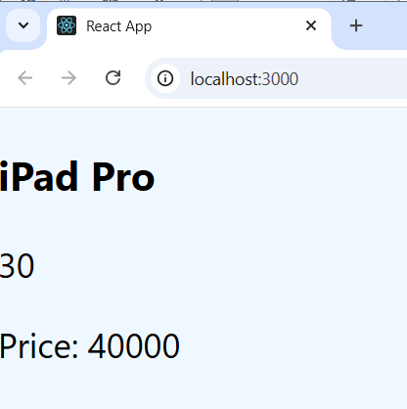

Act 12: **When you have a MULTIPLE product**

App.Js

|  |
| --- |
| **import React from "react";**  **import AdminProducts from "./components/admin/products/AdminProducts";**  **function App() {**  **const products = [**  **{ productId: 1, productName: "iPad Pro", price: 40000.0 },**  **{ productId: 2, productName: "iPhone 16 Pro Max", price: 50000.0 },**  **];**  **return (**  **<div>**  **<div className="pt-6 pb-10 flex justify-end">**  **<AdminProducts products={products} />**  **</div>**  **</div>**  **);**  **}**  **export default App;** |

AdminProducts.jsx

|  |
| --- |
| **const AdminProducts = ({ products }) => {**  **return (**  **<div>**  **{products.map((p) => (**  **<div key={p.productId}>**  **<h3>{p.productName}</h3>**  **<p>Price: {p.price}</p>**  **</div>**  **))}**  **</div>**  **);**  **};**  **export default AdminProducts;** |

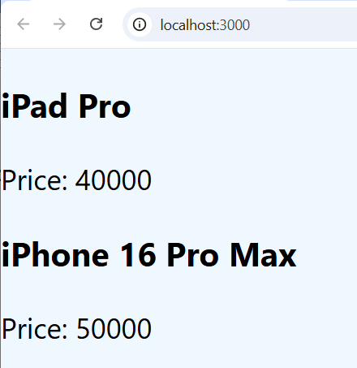

Act 13: Passing multiple Elements to props

App.js

|  |
| --- |
| **import React from "react";**  **import AdminProducts from "./components/AdminProducts";**  **import ProfileCard from "./components/ProfileCard";**  **function App() {**  **return (**  **<div>**  **<div className="pt-6 pb-10 flex justify-end">**  **<AdminProducts />**  **<ProfileCard name="Anitha" age="20" num="2" />**  **<ProfileCard name="Maruthi" age="15" num={3} /> // This is how U pass numbers**  **</div>**  **</div>**  **);**  **}**  **export default App;** |

ProfileCard.jsx

|  |
| --- |
| **function ProfileCard(props) {**  **const sum = props.num + 1;**  **return (**  **<div>**  **<h3>Name: {props.name}</h3>**  **<h3>Age : {props.age}</h3>**  **<h3>Num : {sum}</h3>**  **</div>**  **);**  **}**  **export default ProfileCard;** |

Notice : Num 21 is concatenation (2+1) 🡪 2 as string + 1

Num 4 is addition (3 + 1) 🡪 3 as int

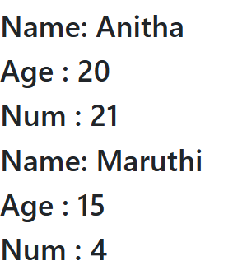

Act 14: Handling Boolean Values

Boolean values should be passed within curly braces {} and NOT within double quotes “ “. But the values will not be displayed. Use ternary operator and display some string

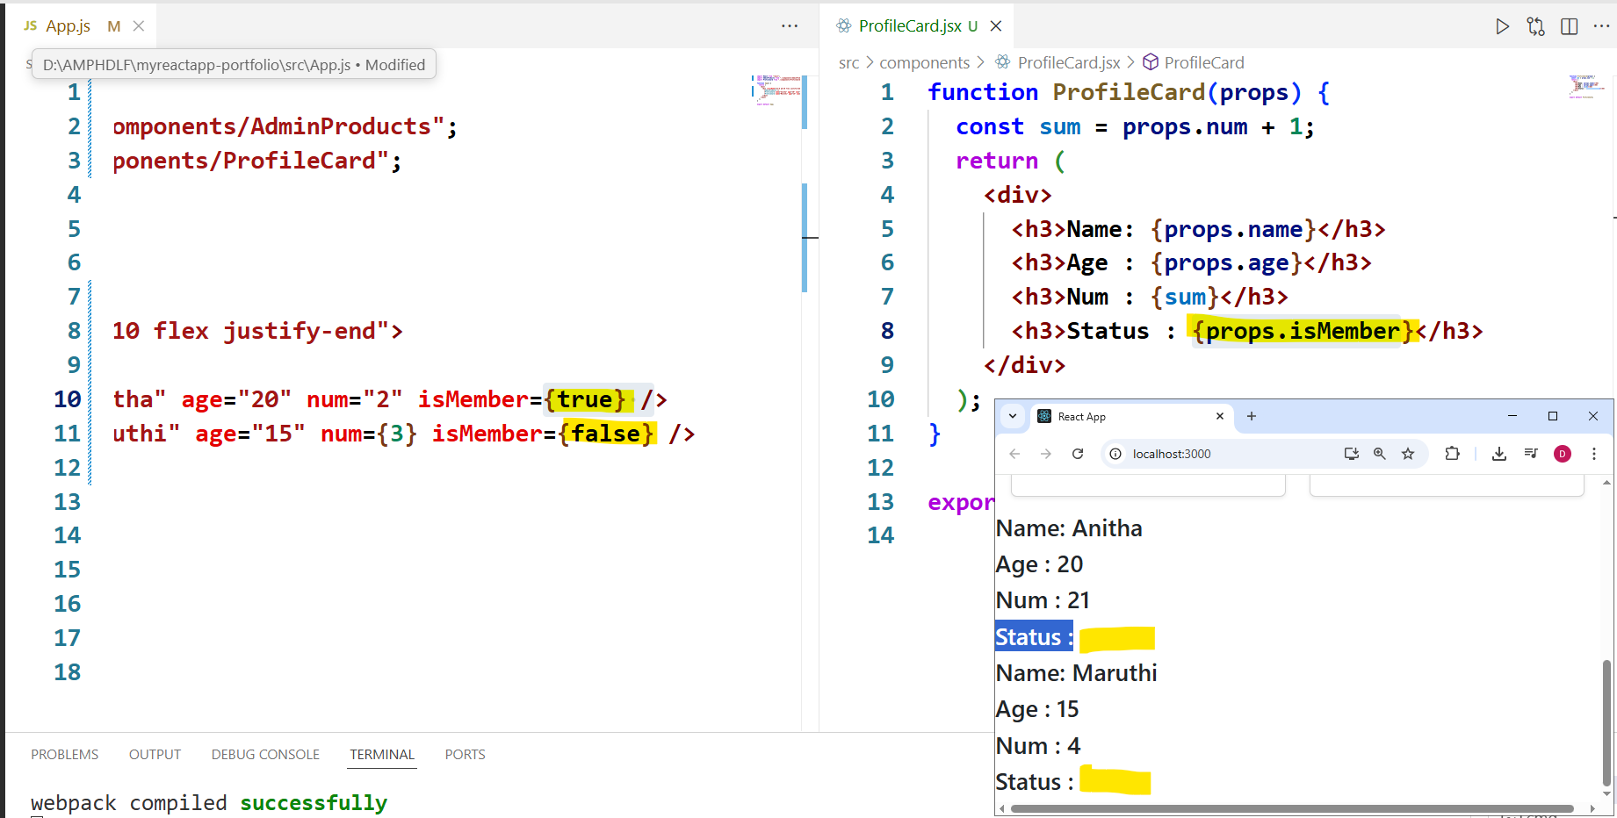

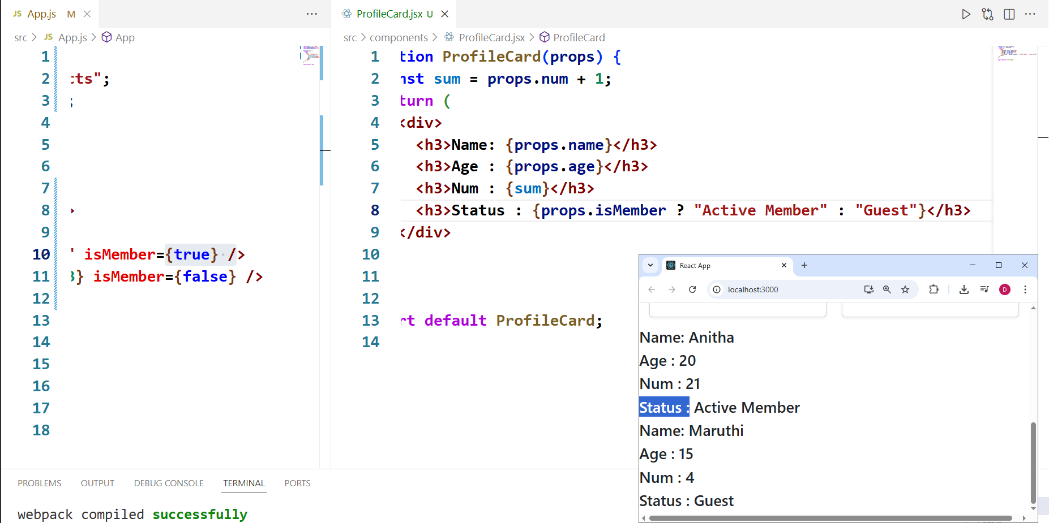

Act 15: **Destructuring**:

**UNPACKING THE PROPERTIES WITHIN THE OBJECTS**

Eg: const person ={ name : ‘John’ , age:30 } 🡪 Object

//Without destructuring

const name = person.name;

const age = person.age;

//With Destructuring

const {name, age} = person;

App.js

|  |
| --- |
| **import React from "react";**  **import ProfileCard from "./components/ProfileCard";**  **function App() {**  **return (**  **<div>**  **<div className="flex gap-6 mt-6">**  **<ProfileCard name="Anitha" age="20" isMember={true} />**  **<ProfileCard name="Maruthi" age="15" isMember={false} />**  **</div>**  **</div>**  **);**  **}**  **export default App;** |

ProfileCard.jsx

|  |
| --- |
| **function ProfileCard({ name, age, isMember }) { // give curly brackets**  **return (**  **<div>**  **<h3>Name: {name}</h3>**  **<h3>Age : {age}</h3>**  **<h3>Status : {isMember ? "Active Member" : "Guest"}</h3>**  **</div>**  **);**  **}**  **export default ProfileCard;** |

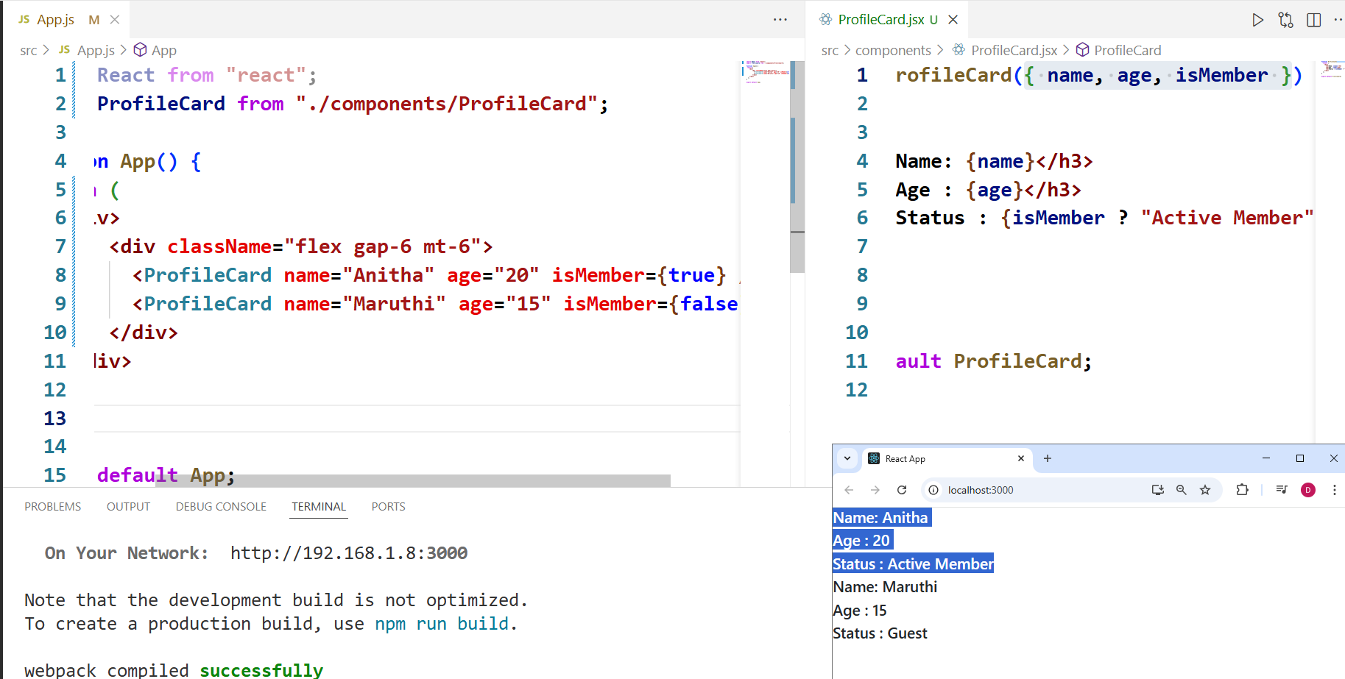

|  |
| --- |
| **Dependency for PropTypes**  ⚠️ **Note for React 19 learners:** PropTypes validation has been **deprecated and removed** in React 19. Even if you install the prop-types package, it will not show validation warnings in the console.  ✅ If you want type-checking in modern React apps, use **TypeScript** instead, which is the recommended approach by the React team.  For this lecture, you can still follow along with the code to understand the concept of prop validation, but if you are on React 19, you will not see runtime warnings.  Official Annoucement: https://react.dev/blog/2024/04/25/react-19-upgrade-guide#removed-proptypes-and-defaultprops  **FOR EARLIER VERSION OF REACT:** In the next lecture, for PropTypes validation to work - please add following dependency in your React project.  https://www.npmjs.com/package/prop-types  You can install using: **npm install prop-types** |

Act 16: Passing Array as props

App.js:

|  |
| --- |
| **import React from "react";**  **import ProfileCard from "./components/ProfileCard";**  **function App() {**  **const hobby1 = ["Reading", "Cooking"];**  **return (**  **<div>**  **<div className="flex gap-6 mt-6">**  **<ProfileCard name="Anitha" age="20" isMember={true} hobbies={hobby1} />**  **<ProfileCard name="Maruthi" age="15" isMember={false} hobbies={hobby1} />**  **</div>**  **</div>**  **);**  **}**  **export default App;** |

ProfileCard.jsx:

|  |
| --- |
| **function ProfileCard({ name, age, isMember, hobbies }) {**  **return (**  **<div>**  **<h3>Name: {name}</h3>**  **<h3>Age : {age}</h3>**  **<h3>Status : {isMember ? "Active Member" : "Guest"}</h3>**  **<h3>Hobbies:</h3>**  **<ul>**  **{hobbies.map((hobby, index) => {**  **return <li key={index}>{hobby}</li>;**  **})}**  **</ul>**  **</div>**  **);**  **}**  **export default ProfileCard;** |

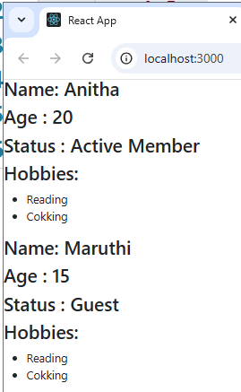

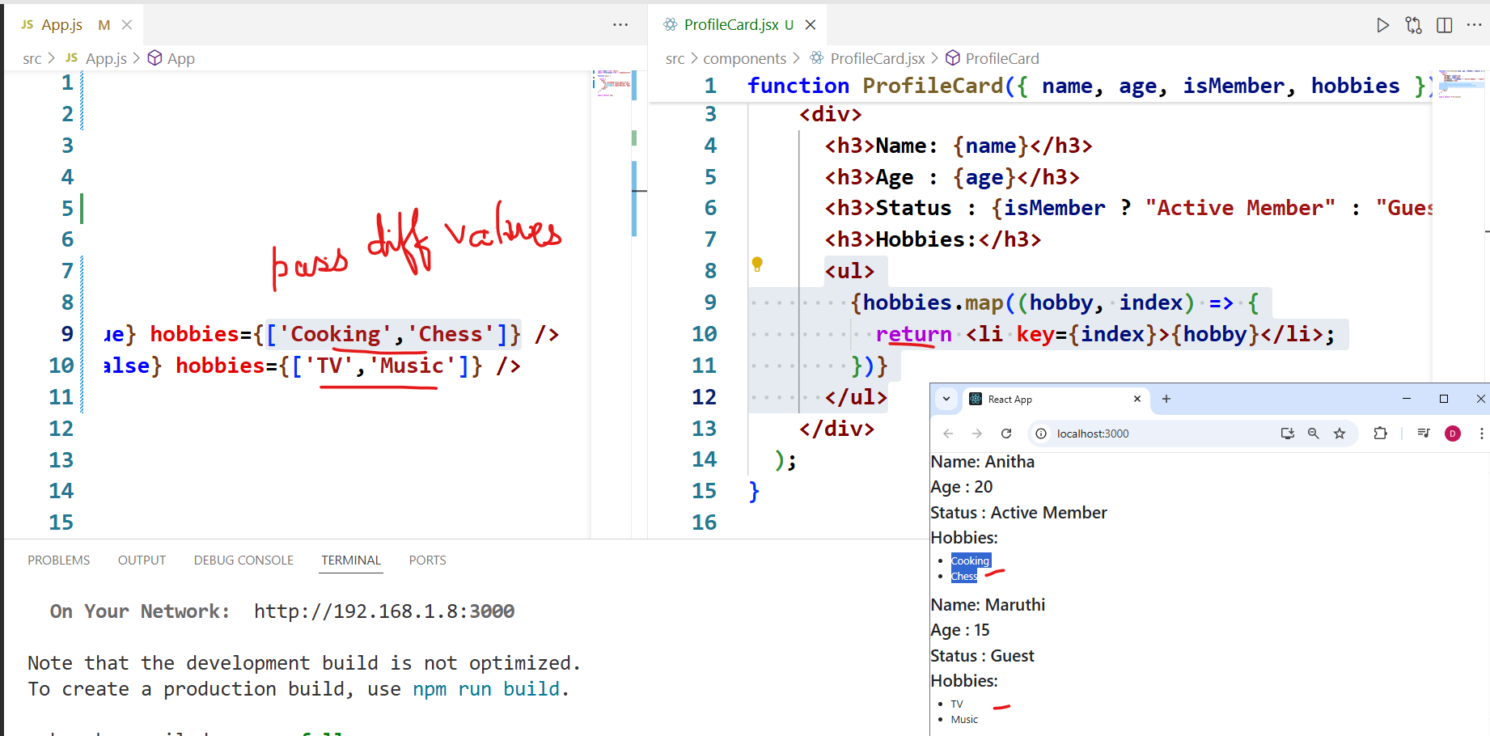

Act 17: Callbacks

Callbacks are functions that are passed as arguments to other functions and executed after a particular task (like rendering, db call, async operation) is completed.

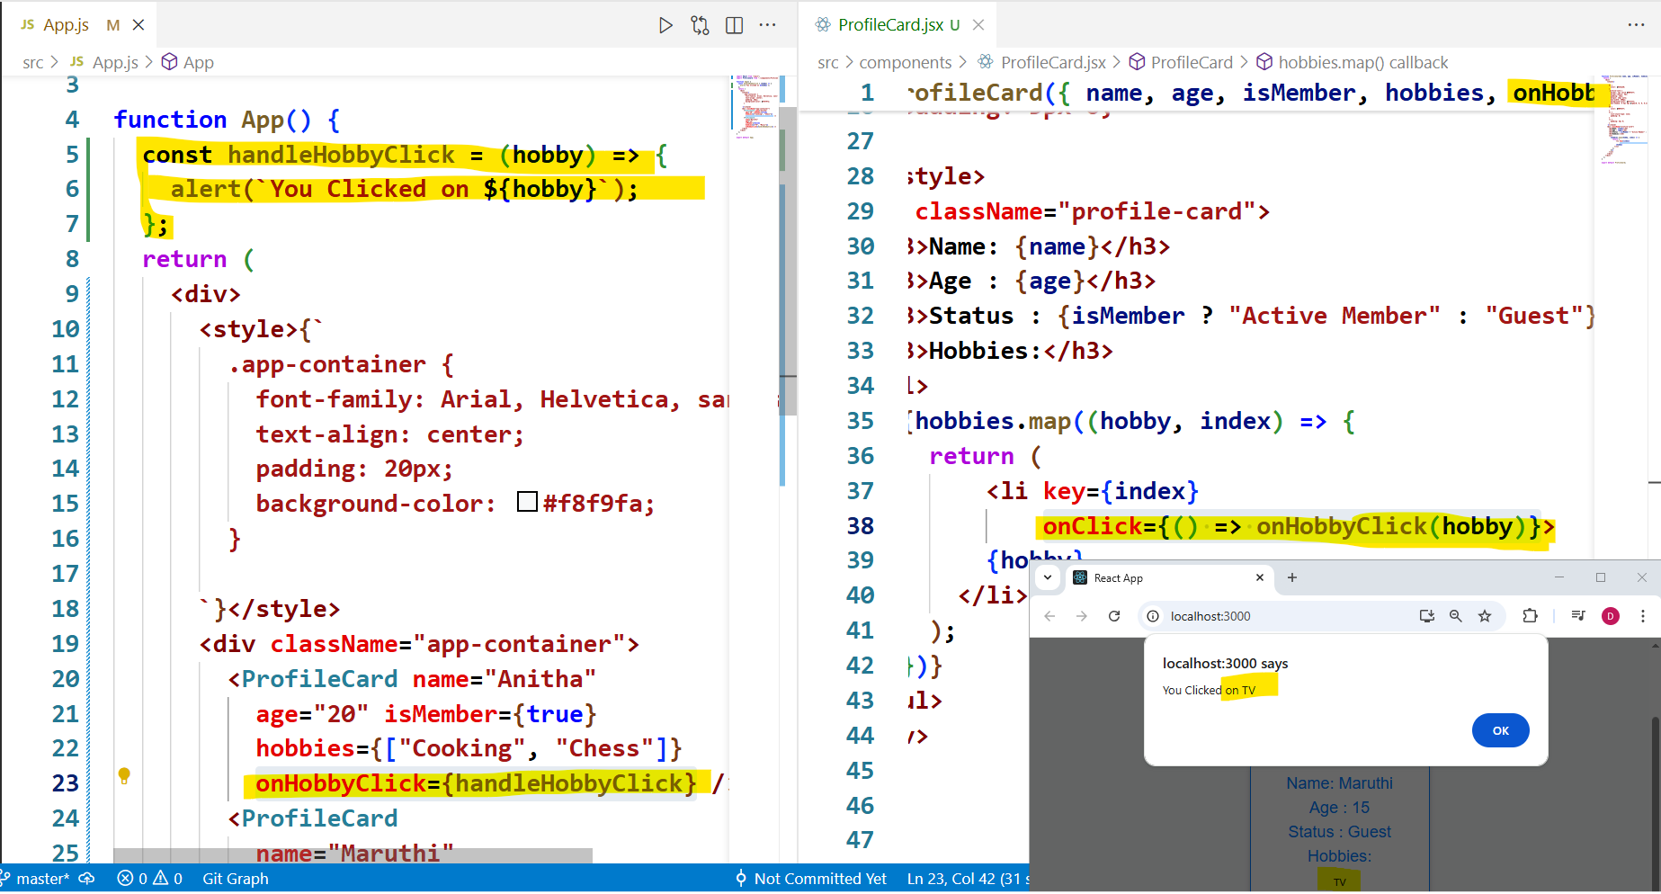

App.js

|  |
| --- |
| **import React from "react";**  **import ProfileCard from "./components/ProfileCard";**  **function App() {**  **const handleHobbyClick = (hobby) => {**  **alert(`You Clicked on ${hobby}`);**  **};**  **return (**  **<div>**  **<style>{`**  **.app-container {**  **font-family: Arial, Helvetica, sans-serif;**  **text-align: center;**  **padding: 20px;**  **background-color: #f8f9fa;**  **}**    **`}</style>**  **<div className="app-container">**  **<ProfileCard name="Anitha"**  **age="20" isMember={true}**  **hobbies={["Cooking", "Chess"]}**  **onHobbyClick={handleHobbyClick} />**  **<ProfileCard**  **name="Maruthi"**  **age="15"**  **isMember={false}**  **hobbies={["TV", "Music"]}**  **onHobbyClick={handleHobbyClick} />**  **</div>**  **</div>**  **);**  **}**  **export default App;** |

ProfileCard.jsx

|  |
| --- |
| **function ProfileCard({ name, age, isMember, hobbies, onHobbyClick }) {**  **return (**  **<div>**  **<style>{`**    **h1 {**  **color: #343a40;**  **}**  **.profile-card {**  **border: 1px solid #007bff;**  **border-radius: 5px;**  **padding: 15px;**  **margin: 15px auto;**  **max-width: 300px;**  **background-color: #ffffff;**  **box-shadow: 0 4px 8px rgba(0, 0, 0, 0.2);**  **}**  **h3 {**  **color: #007bff;**  **}**  **ul {**  **list-style-type: none;**  **padding: 0;**  **}**  **li {**  **padding: 5px 0;**  **}**  **`}</style>**  **<div className="profile-card">**  **<h3>Name: {name}</h3>**  **<h3>Age : {age}</h3>**  **<h3>Status : {isMember ? "Active Member" : "Guest"}</h3>**  **<h3>Hobbies:</h3>**  **<ul>**  **{hobbies.map((hobby, index) => {**  **return (**  **<li key={index}**  **onClick={() => onHobbyClick(hobby)}>**  **{hobby}**  **</li>**  **);**  **})}**  **</ul>**  **</div>**  **</div>**  **);**  **}**  **export default ProfileCard;** |

Act 18: Using Spread Operator

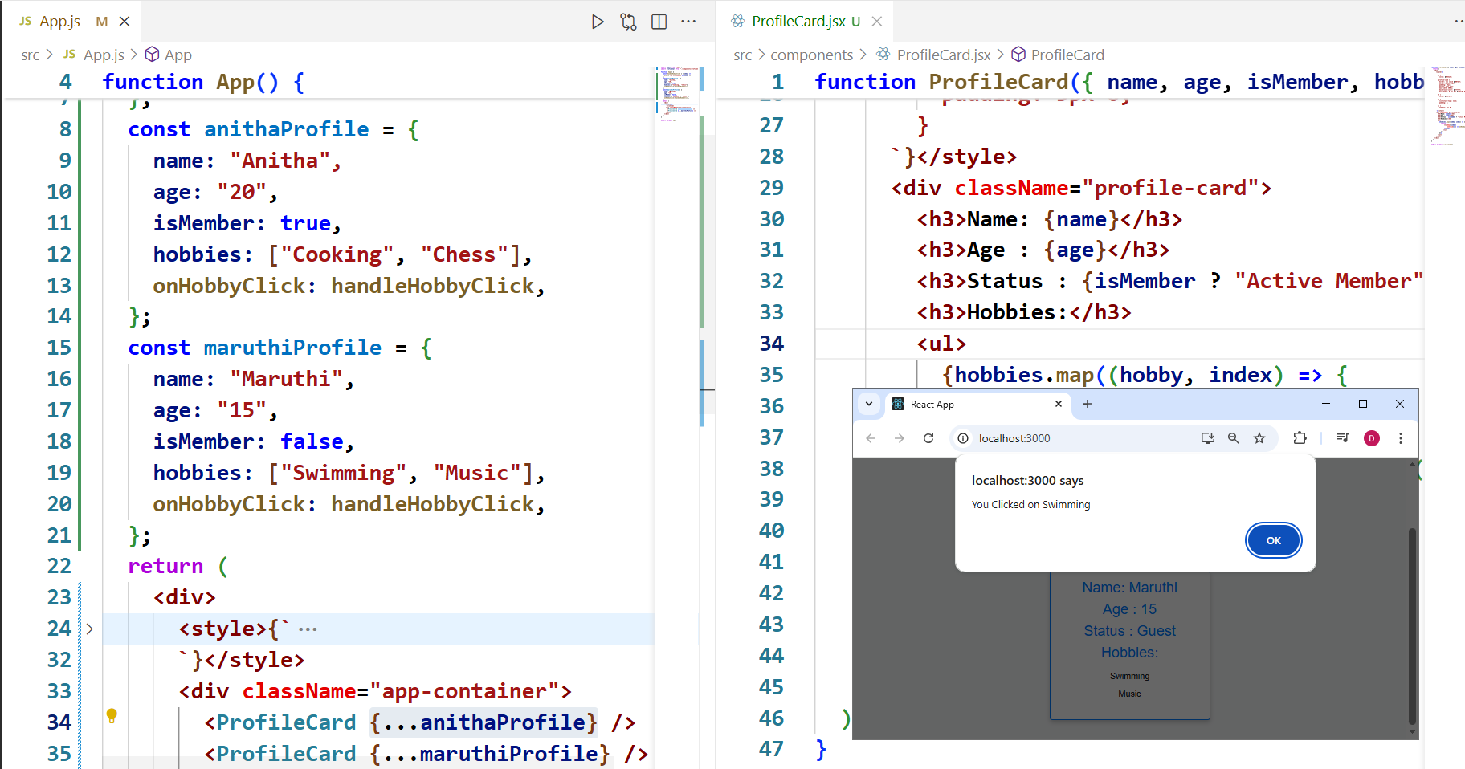

App.js

|  |
| --- |
| import React from "react";  import ProfileCard from "./components/ProfileCard";  function App() {  const handleHobbyClick = (hobby) => {  alert(`You Clicked on ${hobby}`);  };  const anithaProfile = {  name: "Anitha",  age: "20",  isMember: true,  hobbies: ["Cooking", "Chess"],  onHobbyClick: handleHobbyClick,  };  const maruthiProfile = {  name: "Maruthi",  age: "15",  isMember: false,  hobbies: ["Swimming", "Music"],  onHobbyClick: handleHobbyClick,  };  return (  <div>  <style>{`  .app-container {  font-family: Arial, Helvetica, sans-serif;  text-align: center;  padding: 20px;  background-color: #f8f9fa;  }    `}</style>  <div className="app-container">  <ProfileCard {...anithaProfile} />  <ProfileCard {...maruthiProfile} />  </div>  </div>  );  }  export default App; |

ProfileCard.jsx

Same as before.

**Introduction to HOOKS:**

Hooks enable us to add some dynamic features in a simple way

<https://codesandbox.io/p/sandbox/react-codesandbox-l4w3o6my59?file=%2Fsrc%2Findex.js%3A9%2C1>

Counter Demo for useState()

<https://codesandbox.io/p/sandbox/react-hooks-counter-demo-kqm9s?file=%2Fsrc%2Findex.js>

|  |
| --- |
| Usage Reminders  -- Always call hooks at the top level of your component (not inside loops or conditions).  -- Always use hooks in functional components (or custom hooks). They do not work in class components.  -- Use dependencies arrays ([]) properly in useEffect, useMemo, useCallback to avoid stale closures or infinite loops.  -- Use useRef for values/components you want to persist without causing re-renders.  -- For performance-sensitive UI, consider useTransition + useDeferredValue.  -- When you see repeated logic across components, consider pulling it into a custom hook.  ----------------------------------  **1) State Hooks**  useState: declare state variables inside functional components.  const [count, setCount] = useState(0) // counter button  useReducer: manage complex state logic by using a reducer function.  const [state, dispatch] = useReducer(reducer, { tasks: [] })  **2) Context Hooks**  useContext: subscribe to a React context to avoid drilling props.  const theme = useContext(ThemeContext)  **3) Ref Hooks**  useRef: store a mutable value or DOM node that survives re-renders, without causing re-render.  const inputRef = useRef(); inputRef.current.focus()  useImperativeHandle: customize the instance value exposed by forwardRef. Rare.  **4) Effect Hooks**  useEffect: run side-effects (e.g., data fetching, subscriptions, DOM mutations).  useEffect — useEffect(() => { fetchUsers() }, [])  useLayoutEffect: similar to useEffect, but fires synchronously before the browser repaints. Use for layout reads.  useLayoutEffect(() => { const h = ref.current.offsetHeight }, [])  useInsertionEffect: very rare — for libraries to insert CSS before DOM changes.  **5) Performance Hooks**  useMemo: memoize costly computations so they run only when dependencies change.  const filtered = useMemo(() => data.filter(x => x.active), [data])  useCallback: memoize functions so child components don’t re-receive changed handler props unnecessarily.  const handleClick = useCallback(() => setCount(c => c + 1), [])  useTransition: mark updates as non-urgent; helps keep UI responsive during heavy updates.  const [startTransition, isPending] = useTransition()  useDeferredValue: defer a non-critical value update so more urgent updates finish first.  const deferredSearch = useDeferredValue(searchTerm)  **6) Other / Less Common Hooks**  useDebugValue: display a label in React DevTools for custom hooks.  useDebugValue(isOnline ? "Online" : "Offline")  useId: generate a stable unique ID for accessibility or server-rendering.  const id = useId()  useSyncExternalStore: subscribe to external stores (like state managers) with built-in support for concurrent rendering.  useActionState: manage state of user actions (rare).  **7) Custom Hooks**  You can create your own custom hooks: a function starting with use that uses built-in hooks internally. Reuse logic cleanly.  function useToggle(initial = false) { const [state, setState] = useState(initial); const toggle = () => setState(s => !s); return [state, toggle]; } |

States:

States in react is a way for react component to hold on to some information that can change over

a period of time, and it needs to be remembered.

|  |
| --- |
| In React, **state** is how a component stores information that can **change over time** — and needs to be **remembered between renders**.  For example:   * If a user enables **dark mode**, the application should *remember* that preference. * If a user is reading an article and **bookmarks their last read position**, the app should *store* that so it knows where to resume later.   That's exactly what React state is for — **keeping track of changing data that should persist while the app is running.** |

QUESTIONS OR THOUGHTS:

Why not just use variables? – Re-rendering is done automatically by react which is not possible with varibales

The magic of state in react is that whenever it changes, React knows to automatically re-render the component (or parts of it) to reflect those changes on the UI.

HOW IS THIS DIFFERENT FROM PROPS [PROPERTIES] WE PASS DOWM TO COMPONENT?

Props are like the settings or attributes you pass down to a component. They are read only.

**Act 19: useState() -- Hook to add state information**

useState() returns an array. Which has the state and the function to update the state.

**const [page, setPage] = useState(1);**

page – is the state

setPage -- is the function to update the state(page)

useState(1) -- 1 is the initial value set to page

setPage should be triggered by any html component like button

ReadingApp.jsx

|  |
| --- |
| **import { useState } from "react";**  **function ReadingApp() {**  **const [page, setPage] = useState(1);**  **return (**  **<div>**  **<h1>**  **<p>You're on page {page}</p>**  **</h1>**  **<button onClick={() => setPage(page - 1)}>Previous Page</button>**  **<button onClick={() => setPage(page + 1)}>Next Page</button>**  **</div>**  **);**  **}**  **export default ReadingApp;** |

App.js

|  |
| --- |
| **import React from "react";**  **import ReadingApp from "./components/ReadingApp";**  **function App() {**  **return (**  **<div className="app-container">**  **<h1>Hello</h1>**  **<ReadingApp />**  **</div>**  **);**  **}**  **export default App;** |

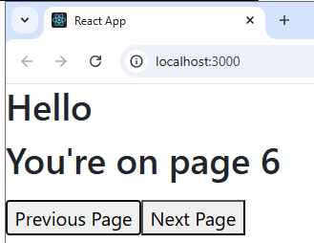

More examples on useState()

Eg2:

|  |
| --- |
| **import React, { useState } from "react";**  **function ShowHideText() {**  **const [visible, setVisible] = useState(true);**  **return (**  **<div>**  **{visible && (**  **<h3 style={{ color: "blue" }}>**  **<p>This text can be shown or hidden!</p>**  **</h3>**  **)}**  **<button onClick={() => setVisible(!visible)}>{visible ? "Hide" : "Show"}</button>**  **</div>**  **);**  **}**  **export default ShowHideText;** |

Eg 3:

|  |
| --- |
| **import React, { useState } from "react";**  **function DarkModeToggle() {**  **const [isDarkMode, setIsDarkMode] = useState(false);**  **return (**  **<div style={{ background: isDarkMode ? "#333" : "#fff", color: isDarkMode ? "#fff" : "#000", padding: "20px" }}>**  **<h2>{isDarkMode ? "Dark Mode" : "Light Mode"}</h2>**  **<button onClick={() => setIsDarkMode(!isDarkMode)}>Toggle Mode</button>**  **</div>**  **);**  **}**  **export default DarkModeToggle;** |

Eg 4:

|  |
| --- |
| **import React, { useState } from "react";**  **function NameForm() {**  **const [name, setName] = useState("");**  **return (**  **<div>**  **<input type="text" placeholder="Enter your name" value={name} onChange={(e) => setName(e.target.value)} />**  **<p>Hello, {name ? name : "stranger"}!</p>**  **</div>**  **);**  **}**  **export default NameForm;** |

App.jsx

|  |
| --- |
| **import React from "react";**  **import ReadingApp from "./components/ReadingApp";**  **import ShowHideText from "./components/ShowHideText";**  **import NameForm from "./components/NameForm";**  **import DarkModeToggle from "./components/DarkModeToggle";**  **function App() {**  **return (**  **<div className="app-container">**  **<h1>Hello</h1>**  **<ReadingApp />**  **<ShowHideText />**  **<NameForm />**  **<DarkModeToggle />**  **</div>**  **);**  **}**  **export default App;** |

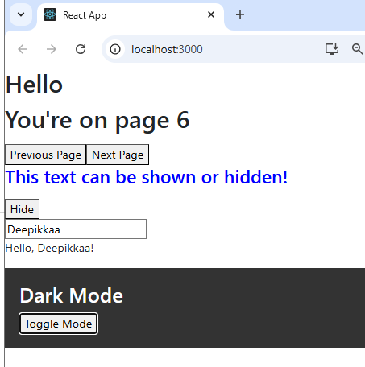

Eg 5:

|  |
| --- |
| **import { useState } from "react";**  **function IncrDecr() {**  **const [count, setcount] = useState(0);**  **const [step, setStep] = useState(1);**  **return (**  **<div>**  **<h1>**  **<p>Count value: {count}</p>**  **</h1>**  **<input type="number" value={step} onChange={(e) => setStep(parseInt(e.target.value))} />**  **<button onClick={() => setcount(count - step)}>Increment</button>**  **<button onClick={() => setcount(count + step)}>Decrement</button>**  **</div>**  **);**  **}**  **export default IncrDecr;**  (or)  **import { useState } from "react";**  **function IncrDecr() {**  **const [count, setcount] = useState(0);**  **const [step, setStep] = useState(1);**  **const incrementCount = () => {**  **setcount(count + step);**  **};**  **const decrementCount = () => {**  **setcount(count - step);**  **};**  **return (**  **<div>**  **<h1>**  **<p>Count value: {count}</p>**  **</h1>**  **<input type="number" value={step} onChange={(e) => setStep(parseInt(e.target.value))} />**  **<button onClick={incrementCount}>Increment</button>**  **<button onClick={decrementCount}>Decrement</button>**  **</div>**  **);**  **}**  **export default IncrDecr;**  **//State updates are async**  **//We need to use updater function for multiple state updates**  **import { useState } from "react";**  **function IncrDecr() {**  **const [count, setCount] = useState(0);**  **const [step, setStep] = useState(1);**  **//State updates are async**  **//We need to use updater function for multiple state updates**  **const incrementTwice = () => {**  **// setCount(count + 1); // Both setCount will incr by 1**  **//setCount(count + 1);**  **setCount((c) => c + 1); //THis is UPDATER function**  **setCount((c) => c + 1);**  **};**  **const incrementCount = () => {**  **setCount(count + step);**  **};**  **const decrementCount = () => {**  **setCount(count - step);**  **};**  **return (**  **<div>**  **<h1>**  **<p>Count value: {count}</p>**  **</h1>**  **<input type="number" value={step} onChange={(e) => setStep(parseInt(e.target.value))} />**  **<button onClick={incrementCount}>Increment</button>**  **<button onClick={decrementCount}>Decrement</button>**  **<button onClick={incrementTwice}>+2</button>**  **</div>**  **);**  **}**  **export default IncrDecr;** |

Eg 6:

|  |
| --- |
| **import React, { useState } from "react";**  **function ProductList() {**  **const [products, setProducts] = useState([**  **{ id: 1, name: "Barbi", price: 4500, quantity: 5 },**  **{ id: 2, name: "iPhone Pro", price: 63000, quantity: 5 },**  **]);**  **// Example: Increase quantity for a product**  **const increaseQuantity = (id) => {**  **setProducts(products.map((product) => (product.id === id ? { ...product, quantity: product.quantity + 1 } : product)));**  **};**  **// Example: Decrease quantity**  **const decreaseQuantity = (id) => {**  **setProducts(**  **products.map((product) => (product.id === id && product.quantity > 0 ? { ...product, quantity: product.quantity - 1 } : product))**  **);**  **};**  **return (**  **<div>**  **<h2>Product List</h2>**  **{products.map((product) => (**  **<div**  **key={product.id}**  **style={{**  **border: "1px solid #007bff",**  **padding: "10px",**  **margin: "10px 0",**  **maxWidth: "300px",**  **}}**  **>**  **<h3>{product.name}</h3>**  **<p>Price: ₹{product.price}</p>**  **<p>Available: {product.quantity}</p>**  **<button onClick={() => increaseQuantity(product.id)}>+</button>**  **<button onClick={() => decreaseQuantity(product.id)} style={{ marginLeft: "10px" }}>**  **-**  **</button>**  **</div>**  **))}**  **</div>**  **);**  **}**  **export default ProductList;** |

App.js

|  |
| --- |
| **import React from "react";**  **import ReadingApp from "./components/ReadingApp";**  **import ShowHideText from "./components/ShowHideText";**  **import NameForm from "./components/NameForm";**  **import DarkModeToggle from "./components/DarkModeToggle";**  **import ProductList from "./components/ProductList";**  **function App() {**  **return (**  **<div className="app-container">**  **<h1>Hello</h1>**  **<ReadingApp />**  **<ShowHideText />**  **<NameForm />**  **<DarkModeToggle />**  **<ProductList />**  **<IncrDecr />**  **</div>**  **);**  **}**  **export default App;** |
|  |

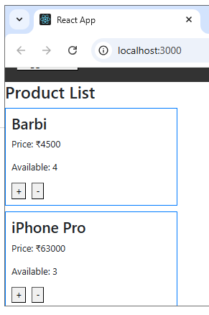

Act 20: To store Arrays, Objects or more complex Data Structures in State.

StateNArrays.jsx

|  |
| --- |
| **import React, { useState } from "react";**  **function StateNArrays() {**  **const [counters, setCounters] = useState([{ id: 1, value: 0 }]);**  **const addCounters = () => {**  **setCounters([...counters, { id: counters.length + 1, value: 0 }]);**  **};**  **const incrementCounter = (id) => {**  **setCounters(counters.map((counter) => (counter.id === id ? { ...counter, value: counter.value + 1 } : counter)));**  **};**  **return (**  **<div className="app-container">**  **<h1>Hello</h1>**  **<button onClick={addCounters}>Add Counter</button>**  **<ul>**  **{counters.map((counter) => (**  **<li key={counter.id}>**  **Counter {counter.id}: {counter.value}**  **<button**  **style={{ color: "blue" }}**  **onClick={() => {**  **incrementCounter(counter.id);**  **}}**  **>**  **Increment**  **</button>**  **</li>**  **))}**  **</ul>**  **</div>**  **);**  **}**  **export default StateNArrays;** |

App.js

|  |
| --- |
| **import React from "react";**  **import StateNArrays from "./components/StateNArrays";**  **function App() {**  **return (**  **<div className="app-container">**  **<h1>Hello</h1>**  **<StateNArrays />**  **</div>**  **);**  **}**  **export default App;** |

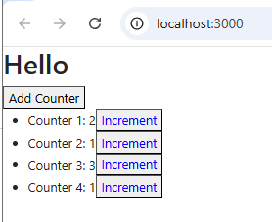

Act 21: Managing Form Inputs with useState

1. UserForm.jsx - Displays Error msgs and clear everything after form successfully submitted

|  |
| --- |
| **import React, { useState } from "react";**  **function UserForm() {**  **const [formData, setFormData] = useState({**  **username: "",**  **gender: "",**  **country: "",**  **acceptedTerms: false,**  **});**  **const [errors, setErrors] = useState({});**  **const handleChange = (e) => {**  **const { name, value, type, checked } = e.target;**  **setFormData((prev) => ({**  **...prev,**  **[name]: type === "checkbox" ? checked : value,**  **}));**  **};**  **const validateForm = () => {**  **let newErrors = {};**  **if (!formData.username.trim()) newErrors.username = "Username is required";**  **if (!formData.gender) newErrors.gender = "Select a gender";**  **if (!formData.country) newErrors.country = "Select a country";**  **if (!formData.acceptedTerms) newErrors.acceptedTerms = "You must accept the terms";**  **setErrors(newErrors);**  **return Object.keys(newErrors).length === 0; // ✅ Valid if no errors**  **};**  **const handleSubmit = (e) => {**  **e.preventDefault();**  **if (validateForm()) {**  **alert("Form submitted successfully!");**  **}**  **};**  **return (**  **<div style={{ padding: "20px" }}>**  **<h2>Registration Form</h2>**  **<form onSubmit={handleSubmit}>**  **{/* Username */}**  **<label>**  **Username:**  **<input type="text" name="username" value={formData.username} onChange={handleChange} />**  **</label>**  **{errors.username && <p style={{ color: "red" }}>{errors.username}</p>}**  **<br />**  **<br />**  **{/* Gender as Radio Buttons */}**  **<label>Gender:</label>**  **<br />**  **{["Male", "Female", "Other"].map((g) => (**  **<label key={g} style={{ marginRight: "10px" }}>**  **<input type="radio" name="gender" value={g} checked={formData.gender === g} onChange={handleChange} /> {g}**  **</label>**  **))}**  **{errors.gender && <p style={{ color: "red" }}>{errors.gender}</p>}**  **<br />**  **{/* Country Dropdown */}**  **<label>**  **Country:**  **<select name="country" value={formData.country} onChange={handleChange}>**  **<option value="">Choose</option>**  **<option value="India">India</option>**  **<option value="Singapore">Singapore</option>**  **<option value="UK">UK</option>**  **</select>**  **</label>**  **{errors.country && <p style={{ color: "red" }}>{errors.country}</p>}**  **<br />**  **<br />**  **{/* Terms Checkbox */}**  **<label>**  **<input type="checkbox" name="acceptedTerms" checked={formData.acceptedTerms} onChange={handleChange} />I accept Terms & Conditions**  **</label>**  **{errors.acceptedTerms && <p style={{ color: "red" }}>{errors.acceptedTerms}</p>}**  **<br />**  **<br />**  **<button type="submit">Submit</button>**  **</form>**  **<hr />**  **<h3>Entered Data:</h3>**  **<div>**  **<p>**  **<b>Username:</b> {formData.username}**  **</p>**  **<p>**  **<b>Gender:</b> {formData.gender}**  **</p>**  **<p>**  **<b>Country:</b> {formData.country}**  **</p>**  **<p>**  **<b>Terms Accepted:</b> {formData.acceptedTerms ? "Yes ✅" : "No ❌"}**  **</p>**  **</div>**  **</div>**  **);**  **}**  **export default UserForm;** |

1. UserForm.jsx : Displays Error msgs and flush that msg once the valid input is entered

|  |
| --- |
| **import React, { useState } from "react";**  **function UserForm() {**  **const [formData, setFormData] = useState({**  **username: "",**  **gender: "",**  **country: "",**  **acceptedTerms: false,**  **});**  **const [errors, setErrors] = useState({});**  **const handleChange = (e) => {**  **const { name, value, type, checked } = e.target;**  **const newValue = type === "checkbox" ? checked : value;**  **setFormData((prev) => ({**  **...prev,**  **[name]: newValue,**  **}));**  **// ✅ Clear error immediately if field becomes valid**  **setErrors((prev) => {**  **const newErrors = { ...prev };**  **if (name === "username" && newValue.trim() !== "") delete newErrors.username;**  **if (name === "gender" && newValue !== "") delete newErrors.gender;**  **if (name === "country" && newValue !== "") delete newErrors.country;**  **if (name === "acceptedTerms" && newValue === true) delete newErrors.acceptedTerms;**  **return newErrors;**  **});**  **};**  **const validateForm = () => {**  **let newErrors = {};**  **if (!formData.username.trim()) newErrors.username = "Username is required";**  **if (!formData.gender) newErrors.gender = "Select a gender";**  **if (!formData.country) newErrors.country = "Select a country";**  **if (!formData.acceptedTerms) newErrors.acceptedTerms = "You must accept the terms";**  **setErrors(newErrors);**  **return Object.keys(newErrors).length === 0;**  **};**  **const handleSubmit = (e) => {**  **e.preventDefault();**  **if (validateForm()) alert("Form submitted successfully!");**  **};**  **return (**  **<div style={{ padding: "20px" }}>**  **<h2>Registration Form</h2>**  **<form onSubmit={handleSubmit}>**  **{/* Username */}**  **<label>**  **Username:**  **<input type="text" name="username" value={formData.username} onChange={handleChange} />**  **</label>**  **{errors.username && <p style={{ color: "red" }}>{errors.username}</p>}**  **<br />**  **<br />**  **{/* Gender */}**  **<label>Gender:</label>**  **<br />**  **{["Male", "Female", "Other"].map((g) => (**  **<label key={g} style={{ marginRight: "10px" }}>**  **<input type="radio" name="gender" value={g} checked={formData.gender === g} onChange={handleChange} /> {g}**  **</label>**  **))}**  **{errors.gender && <p style={{ color: "red" }}>{errors.gender}</p>}**  **<br />**  **{/* Country */}**  **<label>**  **Country:**  **<select name="country" value={formData.country} onChange={handleChange}>**  **<option value="">Choose</option>**  **<option value="India">India</option>**  **<option value="Singapore">Singapore</option>**  **<option value="UK">UK</option>**  **</select>**  **</label>**  **{errors.country && <p style={{ color: "red" }}>{errors.country}</p>}**  **<br />**  **<br />**  **{/* Terms */}**  **<label>**  **<input type="checkbox" name="acceptedTerms" checked={formData.acceptedTerms} onChange={handleChange} />I accept Terms & Conditions**  **</label>**  **{errors.acceptedTerms && <p style={{ color: "red" }}>{errors.acceptedTerms}</p>}**  **<br />**  **<br />**  **<button type="submit">Submit</button>**  **</form>**  **<hr />**  **<h3>Entered Data:</h3>**  **<div>**  **<p>**  **<b>Username:</b> {formData.username}**  **</p>**  **<p>**  **<b>Gender:</b> {formData.gender}**  **</p>**  **<p>**  **<b>Country:</b> {formData.country}**  **</p>**  **<p>**  **<b>Terms Accepted:</b> {formData.acceptedTerms ? "Yes ✅" : "No ❌"}**  **</p>**  **</div>**  **</div>**  **);**  **}**  **export default UserForm;** |

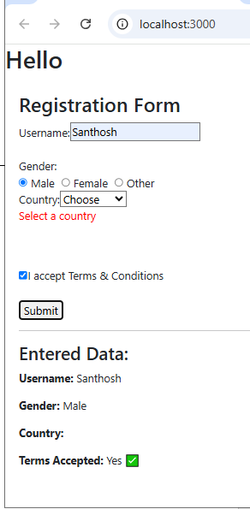 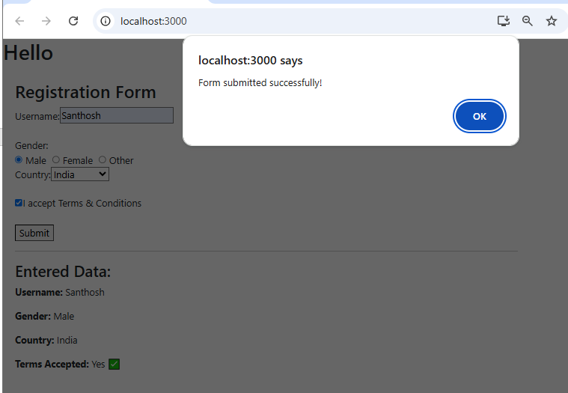

Act 22:  **useEffect() Hook**

UseEffect hook in react lets you run some code automatically when something changes

or when a component loads. component loads, it means that component renders for the first time or it mounts.

Its like setting a task to happen after the screen updates or when certain data is ready.

Syntax:

**useEffect(() => { code to run } , [dependency] )**

**useEffect(() => {} ); //Run on every render**

**useEffect(() => {} , [] ); //Runs only once after the initial render**

**useEffect(() => {} ,[ count ]); //Run on initial render and when count changes**

App.jsx

|  |
| --- |
| **import React, { useEffect, useState } from "react";**  **function App() {**  **const [count, setCount] = useState(0);**  **useEffect(() => {**  **document.title = `Count : ${count + 1}`;**  **}, [count]);**  **const incrementCount = () => {**  **setCount(count + 1);**  **// document.title = `Count : ${count + 1}`;**  **};**  **return (**  **<div className="app-container">**  **<h1>Hello</h1>**  **<button onClick={incrementCount}>Increment</button>**  **</div>**  **);**  **}**  **export default App;** |

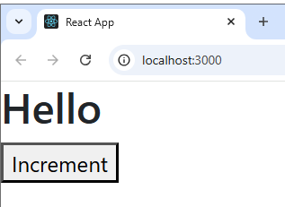 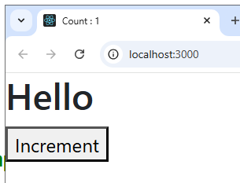

WITHOUT useEffect , see the title WITH useEffect , see the title

Act 23: Why the dependency array in useEffect is important, its usage

|  |
| --- |
| **import React, { useEffect, useState } from "react";**  **function UseEffect2() {**  **const [count, setCount] = useState(0);**  **const [anotherValue, setAnotherValue] = useState(0);**  **//   useEffect(() => {**  **//     console.log("useEffect Triggered"); // Observe the change in the console**  **//   });**  **//   useEffect(() => {**  **//     console.log("useEffect Triggered"); // Observe the change in the console**  **//   }, []);**  **useEffect(() => {**  **console.log("useEffect Triggered"); // Observe the change in the console**  **}, [count]);**  **return (**  **<div className="app-container">**  **<button onClick={() => setCount(count + 1)}>C Increment</button>**  **<button onClick={() => setAnotherValue(anotherValue + 1)}>AV Increment</button>**  **</div>**  **);**  **}**  **export default UseEffect2;** |

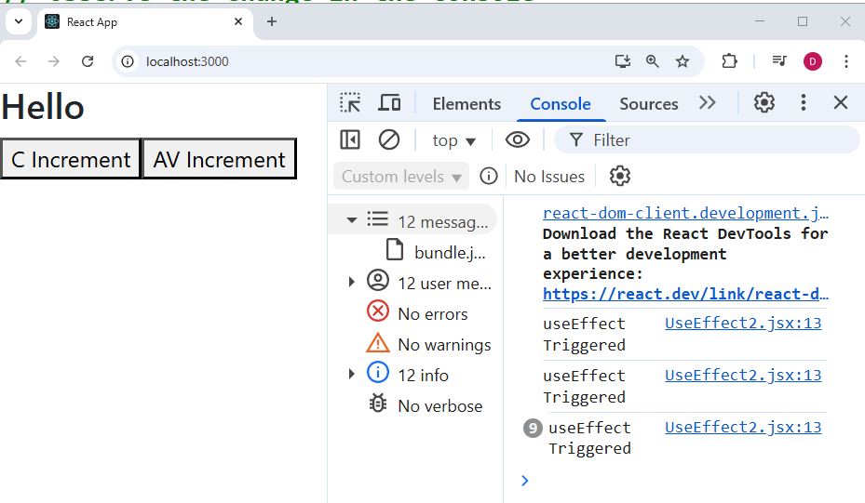

Act 24: Use AXIOS to get the data from backend application -useEffect () and useState()

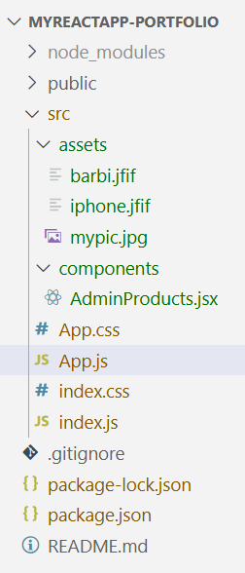 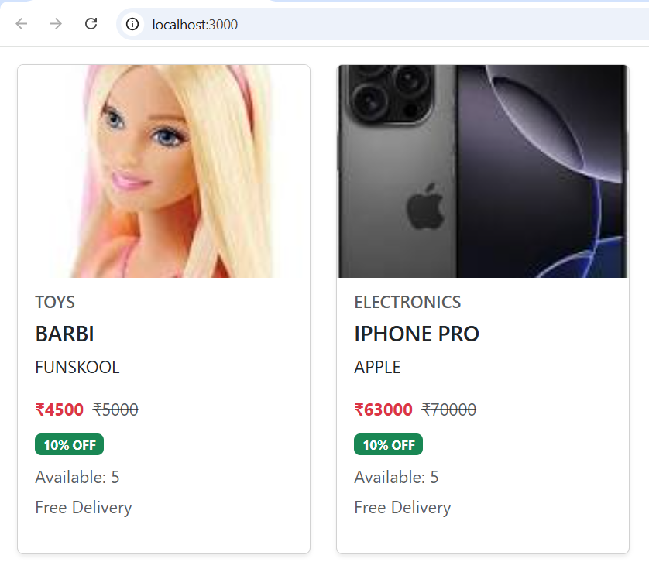

App.js

|  |
| --- |
| **import React from "react";**  **import AdminProducts from "./components/AdminProducts";**  **function App() {**  **return (**  **<div>**  **<div className="pt-6 pb-10 flex justify-end">**  **<AdminProducts />**  **</div>**  **</div>**  **);**  **}**  **export default App;** |

AdminProducts.jsx

|  |
| --- |
| **import { useState, useEffect } from "react";**  **import axios from "axios";**  **import { Card, Row, Col, Badge } from "react-bootstrap";**  **import BarbiImg from "../assets/barbi.jfif";**  **import IPhoneImg from "../assets/iphone.jfif";**  **const AdminProducts = () => {**  **const [products, setProducts] = useState([]);**  **useEffect(() => {**  **axios**  **.get("http://localhost:8082/api/public/products")**  **.then((response) => {**  **const dataWithImages = response.data.map((product) => {**  **// Assign local image based on productName or category**  **let image;**  **if (product.productName.toLowerCase() === "barbi") image = BarbiImg;**  **else if (product.productName.toLowerCase() === "iphone pro") image = IPhoneImg;**  **else image = null; // fallback if no match**  **return { ...product, image };**  **});**  **setProducts(dataWithImages);**  **})**  **.catch((error) => console.error("Error fetching products:", error));**  **}, []);**  **return (**  **<Row className="g-4 p-3">**  **{products.map((product) => (**  **<Col key={product.id} xs={12} sm={6} md={4}>**  **<Card className="h-100 shadow-sm">**  **<Card.Img variant="top" src={product.image} alt={product.productName} style={{ height: "200px", objectFit: "cover" }} />**  **<Card.Body>**  **<Card.Subtitle className="mb-2 text-muted">{product.category}</Card.Subtitle>**  **<Card.Title>{product.productName}</Card.Title>**  **<Card.Text>{product.brandName}</Card.Text>**  **<div className="mb-2">**  **<span className="text-danger fw-bold me-2">₹{product.specialPrice}</span>**  **<span className="text-muted text-decoration-line-through">₹{product.price}</span>**  **</div>**  **{product.discount > 0 && (**  **<Badge bg="success" className="mb-2">**  **{product.discount}% OFF**  **</Badge>**  **)}**  **<p className="text-muted mb-1">Available: {product.quantity}</p>**  **<p className="text-muted">Free Delivery</p>**  **</Card.Body>**  **</Card>**  **</Col>**  **))}**  **</Row>**  **);**  **};**  **export default AdminProducts;** |

Act 25: Mouse Position Tracker using useEffect

**MousePositionTracker.jsx**

|  |
| --- |
| **import React, { useEffect, useState } from "react";**  **function MousePositionTracker() {**  **const [mousePosition, setMousePosition] = useState({ x: 0, y: 0 });**  **useEffect(() => {**  **const handleMouseMove = (event) => {**  **setMousePosition({ x: event.clientX, y: event.clientY });**  **};**  **window.addEventListener("mousemove", handleMouseMove);**  **}, []);**  **return (**  **<div>**  **<style>{`**  **div {**  **font-family: Arial, Helvetica, sans-serif;**  **text-align: center;**  **padding: 20px;**  **margin: 0;**  **padding-top: 40px;**  **min-height:100vh;**  **}**  **`}</style>**  **<h2>Mouse Position</h2>**  **<p>**  **X : {mousePosition.x},Y:{mousePosition.y}**  **</p>**  **</div>**  **);**  **}**  **export default MousePositionTracker;** |

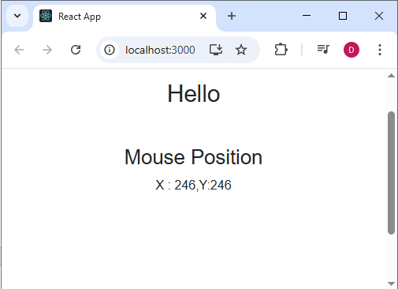

Act 26: Digital Clock

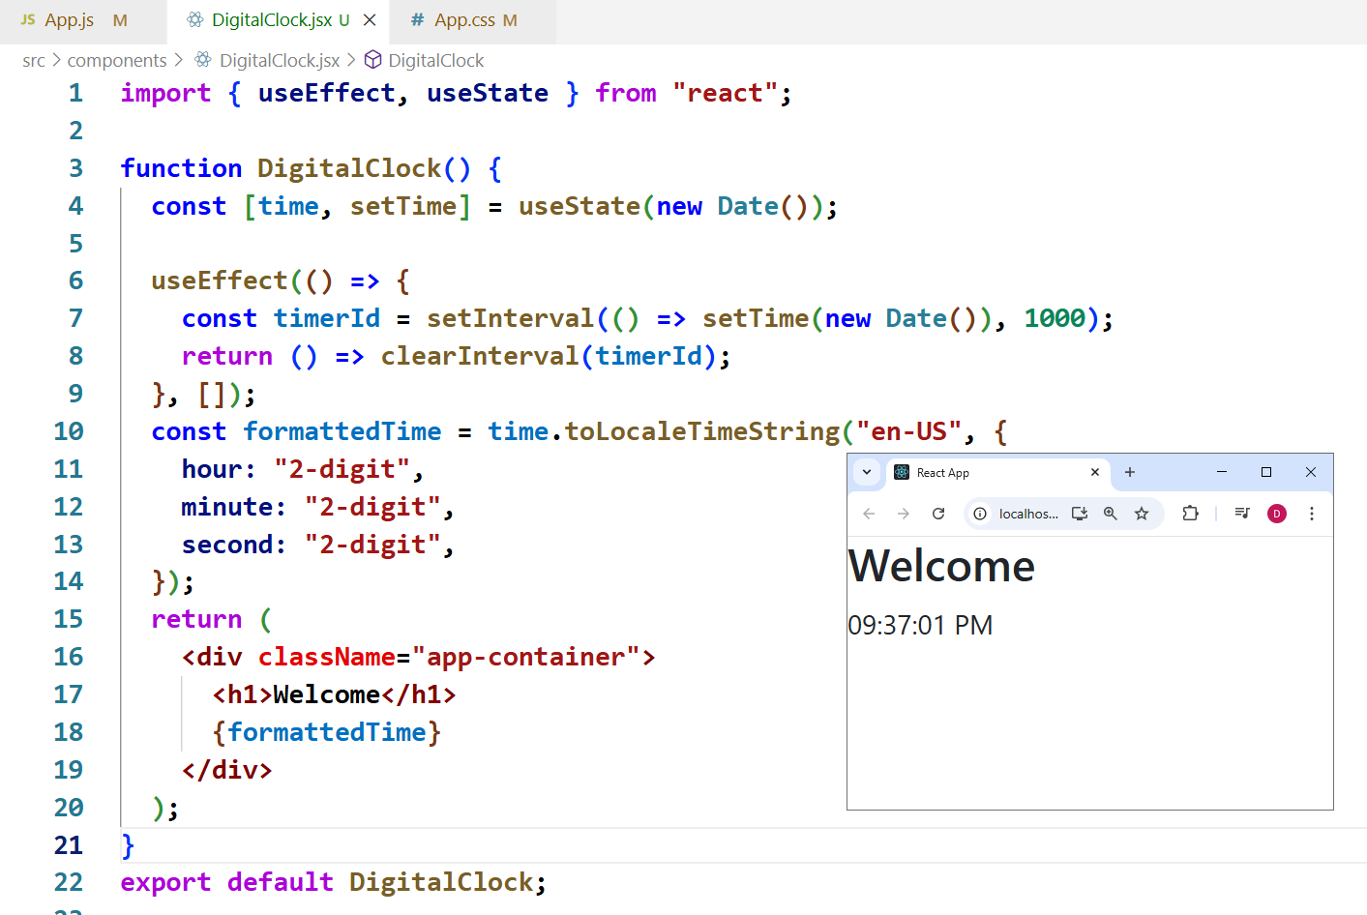

DigitalClock.jsx

|  |
| --- |
| **import { useEffect, useState } from "react";**  **function DigitalClock() {**  **const [time, setTime] = useState(new Date());**  **useEffect(() => {**  **const timerId = setInterval(() => setTime(new Date()), 1000);**  **return () => clearInterval(timerId);**  **}, []);**  **const formattedTime = time.toLocaleTimeString("en-US", {**  **hour: "2-digit",**  **minute: "2-digit",**  **second: "2-digit",**  **});**  **return (**  **<div className="app-container">**  **<h1>Welcome</h1>**  **{formattedTime}**  **</div>**  **);**  **}**  **export default DigitalClock;** |

Act 27: useRef () Hook

Persist values across renders without causing the component to re-render when the value changes

UseRefDemo1.jsx

|  |
| --- |
| **import React, { useState, useRef, useEffect } from "react";**  **function UseRefDemo1() {**  **const [stateCount, setStateCount] = useState(0); // Triggers re-render**  **const refCount = useRef(0); // Persists but no re-render**  **useEffect(() => {**  **console.log("Component Re-rendered");**  **});**  **const incrementState = () => setStateCount(stateCount + 1);**  **const incrementRef = () => {**  **refCount.current += 1;**  **console.log("Ref Count:", refCount.current); // Only visible in console**  **};**  **return (**  **<div style={{ padding: "20px" }}>**  **<h2>useState vs useRef Demo</h2>**  **<div>**  **<h3>useState Counter (Visible on UI)</h3>**  **<p>State Count: {stateCount}</p>**  **<button onClick={incrementState}>Increase useState</button>**  **</div>**  **<hr />**  **<div>**  **<p>Ref Count (Only updates internally): {refCount.current}</p>**  **<button onClick={incrementRef}>Increase useRef</button>**  **</div>**  **</div>**  **);**  **}**  **export default UseRefDemo1;** |

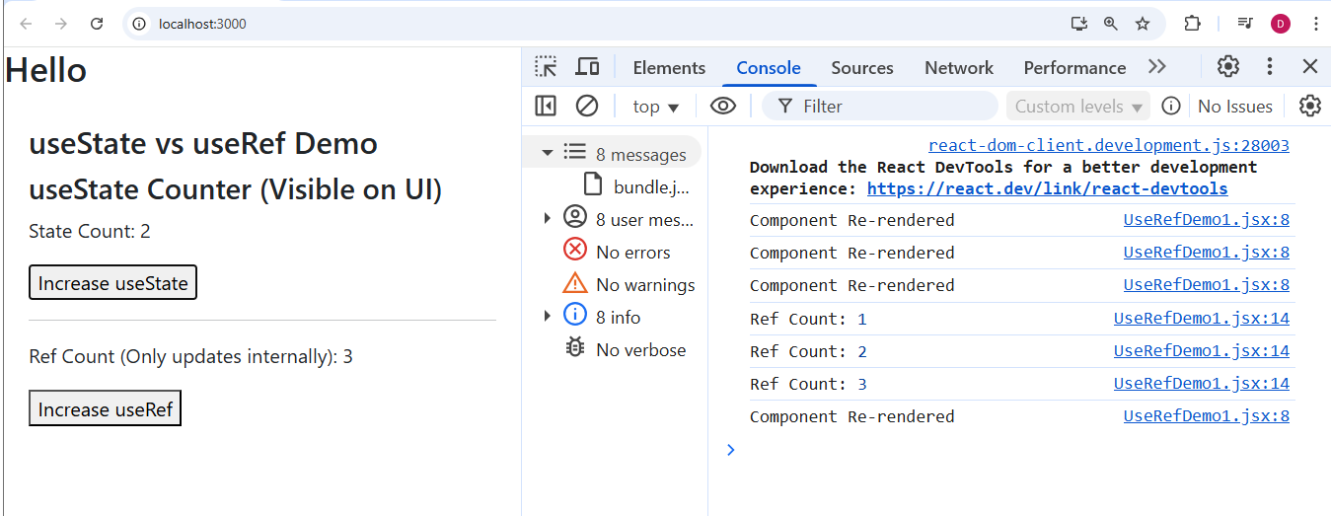

Act 28: Using useRef() with HTML elements

UseRefDemo2.jsx

|  |
| --- |
| **import React, { useRef } from "react";**  **export default function UseRefDemo2() {**  **const inputRef = useRef(null);**  **const highlightAndFocus = () => {**  **if (!inputRef.current) return;**  **inputRef.current.focus();**  **inputRef.current.select?.();**  **inputRef.current.style.backgroundColor = "yellow";**  **};**  **const reset = () => {**  **if (!inputRef.current) return;**  **inputRef.current.style.backgroundColor = "";**  **inputRef.current.blur();**  **};**  **return (**  **<div style={{ fontFamily: "system-ui, sans-serif", maxWidth: 480, margin: "1rem" }}>**  **<h3>UseRef Demo — highlight & focus</h3>**  **<div style={{ marginBottom: 8 }}>**  **<input**  **ref={inputRef}**  **placeholder="Click button to focus & highlight"**  **style={{ padding: 8, width: "100%", transition: "background-color 120ms ease" }}**  **/>**  **</div>**  **<div style={{ display: "flex", gap: 8 }}>**  **<button onClick={highlightAndFocus}>Highlight & Focus</button>**  **<button onClick={reset}>Reset</button>**  **</div>**  **</div>**  **);**  **}** |

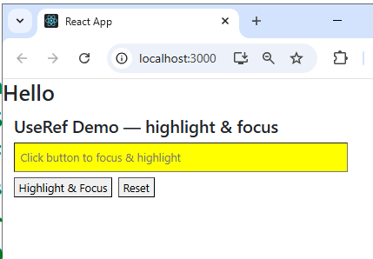 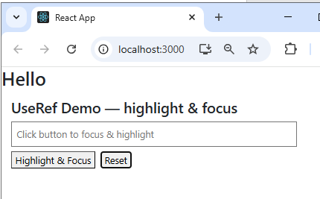

**Act 29 : Props Drilling**

App.js

|  |
| --- |
| **import PropDrillingDemo from "./components/ PropDrillingDemo";**  **function App() {**  **const theme = "dark";**  **return (**  **<div className="app-container">**  **<h1>Hello </h1>**  **< PropDrillingDemo theme={theme} />**  **</div>**  **);**  **}**  **export default App;** |

PropsDrillingDemo.jsx

|  |
| --- |
| **function PropDrillingDemo({ theme }) {**  **return (**  **<div style={{ background: "#7ee787ff", border: "2px solid blue", padding: "10px", margin: "10px" }}>**  **<h3>Inside Component A</h3>**  **<ComponentB theme={theme} />;**  **</div>**  **);**  **}**  **function ComponentB({ theme }) {**  **return (**  **<div style={{ background: "#e68cd7ff", border: "2px solid blue", padding: "10px", margin: "10px" }}>**  **<h3>Inside Component B</h3>**  **<ThemedComponent theme={theme} />;**  **</div>**  **);**  **}**  **function ThemedComponent({ theme }) {**  **return (**  **<div style={{ background: "#00acff", border: "2px solid black", padding: "10px", margin: "10px" }}>**  **<h3>Inside Themed Component</h3>**  **<h2>The current theme is : {theme}</h2>**  **</div>**  **);**  **}**  **export default PropDrillingDemo;** |

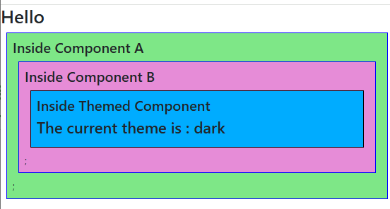

**Acts 30: useContext**

**Create a Context:**

const MyContext = createContext(defaultValue);

**Consume the Context**

const contextValue = useContext(MyContext);

**Provide the Context**

<MyContext.Provider value = {someValue}>

<ComponentA />

<MyContext.Provider>

UseContextEg1.jsx

|  |
| --- |
| **import { createContext, useContext } from "react";**  **const ThemeContext = createContext("DARK");**  **function UseContextEg1() {**  **return (**  **<div style={{ background: "#7ee787ff", border: "2px solid blue", padding: "10px", margin: "10px" }}>**  **<h3>Inside Component A</h3>**  **<ComponentB />;**  **</div>**  **);**  **}**  **function ComponentB() {**  **return (**  **<div style={{ background: "#e68cd7ff", border: "2px solid blue", padding: "10px", margin: "10px" }}>**  **<h3>Inside Component B</h3>**  **<ThemedComponent />;**  **</div>**  **);**  **}**  **function ThemedComponent() {**  **const theme = useContext(ThemeContext);**  **return (**  **<div style={{ background: "#00acff", border: "2px solid black", padding: "10px", margin: "10px" }}>**  **<h3>Inside Themed Component</h3>**  **<h2>The current theme is : {theme}</h2>**  **</div>**  **);**  **}**  **export default UseContextEg1;** |

App.js

|  |
| --- |
| **import UseContextEg1 from "./components/UseContextEg1";**  **function App() {**  **return (**  **<div className="app-container">**  **<h1>Hello </h1>**  **<UseContextEg1 />**  **</div>**  **);**  **}**  **export default App;** |

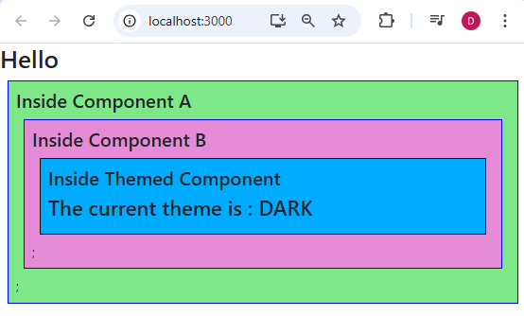

Act 31 : UseContext with Providers

UseContext1.jsx

|  |
| --- |
| **import { createContext, useContext } from "react";**  **const ThemeContext = createContext("DARK");**  **function UseContextEg1() {**  **return (**  **<div style={{ background: "#7ee787ff", border: "2px solid blue", padding: "10px", margin: "10px" }}>**  **<h3>Inside Component A</h3>**  **<ComponentB />;**  **</div>**  **);**  **}**  **function ComponentB() {**  **const theme = useContext(ThemeContext);**  **return (**  **<ThemeContext.Provider value="ROSE">**  **<div**  **style={{**  **background: "#e68cd7ff",**  **border: "2px solid blue",**  **padding: "10px",**  **margin: "10px",**  **}}**  **>**  **<h3>Inside Component B</h3>**  **<h2>The current theme is : {theme}</h2>**  **<ThemedComponent />;**  **</div>**  **</ThemeContext.Provider>**  **);**  **}**  **function ThemedComponent() {**  **const theme = useContext(ThemeContext);**  **return (**  **<div**  **style={{**  **background: "#00acff",**  **border: "2px solid black",**  **padding: "10px",**  **margin: "10px",**  **}}**  **>**  **<h3>Inside Themed Component</h3>**  **<h2>The current theme is : {theme}</h2>**  **</div>**  **);**  **}**  **export default UseContextEg1;** |

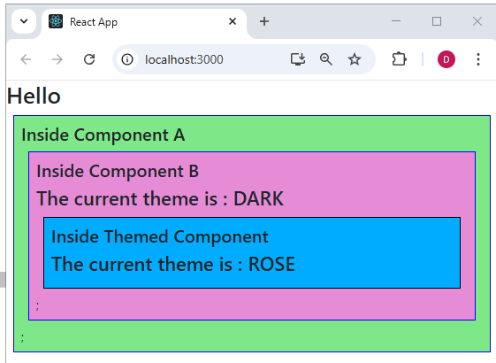

Act 32: Fetch Api , Handling Loading and Error

|  |
| --- |
| **import React, { useEffect } from "react";**  **function UseEffectApi() {**  **const [data, setData] = React.useState([]);**  **const [loading, setLoading] = React.useState(false);**  **useEffect(() => {**  **setLoading(true);**  **fetch("https://jsonplaceholder.typicode.com/todos")**  **.then((response) => response.json())**  **.then((json) => setData(json))**  **.catch((error) => console.error("Error fetching data:", error));**  **setLoading(false);**  **}, []);**  **if (loading) return <p>Loading...</p>;**  **return (**  **<div className="app-container">**  **<h2>Data from API:</h2>**  **<ul>**  **{data.map((tod) => (**  **<li key={tod.id}>**  **<h3>{tod.title}</h3>**  **<p>Completed: {tod.completed.toString()}</p>**  **</li>**  **))}**  **</ul>**  **</div>**  **);**  **}**  **export default UseEffectApi;** |

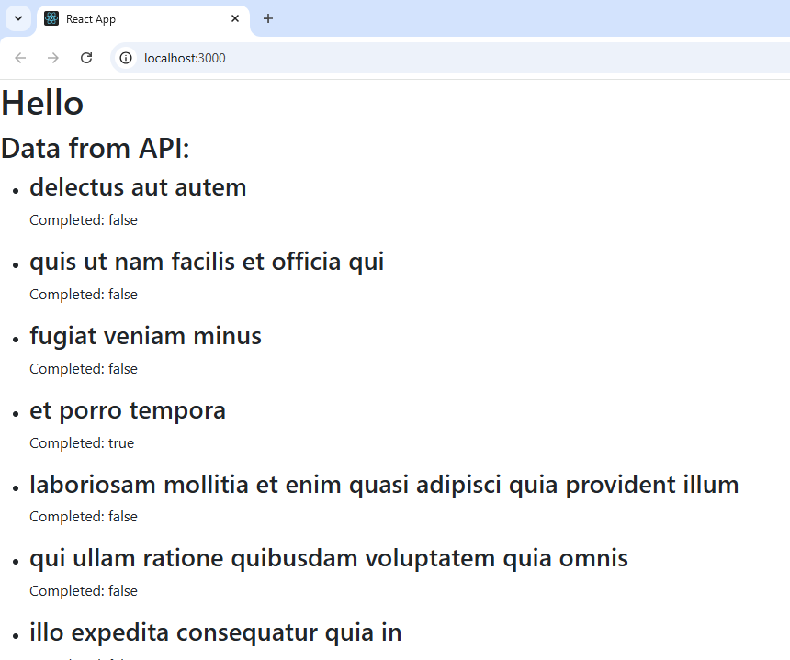

**API 33: AXIOS**

* Promise Based HTTP Client for the browser and nodejs.
* 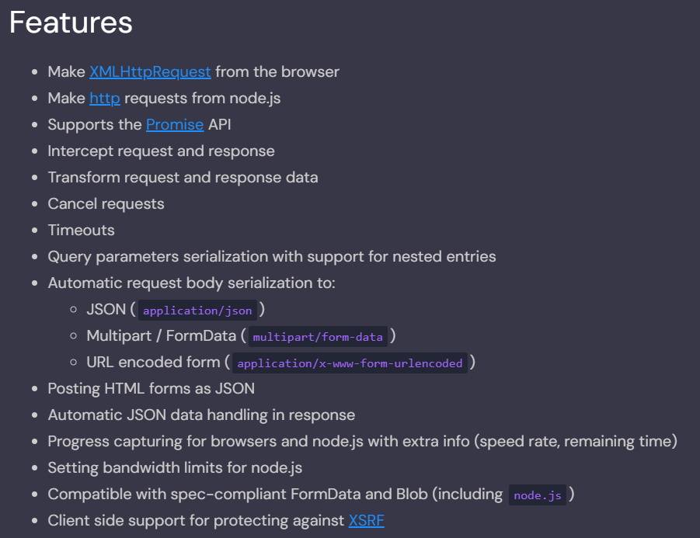
  1. UseEffectApi.jsx

|  |
| --- |
| **import axios from "axios";**  **import React, { useEffect } from "react";**  **function UseEffectApi() {**  **const [data, setData] = React.useState([]);**  **const [loading, setLoading] = React.useState(false);**  **useEffect(() => {**  **setLoading(true);**  **axios**  **.get("https://jsonplaceholder.typicode.com/todos")**  **.then((response) => {**  **console.log(response);**  **setData(response.data);**  **setLoading(false);**  **})**  **.catch((error) => console.error("Error fetching data:", error));**  **}, []);**  **if (loading) return <p>Loading...</p>;**  **return (**  **<div className="app-container">**  **<h2>Data from API:</h2>**  **<ul>**  **{data.map((tod) => (**  **<li key={tod.id}>**  **<h3>{tod.title}</h3>**  **<p>Completed: {tod.completed.toString()}</p>**  **</li>**  **))}**  **</ul>**  **</div>**  **);**  **}**  **export default UseEffectApi;** |

* 1. Fetch more than one GET end point

|  |
| --- |
| **import axios from "axios";**  **import React, { useEffect } from "react";**  **function UseEffectApiAll() {**  **const [data, setData] = React.useState([]);**  **const [loading, setLoading] = React.useState(false);**  **useEffect(() => {**  **setLoading(true);**  **axios.all([**  **axios.get("https://jsonplaceholder.typicode.com/todos"),**  **axios.get("https://jsonplaceholder.typicode.com/users")**  **])**  **.then(**  **axios.spread((todosResponse, usersResponse) => {**  **console.log("Todos:", todosResponse.data);**  **console.log("Users:", usersResponse.data);**  **setData(todosResponse.data);**  **setLoading(false);**  **})**  **)**  **.catch((error) => console.error("Error fetching data:", error));**  **}, []);**  **if (loading) return <p>Loading...</p>;**  **return (**  **<div className="app-container">**  **<h2>Data from API:</h2>**  **<ul>**  **{data.map((tod) => (**  **<li key={tod.id}>**  **<h3>{tod.title}</h3>**  **<p>Completed: {tod.completed.toString()}</p>**  **</li>**  **))}**  **</ul>**  **</div>**  **);**  **}**  **export default UseEffectApiAll;** |

* 1. **AxiosToken.jsx -- Create a POST request with** **JWT token in header**

|  |
| --- |
| **import axios from "axios";**  **import React, { useEffect } from "react";**  **const api = axios.create({**  **baseURL: "https://jsonplaceholder.typicode.com",**  **headers: {**  **Authorization: "Bearer TOKEN",**  **"Content-Type": "application/json",**  **},**  **});**  **api.interceptors.request.use((request) => {**  **console.log("Request made with ", request);**  **return request;**  **});**  **function AxiosToken() {**  **const [data, setData] = React.useState([]);**  **const [loading, setLoading] = React.useState(false);**  **const handleSubmit = (e) => {**  **e.preventDefault();**  **const newPost = { title: "foo", body: "bar", userId: 1 };**  **api.post("/posts", newPost).then((response) => {**  **console.log("Post created:", response.data);**  **setData([response.data]);**  **});**  **};**  **useEffect(() => {**  **setLoading(true);**  **api**  **.get("/todos")**  **.then((response) => {**  **setData(response.data);**  **setLoading(false);**  **})**  **.catch((error) => console.error("Error fetching data:", error));**  **}, []);**  **if (loading) return <p>Loading...</p>;**    **return (**  **<div className="app-container">**  **<h2>API with Token:</h2>**  **<form onSubmit={handleSubmit}>**  **<button type="submit">Create Post</button>**  **</form>**  **<ul>**  **{data.map((tod) => (**  **<li key={tod.id}>**  **<h3>{tod.title}</h3>**  **<p>Completed: {tod.completed}</p>**  **</li>**  **))}**  **</ul>**  **</div>**  **);**  **}**  **export default AxiosToken;** |

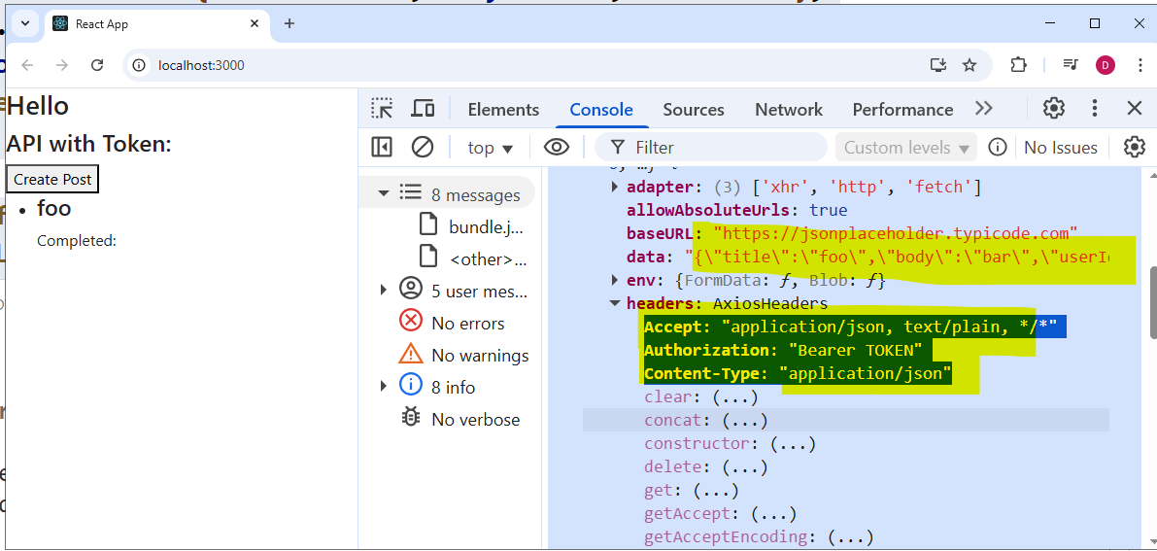

* 1. Make the Axios Token with interceptors in a separate file.

Create a folder named ‘api’ and create api.jsx.

|  |
| --- |
| **import axios from "axios";**  **const api = axios.create({**  **baseURL: "https://jsonplaceholder.typicode.com",**  **headers: {**  **Authorization: "Bearer TOKEN",**  **"Content-Type": "application/json",**  **},**  **});**  **api.interceptors.request.use(**  **(request) => {**  **console.log("Request made with ", request);**  **return request;**  **},**  **(config) => {**  **const token = localStorage.getItem("token");**  **if (token) {**  **config.headers.Authorization = `Bearer ${token}`;**  **}**  **return config;**  **},**  **(error) => {**  **console.error("Error in request:", error);**  **return Promise.reject(error);**  **}**  **);**  **api.interceptors.response.use(**  **(response) => {**  **console.log("Response received ", response);**  **return response;**  **},**  **(error) => {**  **if (error.response && error.response.status === 401) {**  **console.error("Unauthorized access - perhaps redirect to login?");**  **}**  **if (error.response && error.response.status === 500) {**  **console.error("Server error - please try again later.");**  **}**  **return Promise.reject(error);**  **}**  **);**  **export default api;** |

AxiosToken.jsx

|  |
| --- |
| **import React, { useEffect } from "react";**  **import api from "../api/api";**  **function AxiosToken() {**  **const [data, setData] = React.useState([]);**  **const [loading, setLoading] = React.useState(false);**  **const handleSubmit = (e) => {**  **e.preventDefault();**  **const newPost = { title: "fooA", body: "bar", userId: 1 };**  **api.post("/posts", newPost).then((response) => {**  **console.log("Post created:", response.data);**  **setData([response.data]);**  **});**  **};**  **useEffect(() => {**  **setLoading(true);**  **api**  **.get("/todos")**  **.then((response) => {**  **setData(response.data);**  **setLoading(false);**  **})**  **.catch((error) => console.error("Error fetching data:", error));**  **}, []);**  **if (loading) return <p>Loading...</p>;**  **return (**  **<div className="app-container">**  **<h2>API with Token:</h2>**  **<form onSubmit={handleSubmit}>**  **<button type="submit">Create Post</button>**  **</form>**  **<ul>**  **{data.map((tod) => (**  **<li key={tod.id}>**  **<h3>{tod.title}</h3>**  **<p>Completed: {tod.completed}</p>**  **</li>**  **))}**  **</ul>**  **</div>**  **);**  **}**  **export default AxiosToken;** |
|  |

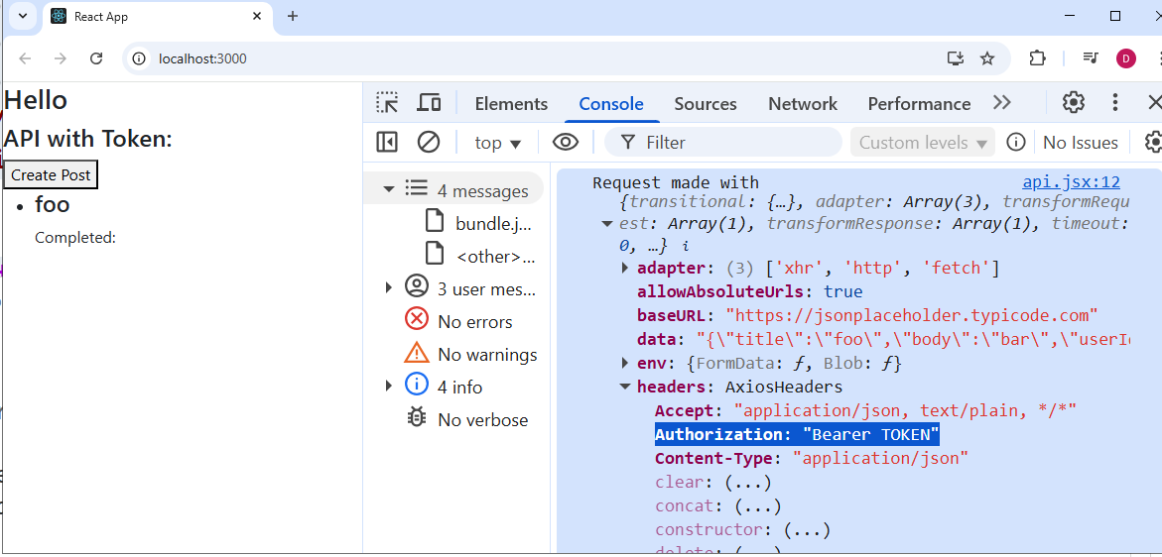

**Act 34: Forms in React -- Creating Basic Forms without react-hook-form**

e.preventDefault() - default behavior in browser is page reloads which has to be prevented

The code is very lengthy , if we create using JavaScript.

BasicForm.jsx

|  |
| --- |
| **import { useState } from "react";**  **function BasicForm() {**  **const [formData, setFormData] = useState({**  **name: "",**  **email: "",**  **});**  **const [errors, setErrors] = useState({});**  **const validate = () => {**  **const newErrors = {};**  **if (!formData.name.trim()) {**  **newErrors.name = "Name is required";**  **}**  **if (!formData.email) {**  **newErrors.email = "Email is required";**  **} else if (!/\S+@\S+\.\S+/.test(formData.email)) {**  **newErrors.email = "Email is invalid";**  **}**  **return newErrors;**  **};**  **const handleChange = (e) => {**  **const { name, value } = e.target;**  **setFormData({**  **...formData,**  **[e.target.name]: e.target.value,**  **});**  **if (errors[name]) {**  **const newErrors = { ...errors };**  **delete newErrors[name];**  **setErrors(newErrors);**  **}**  **};**  **const handleSubmit = (e) => {**  **e.preventDefault();**  **const validationErrors = validate();**  **if (Object.keys(validationErrors).length > 0) {**  **setErrors(validationErrors);**  **} else {**  **console.log("Form submitted", formData);**  **}**  **};**  **return (**  **<div>**  **<h1>Forms in React </h1>**  **<form onSubmit={handleSubmit}>**  **<label>**  **Name:**  **<input type="text" name="name" value={formData.name} onChange={handleChange} />**  **{errors.name && <span style={{ color: "red" }}>{errors.name}</span>}**  **</label>**  **<br />**  **<label>**  **Email:**  **<input type="email" name="email" value={formData.email} onChange={handleChange} />**  **{errors.email && <span style={{ color: "red" }}>{errors.email}</span>}**  **</label>**  **<button type="submit">Submit</button>**  **</form>**  **</div>**  **);**  **}**  **export default BasicForm;** |

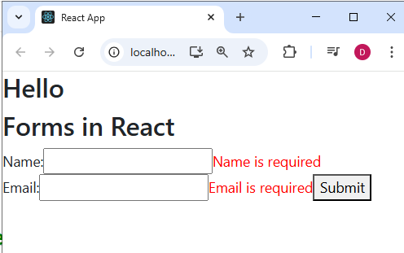 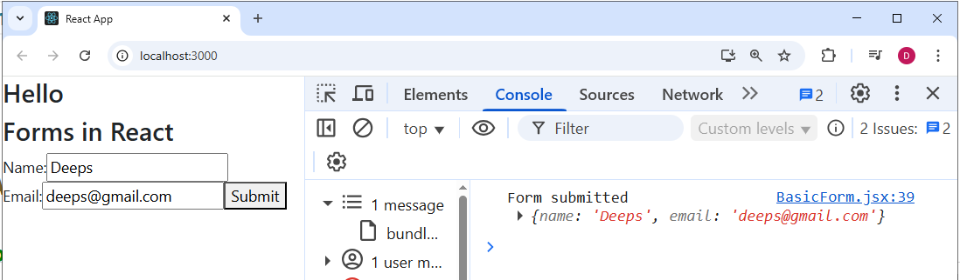

Act 35 : React-hook-form – Registering NEW Fields

**npm install react-hook-form**

[**https://react-hook-form.com/get-started**](https://react-hook-form.com/get-started)

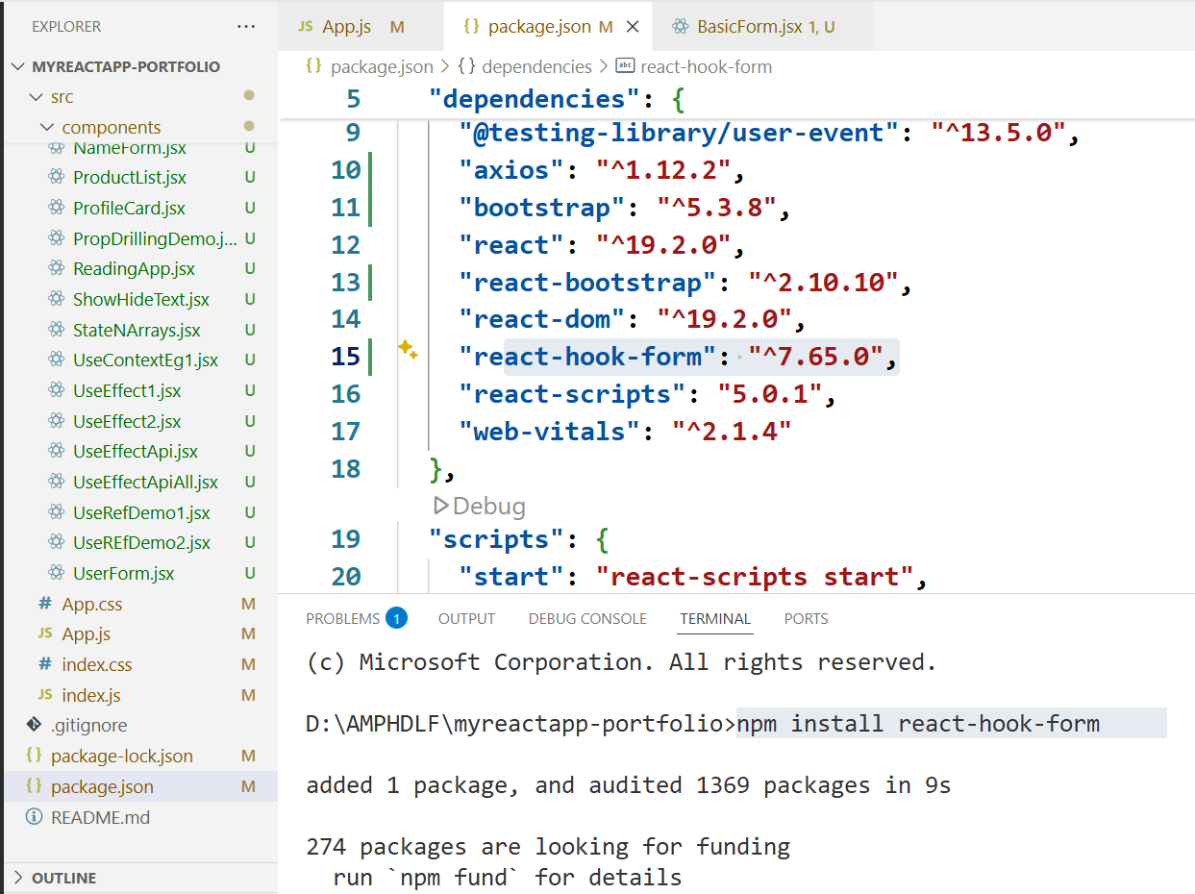

**ReactForms1.jsx**

|  |
| --- |
| **import React from "react";**  **import { useForm } from "react-hook-form";**  **function ReactForm1() {**  **const { register, handleSubmit } = useForm();**  **const onSubmit = (data) => {**  **console.log(data);**  **};**  **return (**  **<div className="app-container">**  **<h1>Forms in React </h1>**  **<form onSubmit={handleSubmit(onSubmit)}>**  **<label>Name:</label>**  **<input {...register("name")} />**  **<label>Email:</label>**  **<input {...register("email")} />**  **<button type="submit">Submit</button>**  **</form>**  **</div>**  **);**  **}**  **export default ReactForm1;** |

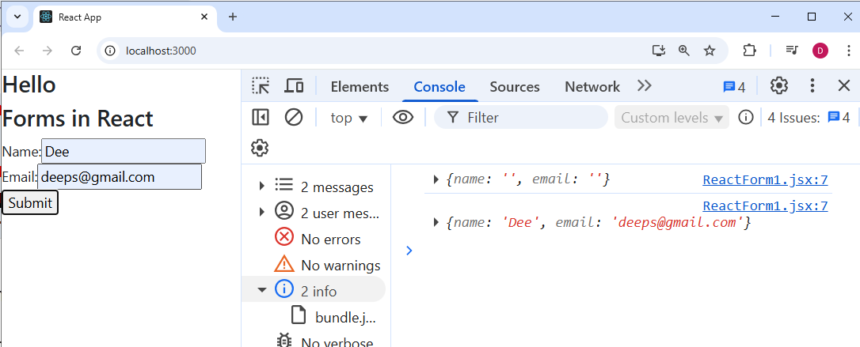

**Act 35.1 ) Watching Values in React Hook Forms – cont…**

**ReactForm1.jsx**

|  |
| --- |
| **import React, { useEffect } from "react";**  **import { useForm } from "react-hook-form";**  **function ReactForm1() {**  **const { register, handleSubmit, watch } = useForm();**  **const onSubmit = (data) => {**  **console.log(data);**  **};**  **//console.log(watch("name")); // Watch the value of the "name" field**  **const watchedName = watch("name");**  **const watchedEmail = watch("email");**  **useEffect(() => {**  **console.log("Name changed:", watchedName);**  **}, [watchedName]);**  **useEffect(() => {**  **console.log("Email changed:", watchedEmail);**  **}, [watchedEmail]);**  **return (**  **<div className="app-container">**  **<h1>Forms in React </h1>**  **<form onSubmit={handleSubmit(onSubmit)}>**  **<label>Name:</label>**  **<input {...register("name")} />**  **<label>Email:</label>**  **<input {...register("email")} />**  **<button type="submit">Submit</button>**  **</form>**  **</div>**  **);**  **}**  **export default ReactForm1;** |

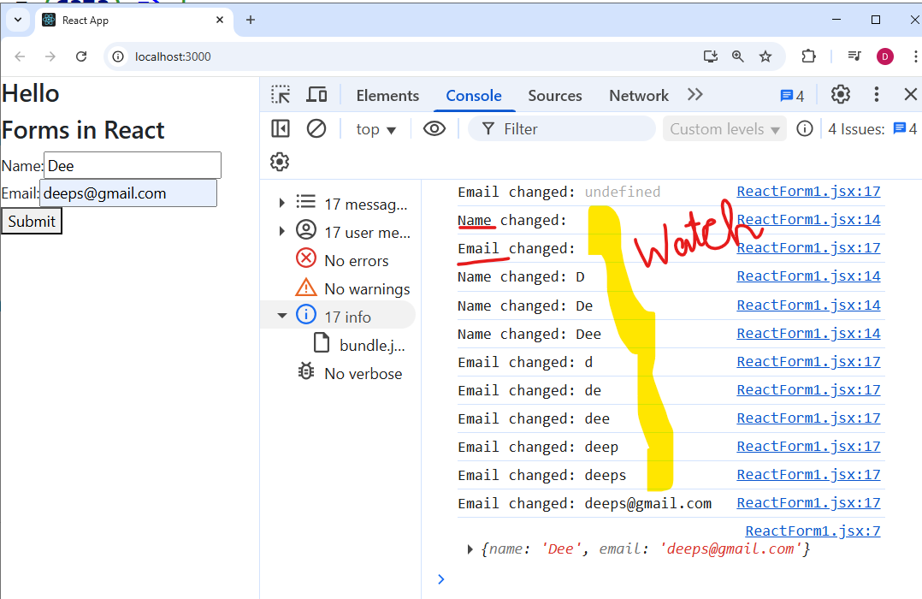

**Act 35.2 ) Validation in react-hook-form**

|  |
| --- |
| **import React, { useEffect } from "react";**  **import { useForm } from "react-hook-form";**  **function ReactForm1() {**  **const {**  **register,**  **handleSubmit,**  **watch,**  **formState: { errors },**  **} = useForm();**  **const onSubmit = (data) => {**  **console.log(data);**  **};**  **//console.log(watch("name")); // Watch the value of the "name" field**  **const watchedName = watch("name");**  **const watchedEmail = watch("email");**  **useEffect(() => {**  **console.log("Name changed:", watchedName);**  **}, [watchedName]);**  **useEffect(() => {**  **console.log("Email changed:", watchedEmail);**  **}, [watchedEmail]);**  **return (**  **<div className="app-container">**  **<h1>Forms in React </h1>**  **<form onSubmit={handleSubmit(onSubmit)}>**  **<label>**  **Name:**  **<input {...register("name", { required: true })} />**  **{errors.name && <span style={{ color: "red" }}>This field is required</span>}**  **</label>**  **<label>**  **Email:**  **<input {...register("email", { required: true })} />**  **{errors.email && <span style={{ color: "red" }}>This field is required</span>}**  **</label>**  **<button type="submit">Submit</button>**  **</form>**  **</div>**  **);**  **}**  **export default ReactForm1;** |

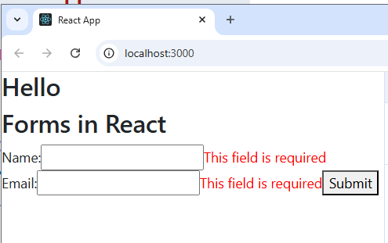

**Act 35.3 ) Validation in react-hook-form – Another Syntax**

**ReactForm1.jsx**

|  |
| --- |
| **import React, { useEffect } from "react";**  **import { useForm } from "react-hook-form";**  **function ReactForm1() {**  **const {**  **register,**  **handleSubmit,**  **watch,**  **formState: { errors },**  **} = useForm();**  **const onSubmit = (data) => {**  **console.log(data);**  **};**  **//console.log(watch("name")); // Watch the value of the "name" field**  **const watchedName = watch("name");**  **const watchedEmail = watch("email");**  **useEffect(() => {**  **console.log("Name changed:", watchedName);**  **}, [watchedName]);**  **useEffect(() => {**  **console.log("Email changed:", watchedEmail);**  **}, [watchedEmail]);**  **return (**  **<div className="app-container">**  **<h1>Forms in React </h1>**  **<form onSubmit={handleSubmit(onSubmit)}>**  **<label>**  **Name:**  **<input {...register("name", { required: "Name is REQUIRED" })} />**  **{errors.name && <p style={{ color: "red" }}>{errors.name.message}</p>}**  **</label>**  **<label>**  **Email:**  **<input {...register("email", { required: true })} />**  **{errors.email && <span style={{ color: "red" }}>This field is required</span>}**  **</label>**  **<button type="submit">Submit</button>**  **</form>**  **</div>**  **);**  **}**  **export default ReactForm1;** |

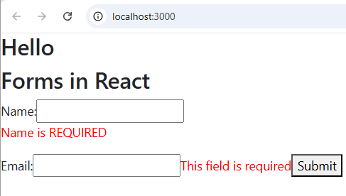

**35.4 ) Multiple Validations and the respective error message for a single HTML field**

|  |
| --- |
| **import React, { useEffect } from "react";**  **import { useForm } from "react-hook-form";**  **function ReactForm1() {**  **const {**  **register,**  **handleSubmit,**  **watch,**  **formState: { errors },**  **} = useForm();**  **const onSubmit = (data) => {**  **console.log(data);**  **};**  **//console.log(watch("name")); // Watch the value of the "name" field**  **const watchedName = watch("name");**  **const watchedEmail = watch("email");**  **useEffect(() => {**  **console.log("Name changed:", watchedName);**  **}, [watchedName]);**  **useEffect(() => {**  **console.log("Email changed:", watchedEmail);**  **}, [watchedEmail]);**  **return (**  **<div className="app-container">**  **<h1>Forms in React </h1>**  **<form onSubmit={handleSubmit(onSubmit)}>**  **<label>**  **Name:**  **<input**  **{...register("name", {**  **required: "Name is REQUIRED",**  **minLength: { value: 3, message: "Minimum length is 3 characters" },**  **maxLength: { value: 20, message: "Maximum length is 20 characters" },**  **})}**  **/>**  **{errors.name && <p style={{ color: "red" }}>{errors.name.message}</p>}**  **</label>**  **<label>**  **Email:**  **<input**  **{...register("email", {**  **required: "Email is REQUIRED",**  **pattern: {**  **value: /^[a-zA-Z0-9._+-]+@[a-zA-Z0-9.-]+\.[a-zA-Z0-9-.]{2,}$/,**  **message: "Invalid email address",**  **},**  **})}**  **/>**  **{errors.email && <span style={{ color: "red" }}>{errors.email.message}</span>}**  **</label>**  **<button type="submit">Submit</button>**  **</form>**  **</div>**  **);**  **}**  **export default ReactForm1;** |

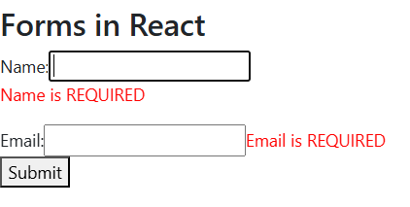 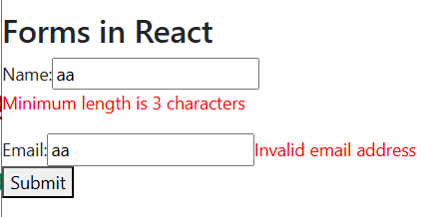

**35.5) Performance Comparison : Basic Forms Vs React Hook Form**

**Make the useEffect in reactive Form and check. Re-rendering will happen for every change in the input. But in react forms , re-rendering will happen on form load. Then re-rendering wont happen.**

**35.6) Reset Functionality**

|  |
| --- |
| **import React, { useEffect } from "react";**  **import { useForm } from "react-hook-form";**  **function ReactForm1() {**  **const {**  **register,**  **handleSubmit,**  **watch,**  **reset,**  **formState: { errors },**  **} = useForm();**  **const onSubmit = (data) => {**  **console.log(data);**  **reset();**  **};**  **//console.log(watch("name")); // Watch the value of the "name" field**  **const watchedName = watch("name");**  **const watchedEmail = watch("email");**  **useEffect(() => {**  **console.log("Name changed:", watchedName);**  **}, [watchedName]);**  **useEffect(() => {**  **console.log("Email changed:", watchedEmail);**  **}, [watchedEmail]);**  **return (**  **<div className="app-container">**  **<h1>Forms in React </h1>**  **<form onSubmit={handleSubmit(onSubmit)}>**  **<label>**  **Name:**  **<input**  **{...register("name", {**  **required: "Name is REQUIRED",**  **minLength: { value: 3, message: "Minimum length is 3 characters" },**  **maxLength: { value: 20, message: "Maximum length is 20 characters" },**  **})}**  **/>**  **{errors.name && <p style={{ color: "red" }}>{errors.name.message}</p>}**  **</label>**  **<br />**  **<label>**    **Email:**  **<input**  **{...register("email", {**  **required: "Email is REQUIRED",**  **pattern: {**  **value: /^[a-zA-Z0-9._+-]+@[a-zA-Z0-9.-]+\.[a-zA-Z0-9-.]{2,}$/,**  **message: "Invalid email address",**  **},**  **})}**  **/>**  **{errors.email && <span style={{ color: "red" }}>{errors.email.message}</span>}**  **</label>**  **<br />**  **<button type="submit">Submit</button>**  **<button type="button" onClick={() => reset()}>**  **Reset**  **</button>**  **</form>**  **</div>**  **);**  **}**  **export default ReactForm1;** |

**Submit the form and check. The value will be submitted and resets the text box. Same way type something in the text fields and click on Reset button to see that the textbox resets.**

**36.7 ) Restrict certain user to submit the form / Allow some user to submit the form**

**Use Validate features for this**

**ReactForm1.jsx**

|  |
| --- |
| **import React, { useEffect } from "react";**  **import { useForm } from "react-hook-form";**  **function ReactForm1() {**  **const {**  **register,**  **handleSubmit,**  **watch,**  **reset,**  **formState: { errors },**  **} = useForm();**  **const onSubmit = (data) => {**  **console.log(data);**  **reset();**  **};**  **//console.log(watch("name")); // Watch the value of the "name" field**  **const watchedName = watch("name");**  **const watchedEmail = watch("email");**  **useEffect(() => {**  **console.log("Name changed:", watchedName);**  **}, [watchedName]);**  **useEffect(() => {**  **console.log("Email changed:", watchedEmail);**  **}, [watchedEmail]);**  **const validateName = (value) => {**  **if (value === "admin") {**  **return "Admin is not allowed";**  **}**  **return true;**  **};**  **return (**  **<div className="app-container">**  **<h1>Forms in React </h1>**  **<form onSubmit={handleSubmit(onSubmit)}>**  **<label> Name:**  **<input**  **{...register("name", { required: "Name is REQUIRED",**  **minLength: { value: 3, message: "Minimum length is 3 characters" },**  **maxLength: { value: 20, message: "Maximum length is 20 characters" },**  **validate: validateName,**  **})}**  **/>**  **{errors.name && <p style={{ color: "red" }}>{errors.name.message}</p>}**  **</label>**  **<br />**  **<label> Email:**  **<input**  **{...register("email", { required: "Email is REQUIRED",**  **pattern: {**  **value: /^[a-zA-Z0-9._+-]+@[a-zA-Z0-9.-]+\.[a-zA-Z0-9-.]{2,}$/,**  **message: "Invalid email address",**  **},**  **})}**  **/>**  **{errors.email && <span style={{ color: "red" }}>{errors.email.message}</span>}**  **</label>**  **<br />**  **<button type="submit">Submit</button>**  **<button type="button" onClick={() => reset()}>**  **Reset**  **</button>**  **</form>**  **</div>**  **);**  **}**  **export default ReactForm1;** |

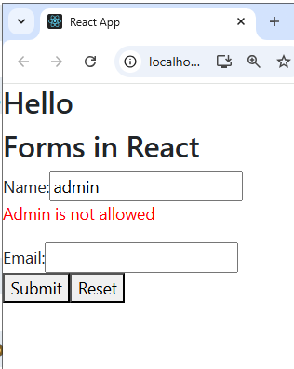

**(or)**

|  |
| --- |
| **import React, { useEffect } from "react";**  **import { useForm } from "react-hook-form";**  **function ReactForm1() {**  **const {**  **register,**  **handleSubmit,**  **watch,**  **reset,**  **formState: { errors },**  **} = useForm();**  **const onSubmit = (data) => {**  **console.log(data);**  **reset();**  **};**  **//console.log(watch("name")); // Watch the value of the "name" field**  **const watchedName = watch("name");**  **const watchedEmail = watch("email");**  **useEffect(() => { console.log("Name changed:", watchedName); }, [watchedName]);**  **useEffect(() => {     console.log("Email changed:", watchedEmail); }, [watchedEmail]);**  **return (**  **<div className="app-container">**  **<h1>Forms in React </h1>**  **<form onSubmit={handleSubmit(onSubmit)}>**  **<label> Name:**  **<input**  **{...register("name", { required: "Name is REQUIRED",**  **minLength: { value: 3, message: "Minimum length is 3 characters" },**  **maxLength: { value: 20, message: "Maximum length is 20 characters" },**  **//validate: validateName,**  **validate: {**  **notAdmin: (value) => value !== "admin" || "Admin is not allowed",**  **isNotNumber: (value) => isNaN(value) || "Name cannot be a number",**  **},**  **})}**  **/>**  **{errors.name && <p style={{ color: "red" }}>{errors.name.message}</p>}**  **</label>**  **<br />**  **<label> Email:**  **<input**  **{...register("email", {**  **required: "Email is REQUIRED",**  **pattern: {**  **value: /^[a-zA-Z0-9._+-]+@[a-zA-Z0-9.-]+\.[a-zA-Z0-9-.]{2,}$/,**  **message: "Invalid email address",**  **},**  **})}**  **/>**  **{errors.email && <span style={{ color: "red" }}>{errors.email.message}</span>}**  **</label>**  **<br />**  **<button type="submit">Submit</button>**  **<button type="button" onClick={() => reset()}>**  **Reset**  **</button>**  **</form>**  **</div>**  **);**  **}**  **export default ReactForm1;** |

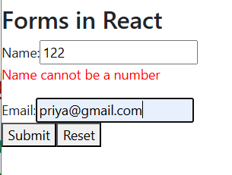 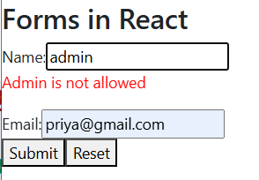

**36.8 ) Check if the username already exists in the database and then allow the user to register**

**Write Custom Validate Function**

**ReactForm1.jsx**

|  |
| --- |
| **import React, { useEffect } from "react";**  **import { useForm } from "react-hook-form";**  **function ReactForm1() {**  **const {**  **register,**  **handleSubmit,**  **watch,**  **reset,**  **formState: { errors },**  **} = useForm();**  **const onSubmit = (data) => {**  **console.log(data);**  **reset();**  **};**  **//console.log(watch("name")); // Watch the value of the "name" field**  **const watchedName = watch("name");**  **const watchedEmail = watch("email");**  **useEffect(() => {**  **console.log("Name changed:", watchedName);**  **}, [watchedName]);**  **useEffect(() => {**  **console.log("Email changed:", watchedEmail);**  **}, [watchedEmail]);**  **const existingUsernames = ["user1", "user2", "admin"];**  **const checkIfUsernameExists = async (username) => {**  **await new Promise((resolve) => setTimeout(resolve, 500));**  **return existingUsernames.includes(username);**  **};**  **return (**  **<div className="app-container">**  **<h1>Forms in React </h1>**  **<form onSubmit={handleSubmit(onSubmit)}>**  **<label>**  **Name:**  **<input     {...register("name", { required: "Name is REQUIRED",**  **minLength: { value: 3, message: "Minimum length is 3 characters" },**  **maxLength: { value: 20, message: "Maximum length is 20 characters" },**  **//validate: validateName,**  **validate: {**  **notAdmin: (value) => value !== "admin" || "Admin is not allowed",**  **isNotNumber: (value) => isNaN(value) || "Name cannot be a number",**  **checkUsername: async (value) => {**  **const exist = await checkIfUsernameExists(value);**  **return !exist || "Username already taken";**  **},**  **},**  **})}**  **/>**  **{errors.name && <p style={{ color: "red" }}>{errors.name.message}</p>}**  **</label>         <br />**  **<label> Email:**  **<input**  **{...register("email", {required: "Email is REQUIRED",**  **pattern: { value: /^[a-zA-Z0-9._+-]+@[a-zA-Z0-9.-]+\.[a-zA-Z0-9-.]{2,}$/,**  **message: "Invalid email address",**  **},**  **})}**  **/>**  **{errors.email && <span style={{ color: "red" }}>{errors.email.message}</span>}**  **</label>**  **<br />**  **<button type="submit">Submit</button>**  **<button type="button" onClick={() => reset()}>**  **Reset**  **</button>**  **</form>**  **</div>**  **);**  **}**  **export default ReactForm1;** |

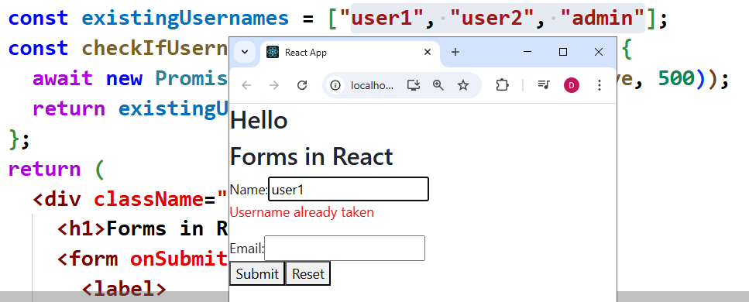

**+++++++++++++++++++**

**Act : 37) Install Tailwind CSS**

**npm uninstall @tailwindcss/cli @tailwindcss/postcss tailwindcss postcss autoprefixer**

**(or)**

**npm install -D tailwindcss@3.3.3 postcss@8.4.31 autoprefixer@10.4.16**

**npx tailwindcss init -p**

**tailwind.config.js**

|  |
| --- |
| **/** @type {import('tailwindcss').Config} */**  **module.exports = {**  **content: [**  **"./src/**/*.{js,jsx,ts,tsx}",**  **"./public/index.html"**  **],**  **theme: {**  **extend: {},**  **},**  **plugins: [],**  **};** |

**Index.css**

|  |
| --- |
| **@tailwind base;**  **@tailwind components;**  **@tailwind utilities;** |

**postcss.config.js**

|  |
| --- |
| **module.exports = {**  **plugins: {**  **tailwindcss: {},**  **autoprefixer: {},**  **},**  **};** |

**output.css**

|  |
| --- |
| **/*! tailwindcss v4.1.15 | MIT License | https://tailwindcss.com */**  **.text-center {**  **text-align: center;**  **}**  **.underline {**  **text-decoration-line: underline;**  **}**  **.transition-colors {**  **transition-property: color, background-color, border-color, outline-color, text-decoration-color, fill, stroke, --tw-gradient-from,**  **--tw-gradient-via, --tw-gradient-to;**  **transition-timing-function: var(--tw-ease, ease);**  **transition-duration: var(--tw-duration, 0s);**  **}** |

**Install the extension from VS code**

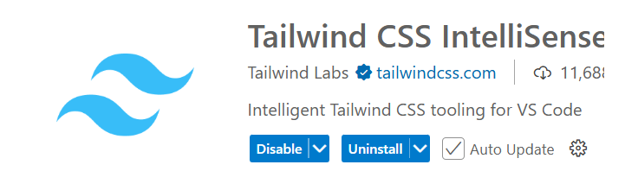

**Test in App.js**

|  |
| --- |
| **import "./App.css";**  **import "./index.css";**  **function App() {**  **return (**  **<div className="App">**  **<h1>Welcome to My React App</h1>**  **<h1 class="bg-blue-500 text-center text-3xl font-bold underline">Hello world!</h1>**  **</div>**  **);**  **}**  **export default App;** |

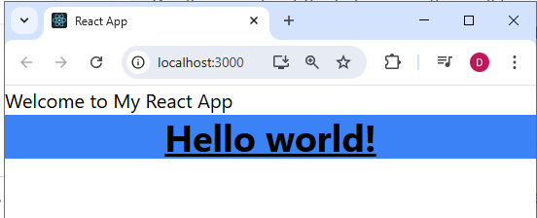

**Act 38: Routing in React:**

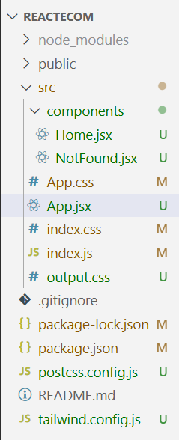

**App.jsx**

|  |
| --- |
| **import { BrowserRouter as Router, Route, Routes, Link } from "react-router-dom";**  **import Home from "./components/Home";**  **import NotFound from "./components/NotFound";**  **//import "./index.css"; // ✅ only if not imported in main.jsx**  **function App() {**  **return (**  **<Router>**  **<div className="min-h-screen bg-gray-100">**  **{/* Navbar */}**  **<nav className="bg-blue-600 p-4">**  **<ul className="flex space-x-6 justify-center">**  **<li>**  **<Link className="text-white hover:text-yellow-300 font-medium transition duration-300" to="/">**  **Home**  **</Link>**  **</li>**  **<li>**  **<Link className="text-white hover:text-yellow-300 font-medium transition duration-300" to="/about">**  **About Us**  **</Link>**  **</li>**  **<li>**  **<Link className="text-white hover:text-yellow-300 font-medium transition duration-300" to="/contact">**  **Contact**  **</Link>**  **</li>**  **</ul>**  **</nav>**  **{/* Routes */}**  **<Routes>**  **<Route path="/" element={<Home />} />**  **<Route path="/about" element={<h2 className="text-center mt-10 text-2xl font-semibold">About Us</h2>} />**  **<Route path="/contact" element={<h2 className="text-center mt-10 text-2xl font-semibold">Contact</h2>} />**  **<Route path="*" element={<NotFound />} />**  **</Routes>**  **</div>**  **</Router>**  **);**  **}**  **export default App;** |

**Home.jsx**

|  |
| --- |
| **function Home() {**  **return (**  **<div className="flex flex-col items-center justify-center h-screen bg-gray-100">**  **<h1 className="text-4xl font-bold text-blue-600">Welcome Home</h1>**  **</div>**  **);**  **}**  **export default Home;** |

**NotFound.jsx**

|  |
| --- |
| **import React from "react";**  **function NotFound() {**  **return (**  **<div className="flex items-center justify-center h-screen">**  **<h2 className="text-3xl font-bold">404 - Page Not Found</h2>**  **<img src="https://httpcats.com/404.jpg" alt="404 Not Found" className="mt-4 rounded-lg shadow-lg" />**  **</div>**  **);**  **}**  **export default NotFound;** |

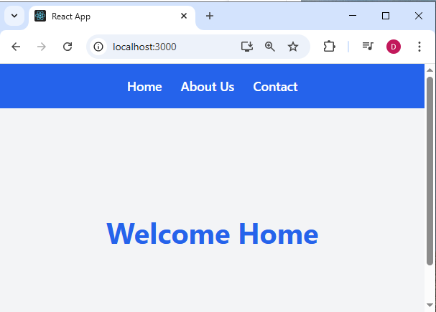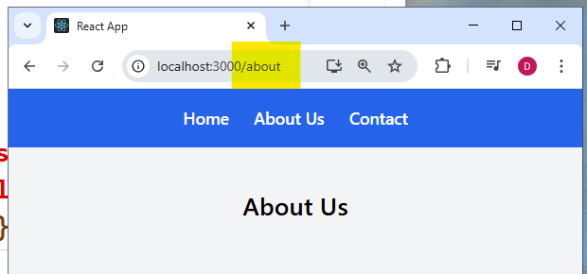

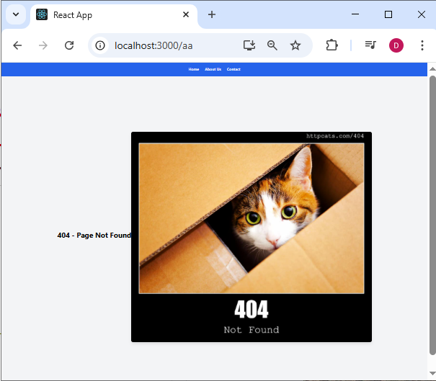

**Act 39: useLocation() Hook**

**useLocation() (from react-router-dom) lets you access the current URL information (pathname, query string, state, etc.) inside your component.**

**It’s useful for:**

* **Highlighting the active navigation link**
* **Logging or debugging routes**
* **Conditional rendering based on the current path**
* **Showing “404 - Not Found” pages dynamically**

**CurrentLocation.jsx**

|  |
| --- |
| **import { useLocation } from "react-router-dom";**  **function CurrentLocation() {**  **const location = useLocation();**  **return (**  **<div className="flex flex-col items-center bg-gray-100">**  **<h1 className="text-4xl font-bold text-blue-600">Current Location</h1>**  **<h3>Current Path : {location.pathname}</h3>**  **</div>**  **);**  **}**  **export default CurrentLocation;** |

**App.jsx**

|  |
| --- |
|  |

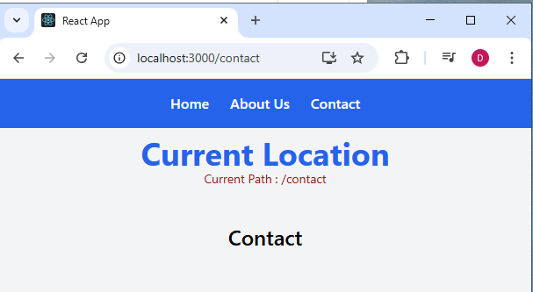

**Act 40: useNavigate() -- Navigate programmatically to a particular URL**

**Eg to handle Login and Logout page. Home 🡪 Dashboard**

**Dashboard 🡪 Home**

**Home.jsx**

|  |
| --- |
| **import { useNavigate } from "react-router-dom";**  **function Home() {**  **const navigate = useNavigate();**  **const handleLogin = () => {**  **navigate("/dashboard");**  **};**  **return (**  **<div className="flex flex-col items-center justify-center h-screen bg-gray-100">**  **<h1 className="text-4xl font-bold text-blue-600">Welcome Home</h1>**  **<button onClick={handleLogin} className="mt-6 px-4 py-2 bg-blue-500 text-white rounded hover:bg-blue-600 transition duration-300">**  **Login**  **</button>**  **</div>**  **);**  **}**  **export default Home;** |

**Dashboard.jsx**

|  |
| --- |
| **import { useNavigate } from "react-router-dom";**  **function Dashboard() {**  **const navigate = useNavigate();**  **const handleLogout = () => {**  **navigate("/");**  **};**  **return (**  **<div className="flex flex-col items-center justify-center h-screen bg-gray-100">**  **<h1 className="text-4xl font-bold text-blue-600">Welcome Back</h1>**  **<button onClick={handleLogout} className="mt-6 px-4 py-2 bg-blue-500 text-white rounded hover:bg-blue-600 transition duration-300">**  **Logout**  **</button>**  **</div>**  **);**  **}**  **export default Dashboard;** |

**App.jsx**

|  |
| --- |
| **<Routes>**  **<Route path="/" element={<Home />} />**  **…..**  **<Route path="/dashboard" element={<Dashboard />} />**  **<Route path="*" element={<NotFound />} />**  **</Routes>** |

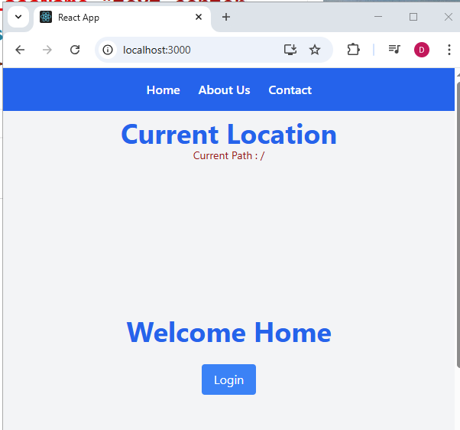 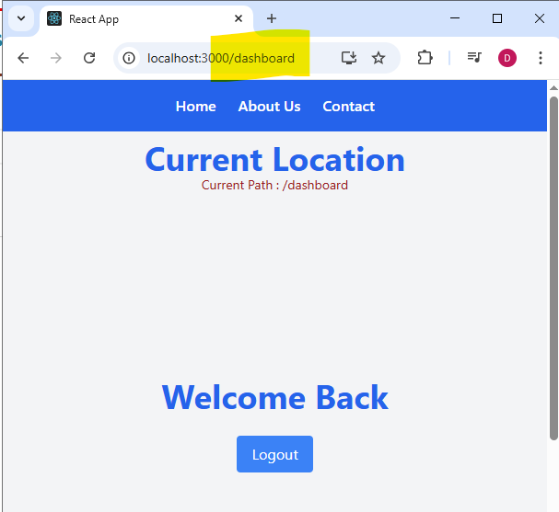

**Act 41 : Redux: (D:\AMPHDLF\ecomreactredux)**

**Store : This is the Single place where all the app’s state lives**

**Action: It is a plain JavaScript object that describes what you want to do, such as adding an item to the cart. It describes what happens(AN EVENT)**

**Reducer: A function that receives the current state and an action, then returns a new state based o the action. All Modification happens in the reducer.**

**useSelector() → reads data from the Redux store (like a getter).**

**useDispatch() → sends actions to the store (like a setter).**

**When the selected part of the store changes, React re-renders the component automatically.**

|  |
| --- |
| **npm install react-redux** |

**Action creaters are functions that returns the action object**

**Action.js**

|  |
| --- |
| **export const increment = () => {**  **return {**  **type: "INCREMENT",          // Action type for incrementing a value**  **};**  **};** |

**counterReducer.js**

|  |
| --- |
| **const initialState = {**  **count: 0,**  **};**  **const counterReducer = (state = initialState, action) => {**  **switch (action.type) {**  **case "INCREMENT":**  **return {**  **...state,**  **count: state.count + 1,**  **};**  **case "DECREMENT":**  **return {**  **...state,**  **count: state.count - 1,**  **};**  **default:**  **return state;**  **}**  **};**  **export default counterReducer;** |

**import { configureStore } from "@reduxjs/toolkit";**

**import counterReducer from "./reducers/counterReduer";**

**const store = configureStore({**

**reducer: counterReducer,**

**});**

**export default store;**

**store.js**

|  |
| --- |
| **import { createStore } from "redux";**  **import counterReducer from "./reducers/counterReduer";**  **const store = createStore(counterReducer);**  **export default store;** |

**index.js**

|  |
| --- |
| **import React from "react";**  **import ReactDOM from "react-dom/client";**  **import "./index.css";**  **import App from "./App";**  **import { Provider } from "react-redux";**  **import store from "./store/store";**  **const root = ReactDOM.createRoot(document.getElementById("root"));**  **root.render(**  **<Provider store={store}>**  **<React.StrictMode>**  **<App />**  **</React.StrictMode>**  **</Provider>**  **);** |

**Counter.jsx**

|  |
| --- |
| **import { useDispatch, useSelector } from "react-redux";**  **/\***  **useSelector and useDispatch are hooks provided by the react-redux library to interact with the Redux store in a React application.**  **useSelector: LETS YOUR REACT COMPONENT ACCESS DATA FROM REDUX STORE.**  **This hook allows you to extract data from the Redux store**  **state. It takes a selector function as an argument, which is called with**  **the entire store state, and returns the part of the state you want.**  **This is useful for reading values from the store and re-rendering**  **your component when those values change.**  **useDispatch: LETS YOUR COMPOENNT SEND ACTIONS TO THE REDUX STORE.**  **This hook returns a reference to the dispatch function**  **from the Redux store. You can use this function to dispatch actions**  **to the store, which will then be processed by the reducers to update**  **the state. This is useful for triggering state changes in response to**  **user interactions or other events.**  **\*/**  **const Counter = () => {**  **const count = useSelector((state) => state.count);**  **const dispatch = useDispatch();**  **return (**  **<div>**  **<h2>Count in Counter Component : {count} </h2>**  **<button onClick={() => dispatch({ type: "INCREMENT" })}>Increment</button>**  **<button onClick={() => dispatch({ type: "DECREMENT" })}>Decrement</button>**  **</div>**  **);**  **};**  **export default Counter;** |

**App.js**

|  |
| --- |
| **import "./App.css";**  **import Counter from "./Counter";**  **function App() {**  **return (**  **<div className="App">**  **<Counter />**  **</div>**  **);**  **}**  **export default App;**  **/\***  **Store → Holds the entire app state (like cartItems).**  **Reducer → Updates state based on actions.**  **Action → Describes what to do (like "ADD_TO_CART").**  **useSelector → Reads data from store.**  **useDispatch → Sends actions to the store.**  **https://redux.js.org/tutorials/quick-start**  **\*/** |

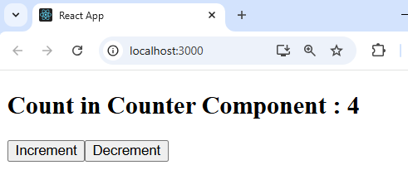

**Now the Value count in store should be accessed by multiple components**

**Display.jsx**

|  |
| --- |
| **import { useSelector } from "react-redux";**  **const Display = () => {**  **const count = useSelector((state) => state.count);**  **return (**  **<div>**  **<h2>Current Count in Display Component : {count}</h2>**  **</div>**  **);**  **};**  **export default Display;** |

**App.jsx**

|  |
| --- |
| **import "./App.css";**  **import Counter from "./Counter";**  **import Display from "./Display";**  **function App() {**  **return (**  **<div className="App">**  **<Counter />**  **<Display />**  **</div>**  **);**  **}**  **export default App;** |

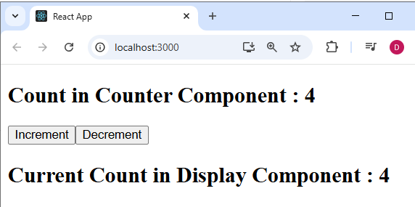

**createStore() is deprecated. So the recent version has configureStore()**

**For which we need @reduxjs/toolkit**

**npm install @reduxjs/toolkit redux react-redux**

**store.js**

|  |
| --- |
| **import { configureStore } from "@reduxjs/toolkit";**  **import counterReducer from "./reducers/counterReduer";**  **const store = configureStore({**  **reducer: counterReducer,**  **});**  **export default store;** |

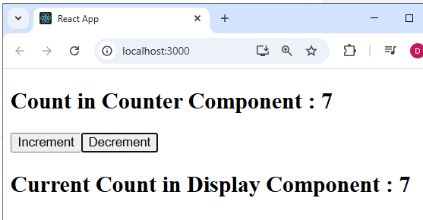

**Act 41.1) Add Redux Devtools to Google Chrome Extension**

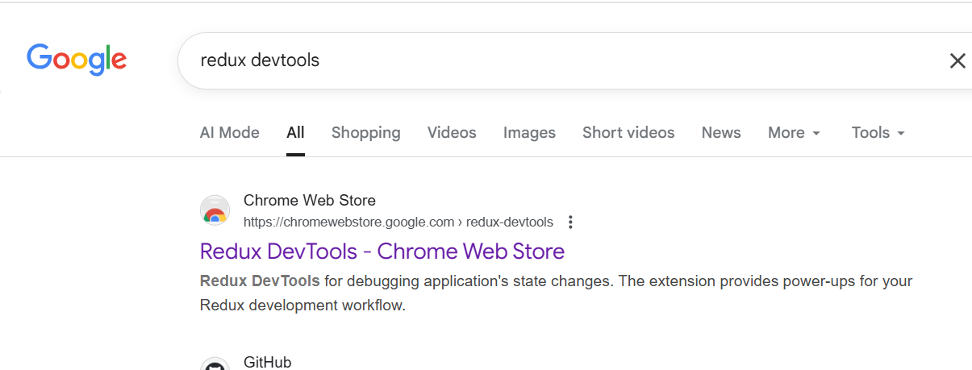

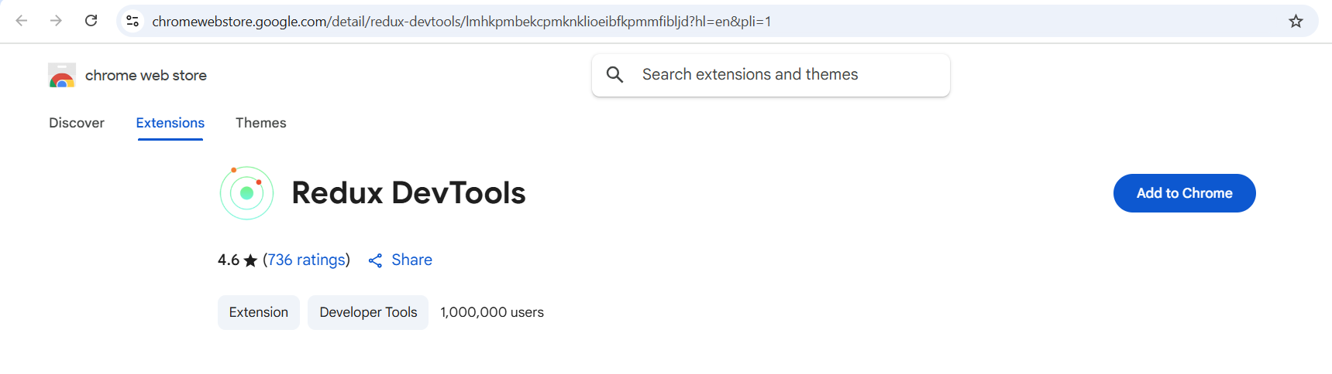

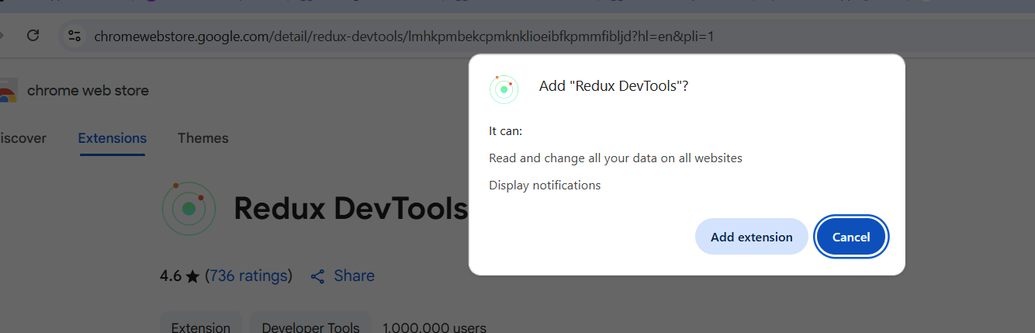

**Access it from the inspect section of browser**

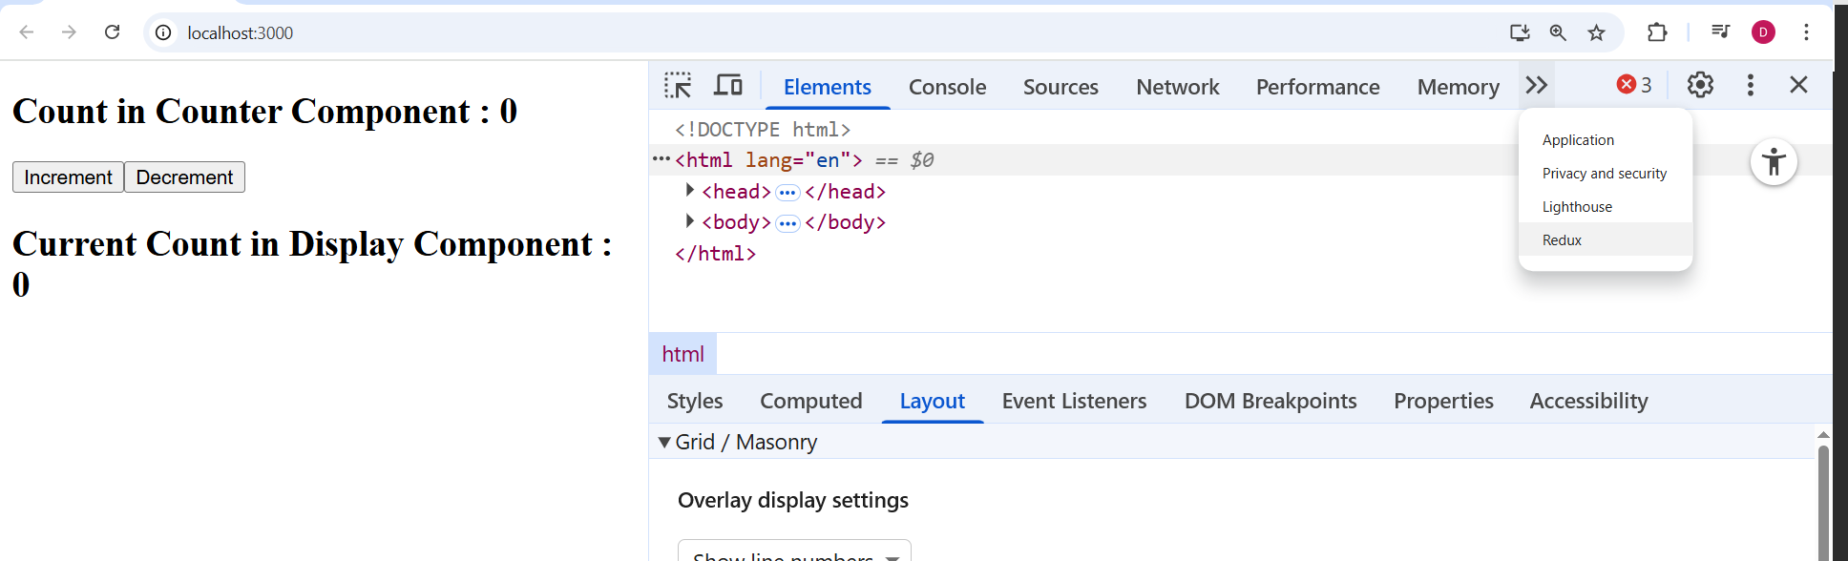

**(or)**

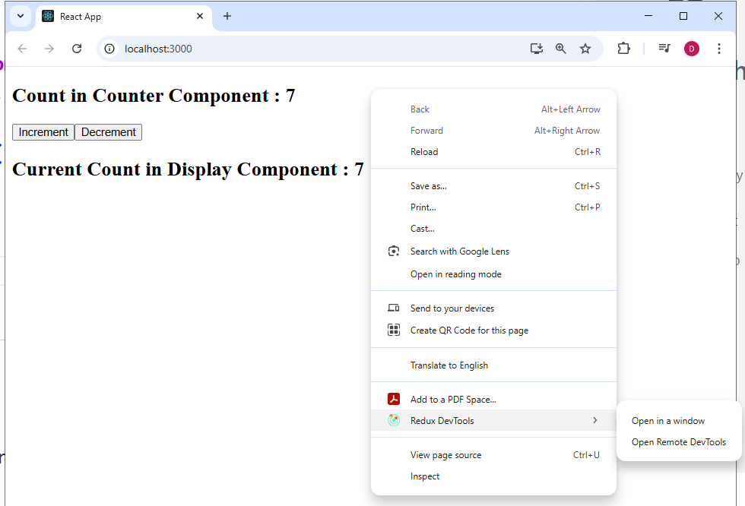

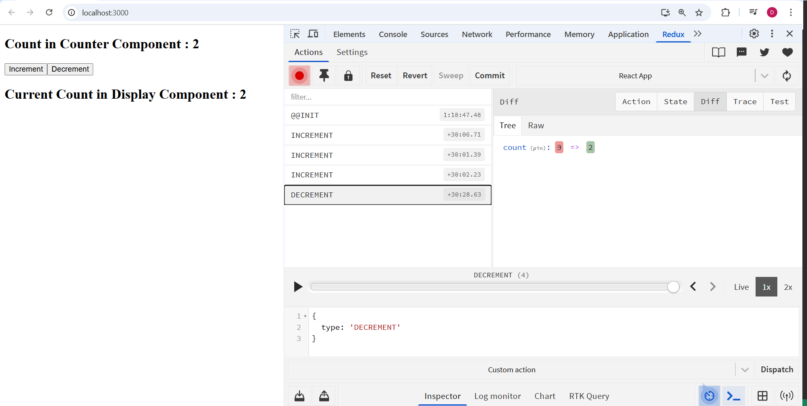

[**https://github.com/EmbarkXOfficial/react-course/tree/main/redux-react**](https://github.com/EmbarkXOfficial/react-course/tree/main/redux-react)

[**https://github.com/EmbarkXOfficial/react-course/tree/main/my-react-app**](https://github.com/EmbarkXOfficial/react-course/tree/main/my-react-app)

**Ecom application(areactecom)**

**D:\AMPHDLF>npm create vite@latest ecom-react**

**|**

**o Select a framework:**

**| React**

**|**

**o Select a variant:**

**| JavaScript**

**|**

**o Use rolldown-vite (Experimental)?:**

**| No**

**|**

**o Install with npm and start now?**

**| Yes**

**D:\AMPHDLF\ecom-react>npm install**

**D:\AMPHDLF\ecom-react>npm run dev**

[**http://localhost:5173/**](http://localhost:5173/)

**Dependencies**

1. **Configure Tailwindcss --https://tailwindcss.com/docs/installation/using-vite**

**npm install tailwindcss @tailwindcss/vite**

**vite.config.ts:**

**import { defineConfig } from 'vite'**

**import tailwindcss from '@tailwindcss/vite'**

**export default defineConfig({**

**plugins: [**

**tailwindcss(),**

**],**

**})**

**Index.css**

**@import "tailwindcss";**

**App.jsx**

**import "./App.css";**

**function App() {**

**return (**

**<>**

**<h1 class="text-3xl text-amber-700 font-bold underline">Hello world!</h1>**

**</>**

**);**

**}**

**export default App;**

**Terminal**

**npm run dev**

1. **Configure Postcss – It is a css which will be processed before sending sth to the browser. It is now added along with vite.**

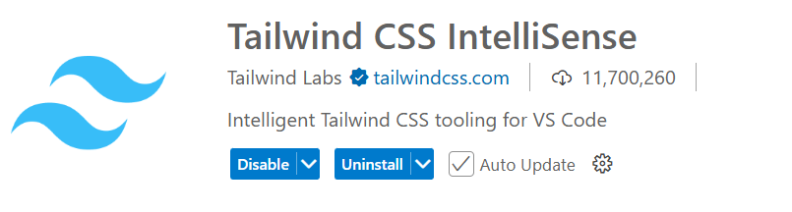

1. **Add a theme in index.css**

|  |
| --- |
| **@import "tailwindcss";**  **@import url("https://fonts.googleapis.com/css2?family=Montserrat:ital,wght@0,100..900;1,100..900&display=swap") layer(base);**  **@theme {**  **--font-montserrat: Montserrat, sans-serif;**  **--shadow-custom: 0 0 15px rgba(0, 0, 0, 0.3);**  **--shadow-right: 10px 0px 10px -5px rgba(0, 0, 0, 0.3);**  **--color-custom-blue: rgba(28, 100, 242, 1);**  **--color-banner-color1: #fdc200;**  **--color-banner-color2: #ff2c2c;**  **--color-banner-color3: #21ad61;**  **--color-banner-color4: #723da6;**  **--background-image-custom-gradient: linear-gradient(to right, #111827, #1f2937);**  **--background-image-button-gradient: linear-gradient(to right, #7e22ce, #ef4444);**  **--background-image-custom-gradient2: linear-gradient(135deg, #f5f5f5, #eae7dc);**  **}**  **/\***  **The default border color has changed to `currentcolor` in Tailwind CSS v4,**  **so we've added these compatibility styles to make sure everything still**  **looks the same as it did with Tailwind CSS v3.**  **If we ever want to remove these styles, we need to add an explicit border**  **color utility to any element that depends on these defaults.**  **\*/**  **@layer base {**  **\*,**  **::after,**  **::before,**  **::backdrop,**  **::file-selector-button {**  **border-color: var(--color-gray-200, currentcolor);**  **}**  **}** |

1. **Add Google font Montserrat**

[**https://fonts.google.com/selection/embed**](https://fonts.google.com/selection/embed)

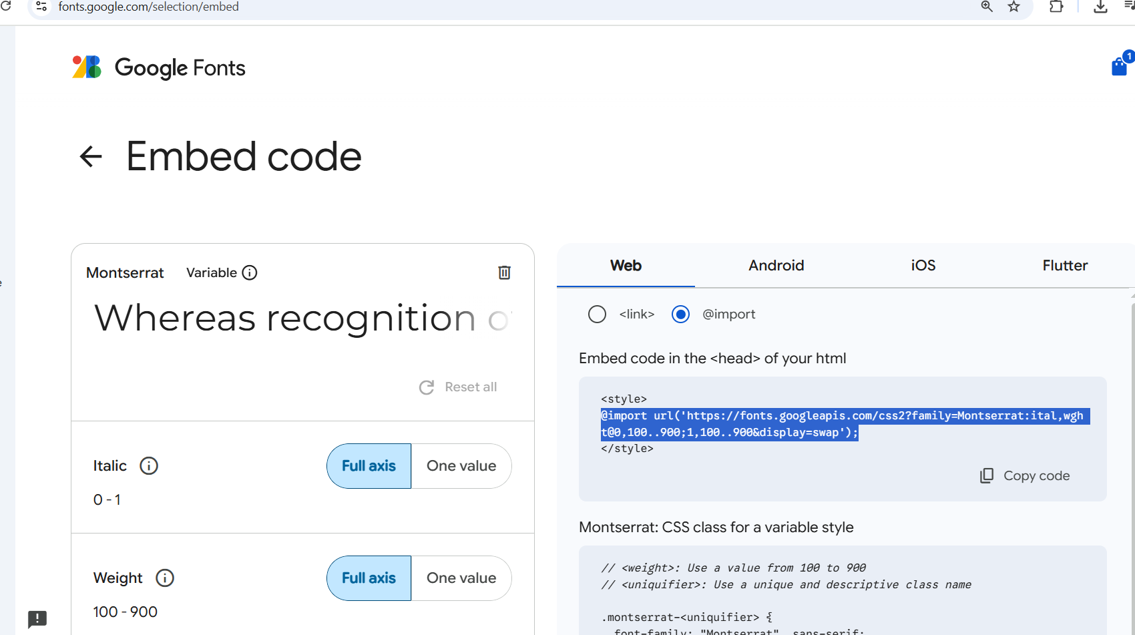

1. **Add Material UI**

[**https://mui.com/material-ui/getting-started/installation/**](https://mui.com/material-ui/getting-started/installation/)

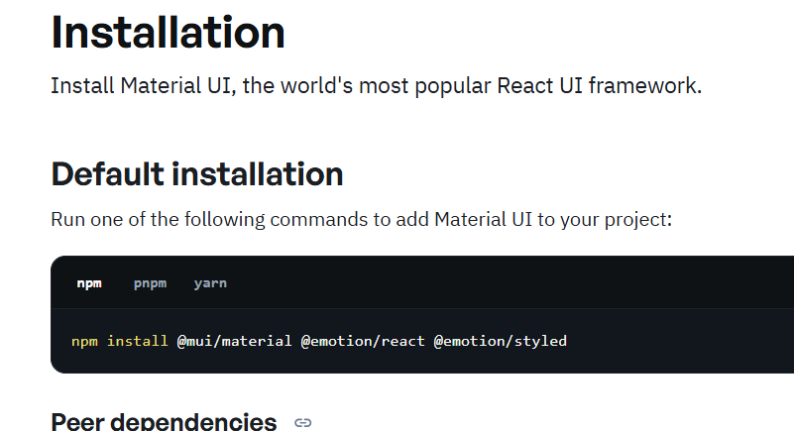

**D:\AMPHDLF\ecom-react>npm install @mui/material @emotion/react @emotion/styled**

1. **Install Recat ICONS :** [**https://react-icons.github.io/react-icons/**](https://react-icons.github.io/react-icons/)

**D:\AMPHDLF\ecom-react>npm install react-icons –save**

1. **Install React Hot Toast**

[**https://react-hot-toast.com/**](https://react-hot-toast.com/)

**D:\AMPHDLF\ecom-react>npm install react-hot-toast**

**YOOO TTTTUUUBBBEEE --** [**https://www.youtube.com/watch?v=1Z_bayY_WQw**](https://www.youtube.com/watch?v=1Z_bayY_WQw)

**npx create-react-app ecomy**

**npm start**

**App.css**

|  |
| --- |
| **html,**  **body {**  **font-family: 'Amazon Ember';**  **width: 100%;**  **height: 100%;**  **margin: 0px;**  **padding: 0px;**  **overflow-x: hidden;**  **}**  **/* Scroll Bar */**  **::-webkit-scrollbar-track {**  **background-color: #f5f5f5;**  **}**  **::-webkit-scrollbar {**  **width: 8px;**  **background-color: #f5f5f5;**  **}**  **::-webkit-scrollbar-thumb {**  **background-color: rgba(66, 66, 66, 0.2);**  **border: 0px;**  **background-clip: padding-box;**  **border-radius: 5px;**  **}**  **nav {**  **background-color: #232f3e;**  **padding: 1rem 1rem;**  **}**  **#search_btn {**  **background-color: #febd69;**  **}**  **.input-group {**  **width: 90%;**  **margin-right: 35%;**  **}**  **#search_field {**  **height: 2.4rem;**  **padding: 1rem;**  **}**  **#login_btn,**  **#view_btn {**  **background-color: #febd69;**  **padding: 0.4rem 1.8rem;**  **font-family: calibri;**  **}**  **#cart {**  **font-size: 1rem;**  **color: white;**  **}**  **#cart_count {**  **background-color: #febd69;**  **padding: 0.2rem 0.5rem;**  **border-radius: 0.2rem;**  **color: black;**  **font-weight: bold;**  **font-size: 0.9rem;**  **}**  **/* Home page */**  **#products_heading {**  **margin-top: 1.8rem;**  **}**  **.card {**  **height: 100%;**  **}**  **.card-title a {**  **color: #2e2e2e;**  **}**  **.card-title a:hover {**  **color: #fa9c23;**  **text-decoration: none;**  **}**  **.card-body {**  **padding-left: 0;**  **}**  **.card-text {**  **font-size: 1.4rem;**  **}**  **#view_btn {**  **background-color: #fa9c23;**  **color: white;**  **}**  **.card-img-top {**  **width: 200px;**  **height: 150px;**  **}**  **.ratings {**  **font-size: 1.2rem;**  **color: #fdcc0d;**  **}**  **#no_of_reviews {**  **font-size: 0.85rem;**  **color: grey;**  **margin-left: 0.5rem;**  **}**  **/* Footer */**  **footer {**  **margin-top: 8rem;**  **color: grey;**  **bottom: 0;**  **width: 100%;**  **}**  **/* Ratings */**  **.rating-outer {**  **display: inline-block;**  **position: relative;**  **font-family: FontAwesome;**  **color: #fdcc0d;**  **}**  **.rating-outer::before {**  **content: '\f006 \f006 \f006 \f006 \f006';**  **}**  **.rating-inner {**  **position: absolute;**  **top: 0;**  **left: 0;**  **white-space: nowrap;**  **overflow: hidden;**  **width: 0;**  **}**  **.rating-inner::before {**  **content: '\f005 \f005 \f005 \f005 \f005';**  **color: #f8ce0b;**  **}**  **/* Product Details Page */**  **#product_id {**  **color: grey;**  **font-size: 0.8rem;**  **}**  **#product_price {**  **font-size: 2rem;**  **font-weight: bold;**  **}**  **#cart_btn,**  **#review_btn {**  **border-radius: 2rem;**  **background-color: #fa9c23;**  **border: none;**  **padding: 0.5rem 2rem;**  **}**  **#product_seller {**  **color: grey;**  **font-size: 0.9rem;**  **}**  **#stock_status {**  **font-size: 1.1rem;**  **font-weight: bold;**  **margin-left: 0.3rem;**  **}**  **.redColor {**  **color: red;**  **}**  **.greenColor {**  **color: green;**  **}**  **#product_image {**  **margin-top: 9rem;**  **}**  **/* Loader */**  **.loader {**  **display: block;**  **margin-left: auto;**  **margin-right: auto;**  **margin-top: 20%;**  **width: 80px;**  **height: 80px;**  **padding-left: 0;**  **}**  **.loader:after {**  **content: ' ';**  **display: block;**  **width: 64px;**  **height: 64px;**  **margin: 8px;**  **border-radius: 50%;**  **border: 6px solid #fa9c23;**  **border-color: #fa9c23 transparent;**  **animation: lds-dual-ring 1.2s linear infinite;**  **}**  **@keyframes lds-dual-ring {**  **0% {**  **transform: rotate(0deg);**  **}**  **100% {**  **transform: rotate(360deg);**  **}**  **}**  **/* Cart */**  **.cart-item {**  **margin: 1.8rem 0rem;**  **padding: 0rem 0.7rem;**  **}**  **.cart-item a {**  **color: grey;**  **}**  **#delete_cart_item {**  **color: red;**  **background: white;**  **padding: 0.3rem 0.5rem;**  **font-size: 1.1rem;**  **border: none;**  **}**  **#card_item_price {**  **color: #febd69;**  **font-weight: bold;**  **font-size: 1.4rem;**  **}**  **#checkout_btn,**  **.review-btn {**  **background-color: #fa9c23;**  **border-color: #fa9c23;**  **margin-top: 2rem;**  **border-radius: 5rem;**  **}**  **#view_order_details {**  **background-color: #fa9c23;**  **border-color: #fa9c23;**  **}**  **#order_summary {**  **border: 1px solid #e3e3e3;**  **border-radius: 1rem;**  **padding: 2rem 1.5rem;**  **}**  **.order-summary-values {**  **float: right;**  **font-weight: bold;**  **}**  **.stockCounter input {**  **border: none;**  **width: 3rem;**  **text-align: center;**  **}**  **.plus,**  **.minus {**  **padding: 0.1rem 0.5rem;**  **}**  **.stockCounter input::-webkit-outer-spin-button,**  **.stockCounter input::-webkit-inner-spin-button {**  **-webkit-appearance: none;**  **margin: 0;**  **}**  **.form-control:disabled,**  **.form-control[readonly] {**  **background-color: white;**  **}**  **/* Login & Register */**  **.wrapper {**  **display: flex;**  **justify-content: center;**  **align-items: center;**  **margin-top: 5rem;**  **font-weight: 700;**  **}**  **.wrapper form {**  **padding: 2.5rem 3rem;**  **}**  **.wrapper form .btn {**  **background-color: #fa9c23;**  **border-color: #fa9c23;**  **color: white;**  **margin-top: 2.5rem;**  **}**  **.wrapper form a {**  **font-size: 0.9rem;**  **color: grey;**  **}**  **/* Avatar */**  **.avatar {**  **display: inline-block;**  **margin-bottom: 0;**  **height: 3rem;**  **width: 3rem;**  **-webkit-border-radius: 50%;**  **-moz-border-radius: 50%;**  **border-radius: 50%;**  **}**  **.avatar img {**  **width: 100%;**  **height: 100%;**  **object-fit: cover;**  **}**  **.rounded-circle {**  **border-radius: 50% !important;**  **}**  **.btn.focus,**  **.btn:focus {**  **outline: 0;**  **box-shadow: none;**  **}**  **/* Header User Profile */**  **.avatar-nav {**  **margin-right: 0.6rem;**  **height: 2.2rem;**  **width: 2.2rem;**  **}**  **/* Checkout Steps */**  **.checkout-progress div {**  **box-sizing: border-box;**  **}**  **.checkout-progress {**  **display: block;**  **clear: both;**  **margin: 20px auto;**  **width: auto;**  **font-family: sans-serif;**  **overflow: auto;**  **}**  **.step {**  **margin: 0;**  **border: 0;**  **letter-spacing: 1px;**  **line-height: 30px;**  **padding: 5px 10px 5px 15px;**  **color: grey;**  **text-decoration: none;**  **cursor: default;**  **font-weight: bold;**  **float: left;**  **height: auto;**  **}**  **.incomplete {**  **background: #eeeeee;**  **}**  **.active-step {**  **background: #fa9c23;**  **color: #fff;**  **}**  **.triangle-active {**  **float: left;**  **width: 0;**  **border-top: 20px solid transparent;**  **border-left: 15px solid #fa9c23;**  **border-bottom: 20px solid transparent;**  **margin-left: -1px;**  **}**  **.triangle2-active {**  **width: 0;**  **float: left;**  **border-top: 20px solid #fa9c23;**  **border-left: 15px solid #fff;**  **border-bottom: 20px solid #fa9c23;**  **margin-right: -1px;**  **}**  **.triangle-incomplete {**  **float: left;**  **width: 0;**  **border-top: 20px solid transparent;**  **border-left: 15px solid #eeeeee;**  **border-bottom: 20px solid transparent;**  **margin-left: -1px;**  **}**  **.triangle2-incomplete {**  **width: 0;**  **float: left;**  **border-top: 20px solid #eeeeee;**  **border-left: 15px solid #fff;**  **border-bottom: 20px solid #eeeeee;**  **margin-right: -1px;**  **}**  **/* User Profile */**  **.avatar-profile {**  **height: 16rem;**  **width: 16rem;**  **}**  **.user-info h4 {**  **font-weight: 800;**  **color: grey;**  **margin-top: 2rem;**  **}**  **.user-info p {**  **font-size: 1.1rem;**  **}**  **#edit_profile {**  **background-color: #fa9c23;**  **border-color: #fa9c23;**  **}**  **/* Confirm Order */**  **.order-confirm p,**  **.order-details p {**  **margin-left: 1.5rem;**  **}**  **.update-btn {**  **background-color: #fa9c23;**  **border-color: #fa9c23;**  **color: white;**  **}**  **.update-btn:hover {**  **color: white;**  **}**  **/* Pagination */**  **.page-item.active .page-link {**  **background-color: #fa9c23;**  **border-color: #fa9c23;**  **}**  **.page-link {**  **color: #fa9c23;**  **}**  **.page-link:hover {**  **color: #fa9c23;**  **}**  **/* Admin Sidebar */**  **.sidebar-wrapper {**  **display: flex;**  **width: 100%;**  **align-items: stretch;**  **min-height: 100vh;**  **font-weight: normal;**  **margin-top: 0;**  **height: 100%;**  **left: 0;**  **top: 0;**  **z-index: 10;**  **}**  **#sidebar {**  **min-width: 100%;**  **max-width: 100%;**  **background: #232f3e;**  **color: #fff;**  **transition: all 0.3s;**  **}**  **#sidebar.active {**  **margin-left: -250px;**  **}**  **#sidebar .sidebar-header {**  **padding: 20px;**  **background: #232f3e;**  **}**  **#sidebar ul.components {**  **padding: 5px 0px;**  **border-bottom: 1px solid #232f3e;**  **}**  **#sidebar ul li a {**  **padding: 10px;**  **font-size: 1.1em;**  **display: block;**  **color: white;**  **text-decoration: none;**  **}**  **#sidebar ul li a:hover {**  **color: #232f3e;**  **background: #fff;**  **}**  **#sidebar ul li a i {**  **margin-right: 0.3rem;**  **}**  **#sidebar ul li.active > a,**  **a[aria-expanded='true'] {**  **color: #fff;**  **background: #232f3e;**  **}**  **a[data-toggle='collapse'] {**  **position: relative;**  **}**  **.dropdown-toggle::after {**  **display: block;**  **position: absolute;**  **top: 50%;**  **right: 20px;**  **transform: translateY(-50%);**  **}**  **ul ul a {**  **font-size: 1rem !important;**  **padding-left: 30px !important;**  **background: #232f3e;**  **}**  **ul.CTAs {**  **padding: 20px;**  **}**  **ul.CTAs a {**  **text-align: center;**  **font-size: 0.9em !important;**  **display: block;**  **border-radius: 5px;**  **margin-bottom: 5px;**  **}**  **/* Products List Admin */**  **#products_table .btn {**  **padding: 0.2rem 0.5rem;**  **margin-left: 0.4rem;**  **}**  **/* Dashboard */**  **.card-font-size {**  **font-size: 1.5rem;**  **}**  **/* Reviews */**  **.rating {**  **margin-top: 10rem;**  **}**  **.stars {**  **height: 100px;**  **display: flex;**  **align-items: center;**  **padding-left: 0;**  **}**  **.star {**  **display: inline;**  **list-style: none;**  **font-size: 3rem;**  **padding-left: 0.9rem;**  **color: #e3e3e3;**  **}**  **.star:first-child {**  **padding-left: 0;**  **}**  **.orange {**  **color: #fa9c23;**  **}**  **.yellow {**  **color: #fdcc0d;**  **}**  **.review_user {**  **font-size: 0.8rem;**  **color: grey;**  **}** |

**Public folder, index.html**

|  |
| --- |
| **<link rel="stylesheet" type="text/css" href="https://cdn.jsdelivr.net/npm/bootstrap@5.3.8/dist/css/bootstrap.min.css" rel="stylesheet"**  **integrity="sha384-sRIl4kxILFvY47J16cr9ZwB07vP4J8+LH7qKQnuqkuIAvNWLzeN8tE5YBujZqJLB" crossorigin="anonymous""**  **<link**  **rel="stylesheet"**  **href="https://cdn.jsdelivr.net/npm/@fortawesome/fontawesome-free@6.6.0/css/fontawesome.min.css"**  **integrity="sha384-NvKbDTEnL+A8F/AA5Tc5kmMLSJHUO868P+lDtTpJIeQdGYaUIuLr4lVGOEA1OcMy"**  **crossorigin="anonymous"**  **/>**  **<link rel="stylesheet" href="https://cdnjs.cloudflare.com/ajax/libs/font-awesome/6.4.2/css/all.min.css" />**  **<link href="https://fonts.cdnfonts.com/css/amazon-ember" rel="stylesheet" type="text/css" />** |

**Create a Home Component inside pages folder**

**Create a NavbarComp, Footer Component inside pages folder**

**Home.jsx**

|  |
| --- |
| **import { Fragment } from "react/jsx-runtime";**  **export default function Home() {**  **return (**  **<Fragment>**  **<h1 id="products_heading">Latest Products</h1>**  **<section id="products" class="container mt-5">**  **<div class="row">**  **<div class="col-sm-12 col-md-6 col-lg-3 my-3">**  **<div class="card p-3 rounded">**  **<img class="card-img-top mx-auto" src="/images/products/1.jpg" />**  **<div class="card-body d-flex flex-column">**  **<h5 class="card-title">**  **<a href="">OPPO F21s Pro 5G (Dawnlight Gold, 8GB RAM, 128 Storage) with No Cost EMI/Additional Exchange Offers</a>**  **</h5>**  **<p class="card-text mb-1">**  **<span class="card-text text-danger font-weight-bold">₹63000</span>**  **<small class="text-muted">**  **<del>₹70000</del>**  **</small>**  **<span class="badge bg-success ms-2">10% OFF</span>**  **</p>**  **<a href="#" id="view_btn" class="btn btn-block">**  **View Details**  **</a>**  **</div>**  **</div>**  **</div>**  **<div class="col-sm-12 col-md-6 col-lg-3 my-3">**  **<div class="card p-3 rounded">**  **<img class="card-img-top mx-auto" src="/images/products/2.jpg" />**  **<div class="card-body d-flex flex-column">**  **<h5 class="card-title">**  **<a href="">**  **Wrist Watch Fire-Boltt Ninja Call Pro Plus Smart Watch 1.83” HD Display, Bluetooth Calling, AI Voice Assistant**  **</a>**  **</h5>**  **<p class="card-text mb-1">**  **<span class="card-text text-danger font-weight-bold">₹9000</span>**  **<small class="text-muted">**  **<del>₹19000</del>**  **</small>**  **<span class="badge bg-success ms-2">53% OFF</span>**  **</p>**  **<a href="#" id="view_btn" class="btn btn-block">**  **View Details**  **</a>**  **</div>**  **</div>**  **</div>**  **<div class="col-sm-12 col-md-6 col-lg-3 my-3">**  **<div class="card p-3 rounded">**  **<img class="card-img-top mx-auto" src="/images/products/3.jpg" />**  **<div class="card-body d-flex flex-column">**  **<h5 class="card-title">**  **<a href="">HP 15, 13th Gen Intel Core i5-1334U, (16GB DDR4,512GB SSD) Anti-Glare, Micro-Edge, FHD, 15.6''/39.6cm</a>**  **</h5>**  **<p class="card-text mb-1">**  **<span class="card-text text-danger font-weight-bold">₹51000</span>**  **<small class="text-muted">**  **<del>₹70000</del>**  **</small>**  **<span class="badge bg-success ms-2">27% OFF</span>**  **</p>**  **<a href="#" id="view_btn" class="btn btn-block">**  **View Details**  **</a>**  **</div>**  **</div>**  **</div>**  **<div class="col-sm-12 col-md-6 col-lg-3 my-3">**  **<div class="card p-3 rounded">**  **<img class="card-img-top mx-auto" src="/images/products/Shampoo.jpg" />**  **<div class="card-body d-flex flex-column">**  **<h5 class="card-title">**  **<a href="">L'Oréal Professionnel Absolut Repair Molecular Sulfate-Free Deep Repairing Shampoo for Damaged Hair</a>**  **</h5>**  **<p class="card-text mb-1">**  **<span class="card-text text-danger font-weight-bold">₹1326</span>**  **<small class="text-muted">**  **<del>₹1490</del>**  **</small>**  **<span class="badge bg-success ms-2">11% OFF</span>**  **</p>**  **<a href="#" id="view_btn" class="btn btn-block">**  **View Details**  **</a>**  **</div>**  **</div>**  **</div>**  **<div class="col-sm-12 col-md-6 col-lg-3 my-3">**  **<div class="card p-3 rounded">**  **<img class="card-img-top mx-auto" src="/images/products/chopper.jpg" />**  **<div class="card-body d-flex flex-column">**  **<h5 class="card-title">**  **<a href="">**  **VOLTURI Chopper for Kitchen Use, Push Chopper with 3 Blades, Vegetable Chopper Kitchen Accessories Items for Home**  **</a>**  **</h5>**  **<p class="card-text mb-1">**  **<span class="card-text text-danger font-weight-bold">₹399</span>**  **<small class="text-muted">**  **<del>₹999</del>**  **</small>**  **<span class="badge bg-success ms-2">60% OFF</span>**  **</p>**  **<a href="#" id="view_btn" class="btn btn-block">**  **View Details**  **</a>**  **</div>**  **</div>**  **</div>**  **<div class="col-sm-12 col-md-6 col-lg-3 my-3">**  **<div class="card p-3 rounded">**  **<img class="card-img-top mx-auto" src="/images/products/spinner.jpg" />**  **<div class="card-body d-flex flex-column">**  **<h5 class="card-title">**  **<a href="">GRAPHENE Spinning Top Gyro Magic Lattoo Toy Flashing Plastic Magic Spinner with LED Lights Music</a>**  **</h5>**  **<p class="card-text mb-1">**  **<span class="card-text text-danger font-weight-bold">₹121</span>**  **<small class="text-muted">**  **<del>₹599</del>**  **</small>**  **<span class="badge bg-success ms-2">80% OFF</span>**  **</p>**  **<a href="#" id="view_btn" class="btn btn-block">**  **View Details**  **</a>**  **</div>**  **</div>**  **</div>**  **<div class="col-sm-12 col-md-6 col-lg-3 my-3">**  **<div class="card p-3 rounded">**  **<img class="card-img-top mx-auto" src="/images/products/kurtha.jpg" />**  **<div class="card-body d-flex flex-column">**  **<h5 class="card-title">**  **<a href="">Rangnavi Women Rayon Anarkali Embroidered Printed Kurta Pant and Dupatta Set Super Color</a>**  **</h5>**  **<p class="card-text mb-1">**  **<span class="card-text text-danger font-weight-bold">₹799</span>**  **<small class="text-muted">**  **<del>₹2999</del>**  **</small>**  **<span class="badge bg-success ms-2">73% OFF</span>**  **</p>**  **<a href="#" id="view_btn" class="btn btn-block">**  **View Details**  **</a>**  **</div>**  **</div>**  **</div>**  **</div>**  **</section>**  **</Fragment>**  **);**  **}** |

**Header.jsx**

|  |
| --- |
| **import CategoryNavbar from "./CategoryNavbar";**  **export default function Header() {**  **return (**  **<div>**  **<nav class="navbar row">**  **<div class="col-12 col-md-3">**  **<div class="navbar-brand">**  **<img src="/images/logo.png" height="50px" width="150px" />**  **</div>**  **</div>**  **<div class="col-12 col-md-6 mt-2 mt-md-0">**  **<div class="input-group">**  **<input type="text" id="search_field" class="form-control" placeholder="Enter Product Name ..." />**  **<div class="input-group-append">**  **<button id="search_btn" class="btn">**  **<i class="fa fa-search" aria-hidden="true"></i>**  **</button>**  **</div>**  **</div>**  **</div>**  **<div class="col-12 col-md-3 mt-4 mt-md-0 text-center">**  **<a href="#" class="cart-link">**  **<div class="cart-icon-container">**  **<i class="fa-solid fa-cart-shopping cart-icon"></i>**  **<span class="cart-count">1</span>**  **</div>**  **<span class="cart-text">Cart</span>**  **</a>**  **</div>**  **</nav>**  **<CategoryNavbar />**  **</div>**  **);**  **}** |

**Footer.jsx**

|  |
| --- |
| **import React from "react";**  **import { Container } from "react-bootstrap";**  **function Footer() {**  **return (**  **<>**  **<footer className="bg-primary text-white py-3 text-center mt-auto">**  **<Container>**  **<p className="mb-0">&copy; 2025 XYZ Example Ltd . All rights reserved.</p>**  **</Container>**  **</footer>**  **</>**  **);**  **}**  **export default Footer;** |

**CategoryNavbar.jsx 🡪 npm install react-bootstrap**

|  |
| --- |
| **import React from "react";**  **import { Container, Nav, Navbar } from "react-bootstrap";**  **function CategoryNavbar() {**  **return (**  **<Navbar bg="primary" expand="lg" className="shadow-sm category-navbar mb-5 category-navbar-custom">**  **<Container>**  **<Navbar.Toggle aria-controls="category-navbar" />**  **<Navbar.Collapse id="category-navbar">**  **<Nav className="me-auto">**  **<Nav.Link href="/electronics">Electronics</Nav.Link>**  **<Nav.Link href="/toys">Toys</Nav.Link>**  **<Nav.Link href="/clothes">Clothes</Nav.Link>**  **<Nav.Link href="/kitchen">Kitchen & Dining</Nav.Link>**  **<Nav.Link href="/health-beauty">Health & Beauty</Nav.Link>**  **</Nav>**  **</Navbar.Collapse>**  **</Container>**  **</Navbar>**  **);**  **}**  **export default CategoryNavbar;** |

**App.js**

|  |
| --- |
| **import "./App.css";**  **import Home from "./pages/Home";**  **import Footer from "./components/Footer";**  **import Header from "./components/Header";**  **function App() {**  **return (**  **<div className="App">**  **<Header />**  **<Home />**  **<Footer />**  **</div>**  **);**  **}**  **export default App;** |
| **Index.js**  **import React from "react";**  **import ReactDOM from "react-dom/client";**  **import "./index.css";**  **import App from "./App";**  **const root = ReactDOM.createRoot(document.getElementById("root"));**  **root.render(**  **<React.StrictMode>**  **<App />**  **</React.StrictMode>**  **);** |

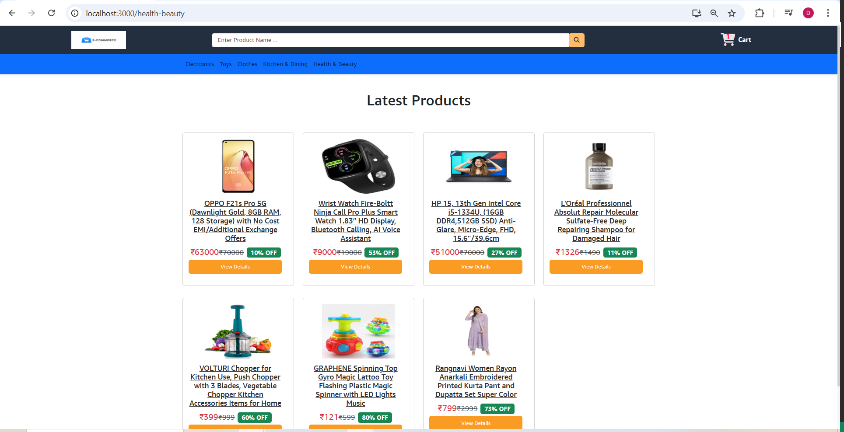

**NOW IMAGES AND DATA ARE STATIC. NOW FETCH IT FROM API**

**In Home.jsx, remove all the product <div> except the first one.**

|  |
| --- |
| **import { Fragment } from "react/jsx-runtime";**  **export default function Home() {**  **return (**  **<Fragment>**  **<h1 id="products_heading">Latest Products</h1>**  **<section id="products" class="container mt-5">**  **<div class="row">**  **<div class="col-sm-12 col-md-6 col-lg-3 my-3">**  **<div class="card p-3 rounded">**  **<img class="card-img-top mx-auto" src="/images/products/1.jpg" />**  **<div class="card-body d-flex flex-column">**  **<h5 class="card-title">**  **<a href="">OPPO F21s Pro 5G (Dawnlight Gold, 8GB RAM, 128 Storage) with No Cost EMI/Additional Exchange Offers</a>**  **</h5>**  **<p class="card-text mb-1">**  **<span class="card-text text-danger font-weight-bold">₹63000</span>**  **<small class="text-muted">**  **<del>₹70000</del>**  **</small>**  **<span class="badge bg-success ms-2">10% OFF</span>**  **</p>**  **<a href="#" id="view_btn" class="btn btn-block">**  **View Details**  **</a>**  **</div>**  **</div>**  **</div>**  **</div>**  **</section>**  **</Fragment>**  **);**  **}** |

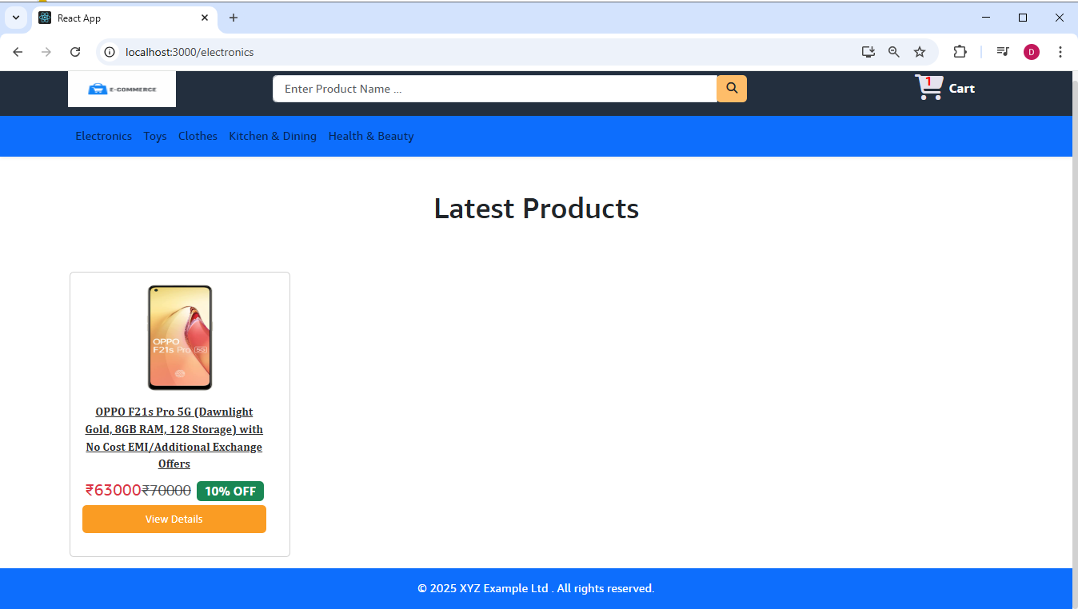

**The highlighted <div> will be repeated again and again, so keep it as a separate component named**

**ProductCard.jsx**

|  |
| --- |
| **import React from "react";**  **function ProductCard() {**  **return (**  **<div>**  **<div class="col-sm-12 col-md-6 col-lg-3 my-3">**  **<div class="card p-3 rounded">**  **<img class="card-img-top mx-auto" src="/images/products/1.jpg" />**  **<div class="card-body d-flex flex-column">**  **<h5 class="card-title">**  **<a href="">OPPO F21s Pro 5G (Dawnlight Gold, 8GB RAM, 128 Storage) with No Cost EMI/Additional Exchange Offers</a>**  **</h5>**  **<p class="card-text mb-1">**  **<span class="card-text text-danger font-weight-bold">₹63000</span>**  **<small class="text-muted">**  **<del>₹70000</del>**  **</small>**  **<span class="badge bg-success ms-2">10% OFF</span>**  **</p>**  **<a href="#" id="view_btn" class="btn btn-block">**  **View Details**  **</a>**  **</div>**  **</div>**  **</div>**  **</div>**  **);**  **}**  **export default ProductCard;** |

**Call this component ProductCard in Home.jsx**

|  |
| --- |
| **import { Fragment } from "react/jsx-runtime";**  **import ProductCard from "../components/ProductCard";**  **export default function Home() {**  **return (**  **<Fragment>**  **<h1 id="products_heading">Latest Products</h1>**  **<section id="products" class="container mt-5">**  **<div class="row">**  **<ProductCard />**  **</div>**  **</section>**  **</Fragment>**  **);**  **}** |

**Now create a .env file for environment variable under project folder and start the API as REACT_APP_**

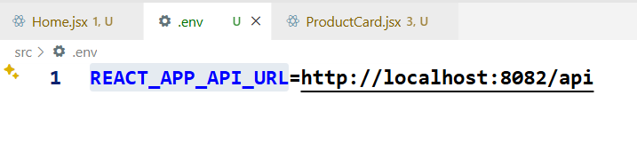

**In Home.jsx**

|  |
| --- |
| **import { Fragment } from "react/jsx-runtime";**  **import ProductCard from "../components/ProductCard";**  **import { useEffect, useState } from "react";**  **export default function Home() {**  **//Add this**  **const [products, setProducts] = useState([]);**  **useEffect(() => {**  **fetch(process.env.REACT_APP_API_URL + "/public/products")**  **.then((res) => res.json())**  **.then((data) => setProducts(data))**  **.catch((err) => console.error(err));**  **}, []);**  **return (**  **<Fragment>**  **<h1 id="products_heading">Latest Products</h1>**  **<section id="products" class="container mt-5">**  **<div className="row">**  **{products.map((pr) => (**  **<ProductCard key={pr.id} product={pr} />**  **))}**  **</div>**  **</section>**  **</Fragment>**  **);**  **}** |
| **GOTO the browser and refresh. U get error. After creating .env file, we need to restart the app.** |

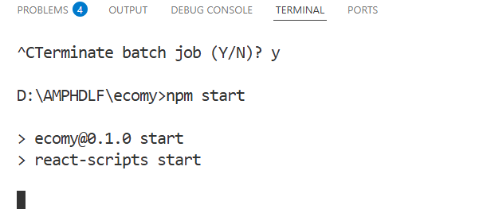

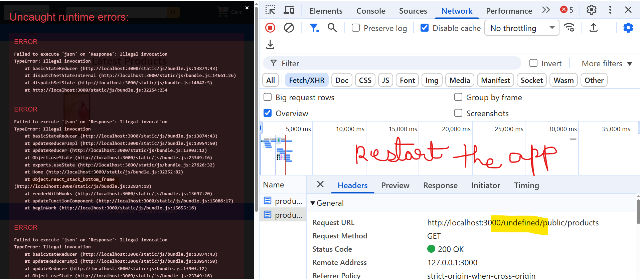

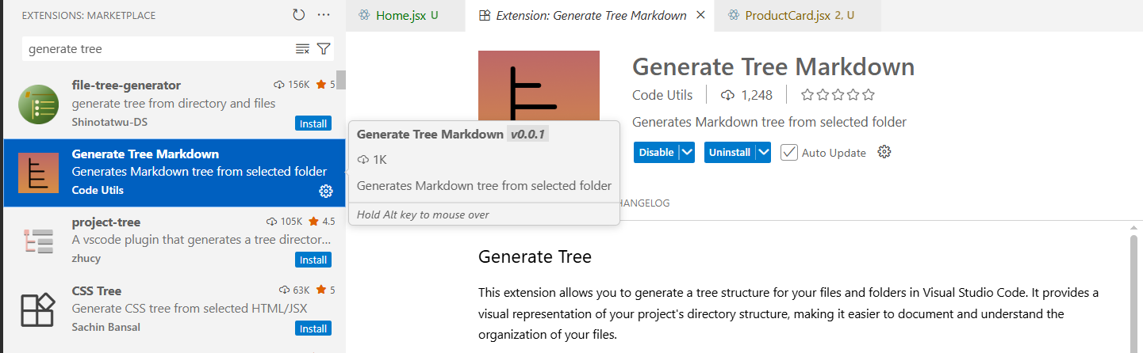

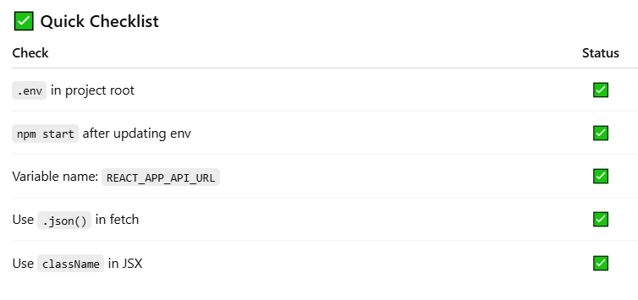

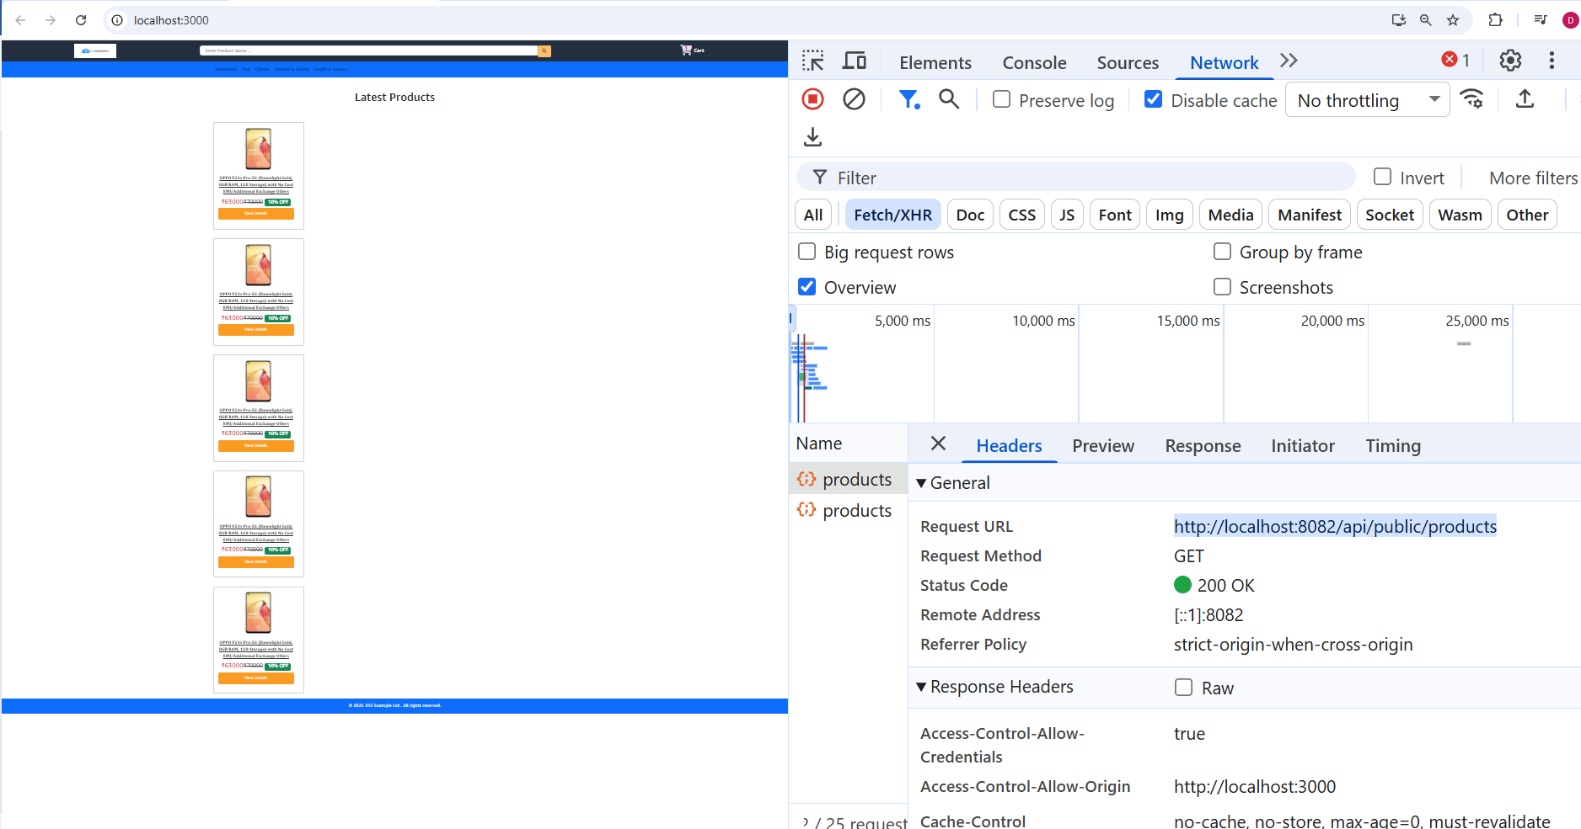

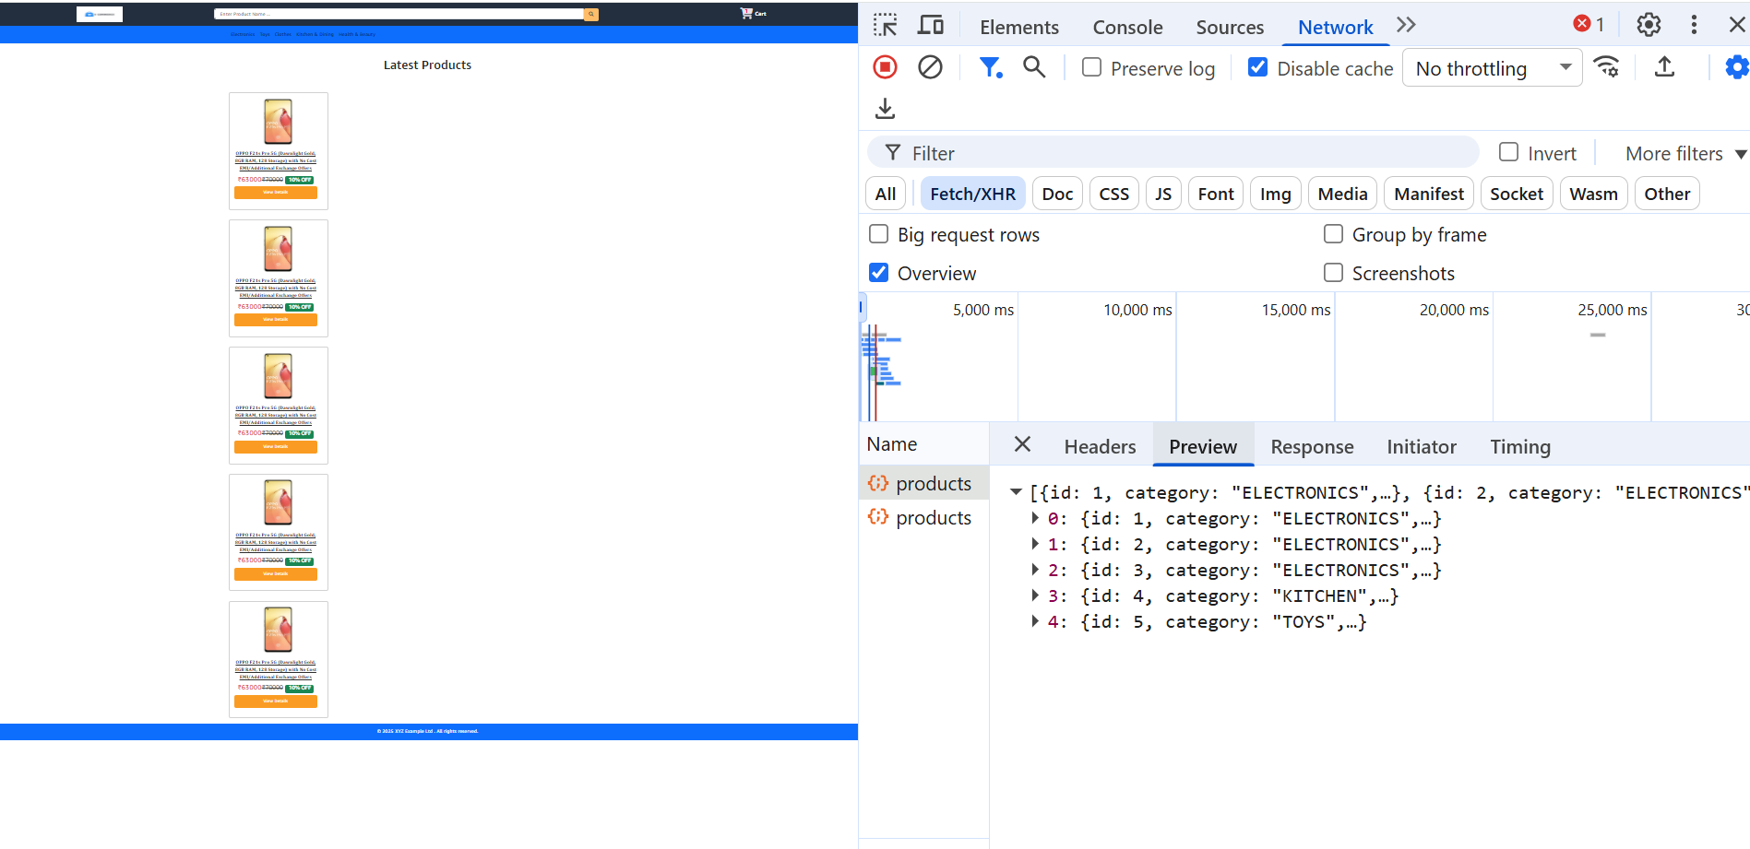

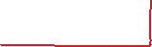

**Ensure in springboot**

|  |
| --- |
| **@PutMapping("/admin/products/{productId}/image")**  **public ResponseEntity<ProductDTO> updateProductImage(@PathVariable Long productId,**  **@RequestParam("image") MultipartFile image) throws IOException {**  **ProductDTO updatedProduct = productService.updateProductImage(productId, image);**  **return new ResponseEntity<ProductDTO>(updatedProduct, HttpStatus.*OK*);**  **}**    **@GetMapping("/products/image/{filename}")**  **public ResponseEntity<Resource> getImage(@PathVariable String filename) throws IOException {**  **Path imagePath = Paths.*get*("images", filename);**  **if (!Files.*exists*(imagePath)) {**  **return ResponseEntity.*notFound*().build();**  **}**  **Resource resource = new UrlResource(imagePath.toUri());**  **String contentType = Files.*probeContentType*(imagePath);**  **return ResponseEntity.*ok*()**  **.contentType(MediaType.*parseMediaType*(contentType))**  **.body(resource);**  **}** |

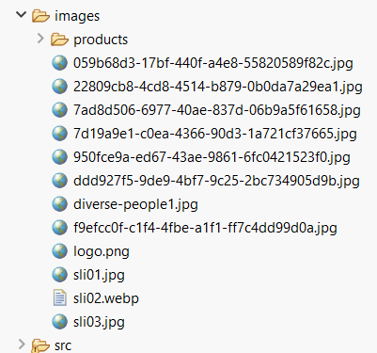 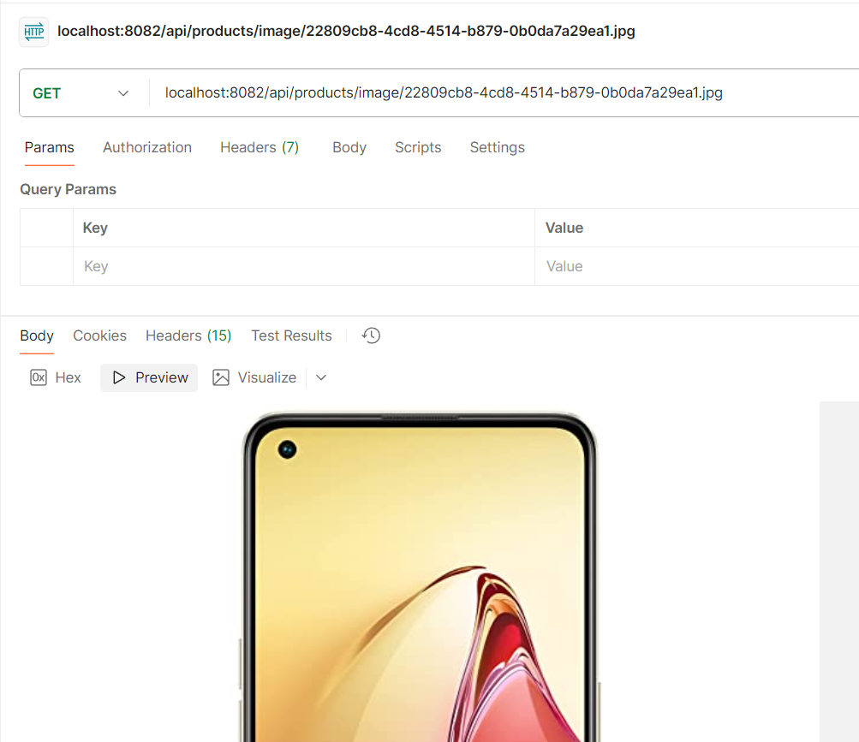

**ProductCard.jsx**

|  |
| --- |
| **import React from "react";**  **function ProductCard({ product }) {**  **const imageUrl = `${process.env.REACT_APP_API_URL}/products/image/${product.image}`;**  **return (**  **<div>**  **<div class="col-sm-12 col-md-6 col-lg-3 my-3">**  **<div class="card p-3 rounded">**  **<img class="card-img-top mx-auto" src={imageUrl} alt="image-unavailable" />**  **<div class="card-body d-flex flex-column">**  **<h5 class="card-title">**  **<a href="#">{product.productName}</a>**  **</h5>**  **<p class="card-text mb-1">**  **<span class="card-text text-danger font-weight-bold"> ₹{product.specialPrice}</span>**  **<small class="text-muted">**  **<del>₹{product.price}</del>**  **</small>**  **<span class="badge bg-success ms-2">{product.discount}% OFF</span>**  **</p>**  **<a href="#" id="view_btn" class="btn btn-block">**  **View Details**  **</a>**  **</div>**  **</div>**  **</div>**  **</div>**  **);**  **}**  **export default ProductCard;** |

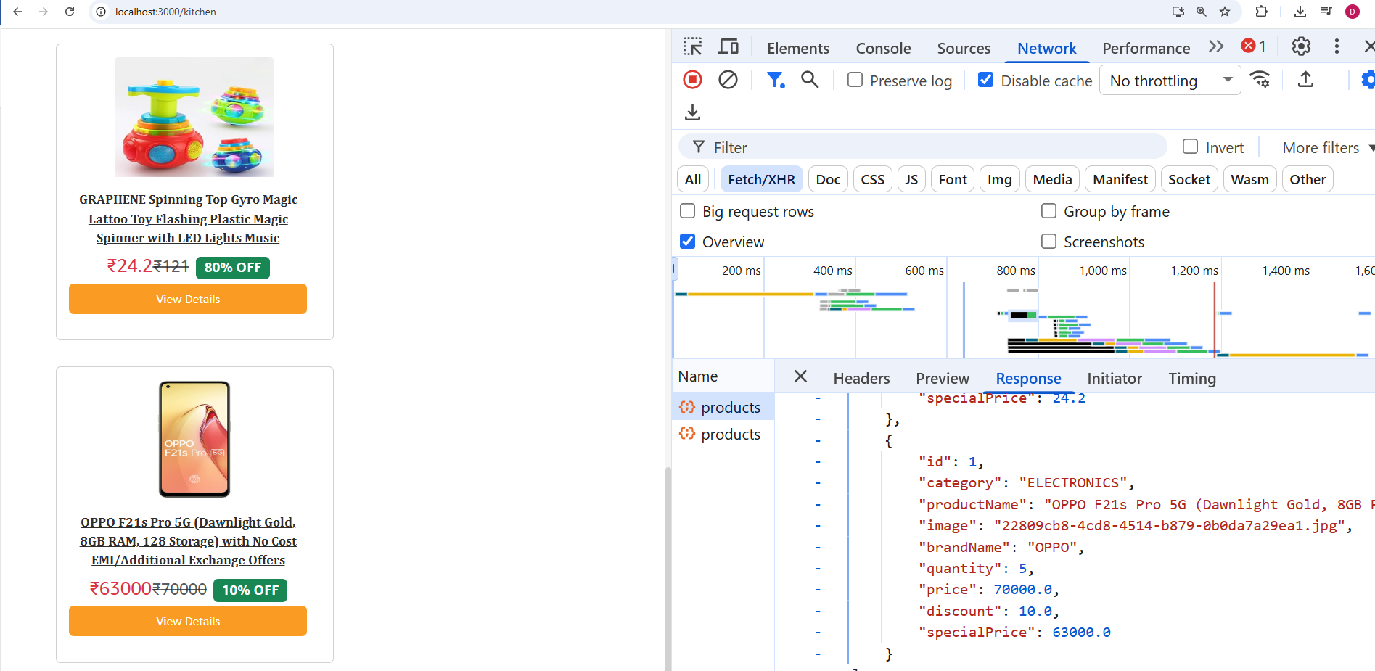

**PRODUCTS FETCHED SUCCESSFULLY FROM BACKEND. CORS ENABLED. IMAGES UPLOADED.**

**NOW INSTALL**

**npm install react-router-dom**

**When you click on ViewDetails button (or) the product name,it should take it to ProductDetails page for a single product.**

**So create a route, in App.js**

**App.js**

|  |
| --- |
| **import "./App.css";**  **import Home from "./pages/Home";**  **import Footer from "./components/Footer";**  **import Header from "./components/Header";**  **import { BrowserRouter as Router, Routes, Route } from "react-router-dom";**  **function App() {**  **return (**  **<div className="App">**  **<Router>**  **<div>**  **<Header />**  **<Routes>**  **<Route path="/" element={<Home />} />**  **</Routes>**  **</div>**  **</Router>**  **<Footer />**  **</div>**  **);**  **}**  **export default App;** |

**ProductCard.jsx**

|  |
| --- |
| **import React from "react";**  **import { Link } from "react-router-dom";**  **function ProductCard({ product }) {**  **<h5 class="card-title">**  **<Link to={"/product/" + product.id}>{product.productName}</Link>**  **</h5>**  **…..**  **<span class="badge bg-success ms-2">{product.discount}% OFF</span>**  **</p>**  **<Link to={"/product/" + product.id} id="view_btn" class="btn btn-block">**  **View Details**  **</Link>**  **</div>**  **…**  **);**  **}**  **export default ProductCard;** |

**Now click the ViewDetails and check , it shd be navigated to the new page, (it has to be created)**

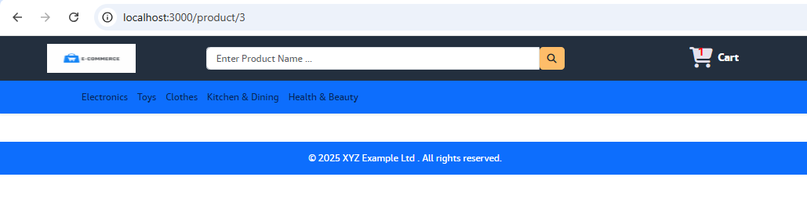

**ADDING SEARCH TO PRODUCT API**

**In Backend,**

**ProductsRepository.java**

|  |
| --- |
| **@Repository**  **public interface ProductsRepository extends JpaRepository<Products, Long>{**  **public boolean existsByProductNameIgnoreCase(String productName);**  **List<Products> findByProductNameContainingIgnoreCase(String keyword);**  **}** |

**ProductService.java**

|  |
| --- |
| **package com.hcl.springecomapp.service;**  **public interface ProductService {**  **….**  **public List<ProductDTO> searchProductByKeyword(String keyword);**  **….**  **}** |

**ProductServiceImpl.java**

|  |
| --- |
| **public List<ProductDTO> searchProductByKeyword(String keyword) {**  **List<Products> products = productRepository.findByProductNameContainingIgnoreCase(keyword);**  **return products.stream()**  **.map(product -> modelMapper.map(product, ProductDTO.class))**  **.collect(Collectors.*toList*());**  **}** |

**ProductsController.java**

|  |
| --- |
| **@GetMapping("/public/products/search")**  **public ResponseEntity<List<ProductDTO>> searchProducts(@RequestParam("keyword") String keyword) {**  **List<ProductDTO> result = productService.searchProductByKeyword(keyword);**  **return ResponseEntity.*ok*(result);**  **}** |

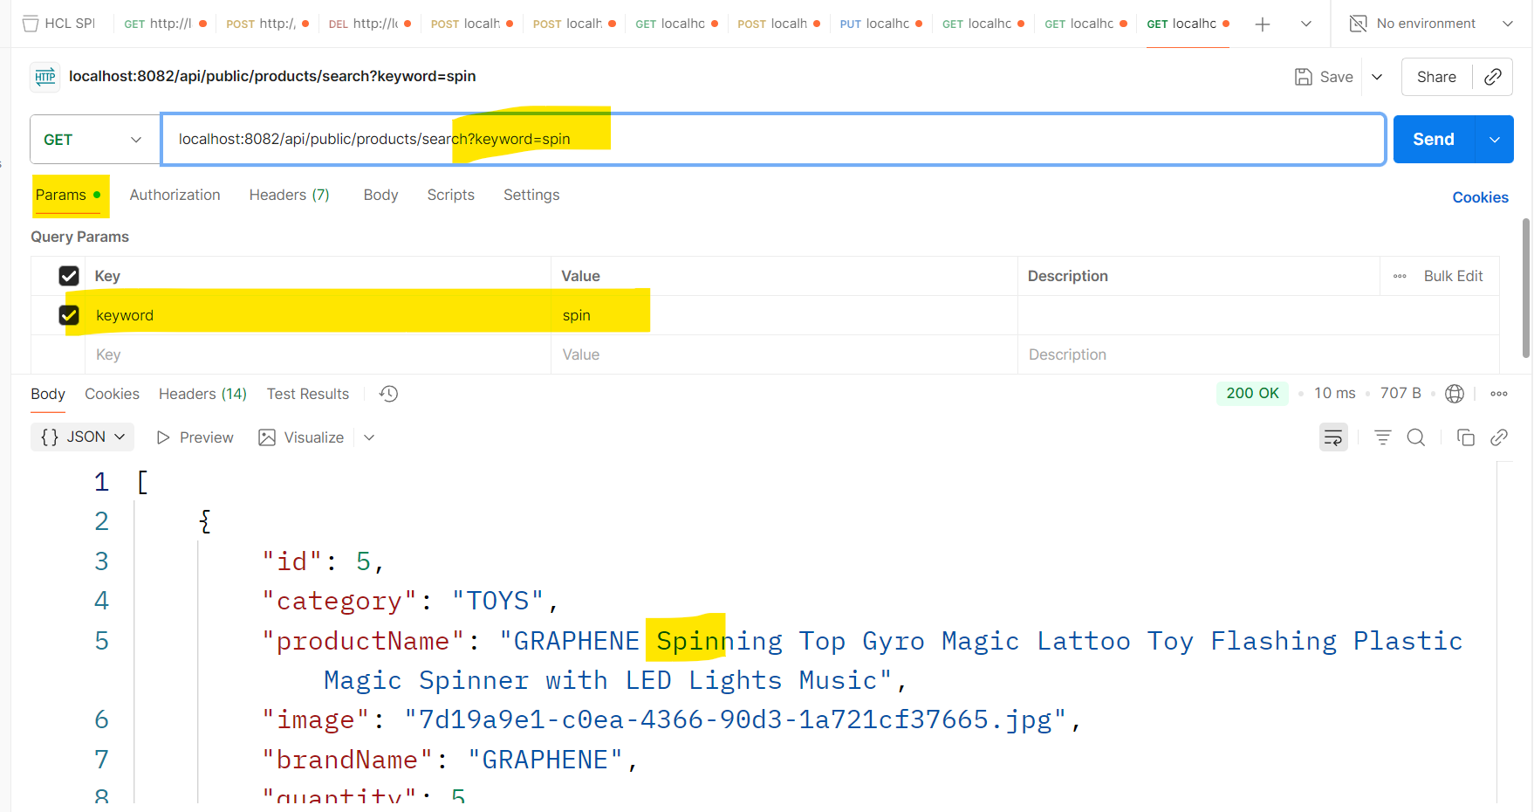

**In React,**

**Create a new Search Component**

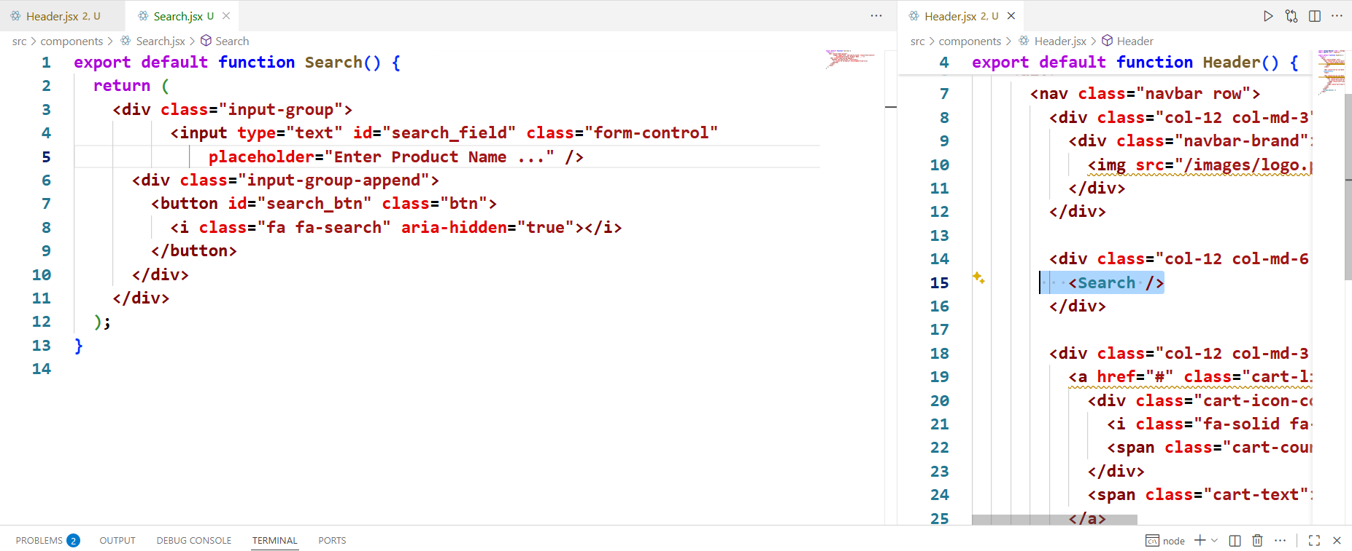

**Search.jsx**

|  |
| --- |
| **export default function Search() {**  **return (**  **<div class="input-group">**  **<input type="text" id="search_field" class="form-control"**  **placeholder="Enter Product Name ..." />**  **<div class="input-group-append">**  **<button id="search_btn" class="btn">**  **<i class="fa fa-search" aria-hidden="true"></i>**  **</button>**  **</div>**  **</div>**  **);**  **}** |

**Header.jsx**

|  |
| --- |
| **import CategoryNavbar from "./CategoryNavbar";**  **import Search from "./Search";**  **export default function Header() {**  **return (**  **<div>**  **<nav class="navbar row">**  **…..**  **<div class="col-12 col-md-6 mt-2 mt-md-0">**  **<Search />**  **</div>**  **……..**  **<CategoryNavbar />**  **</div>**  **);**  **}** |

**NOW GO TO Search component**

**Search.jsx**

|  |
| --- |
| **import { useState } from "react";**  **import { useNavigate } from "react-router-dom";**  **export default function Search() {**  **const [keyword, setKeyword] = useState("");**  **const navigate = useNavigate();**  **const searchHandler = () => {**  **navigate("/search?keyword=" + keyword);**  **};**  **return (**  **<div class="input-group">**  **<input type="text"  id="search_field" class="form-control"**  **onChange={(e) => setKeyword(e.target.value)}**  **onBlur={searchHandler} {/* will get back to home page if keyword in serch box removed */}**  **placeholder="Enter Product Name ..."**  **/>**  **<div class="input-group-append">**  **<button id="search_btn" class="btn" onClick={searchHandler}>**  **<i class="fa fa-search" aria-hidden="true"></i>**  **</button>**  **</div>**  **</div>**  **);**  **}** |

**App.js**

|  |
| --- |
| **import "./App.css";**  **import Home from "./pages/Home";**  **import Footer from "./components/Footer";**  **import Header from "./components/Header";**  **import { BrowserRouter as Router, Routes, Route } from "react-router-dom";**  **function App() {**  **return (**  **<div className="App">**  **<Router>**  **<div>**  **<Header />**  **<Routes>**  **<Route path="/" element={<Home />} />**  **<Route path="/search" element={<Home />} />**  **</Routes>**  **</div>**  **</Router>**  **<Footer />**  **</div>**  **);**  **}**  **export default App;** |

**Home.jsx**

|  |
| --- |
| **import { Fragment } from "react/jsx-runtime";**  **import ProductCard from "../components/ProductCard";**  **import { useEffect, useState } from "react";**  **import { useSearchParams } from "react-router-dom";**  **export default function Home() {**  **const [products, setProducts] = useState([]);**  **const [searchParams, setSearchParams] = useSearchParams();**  **useEffect(() => {**  **fetch(process.env.REACT_APP_API_URL + "/public/products")**  **.then((res) => res.json())**  **.then((data) => setProducts(data))**  **.catch((err) => console.error(err));**  **}, []);**  **useEffect(() => {**  **const queryString = searchParams.toString(); // "keyword=abc"**  **if (!queryString) return; // skip if no search**  **fetch(`${process.env.REACT_APP_API_URL}/public/products/search?${queryString}`)**  **.then((res) => res.json())**  **.then((data) => {**  **if (Array.isArray(data)) setProducts(data);**  **else setProducts([]);**  **})**  **.catch((err) => console.error(err));**  **}, [searchParams]);**  **return (**  **<Fragment>**  **<h1 id="products_heading">Latest Products</h1>**  **<section id="products" class="container mt-5">**  **<div className="row">**  **{products.map((pr) => (**  **<ProductCard key={pr.id} product={pr} />**  **))}**  **</div>**  **</section>**  **</Fragment>**  **);**  **}** |

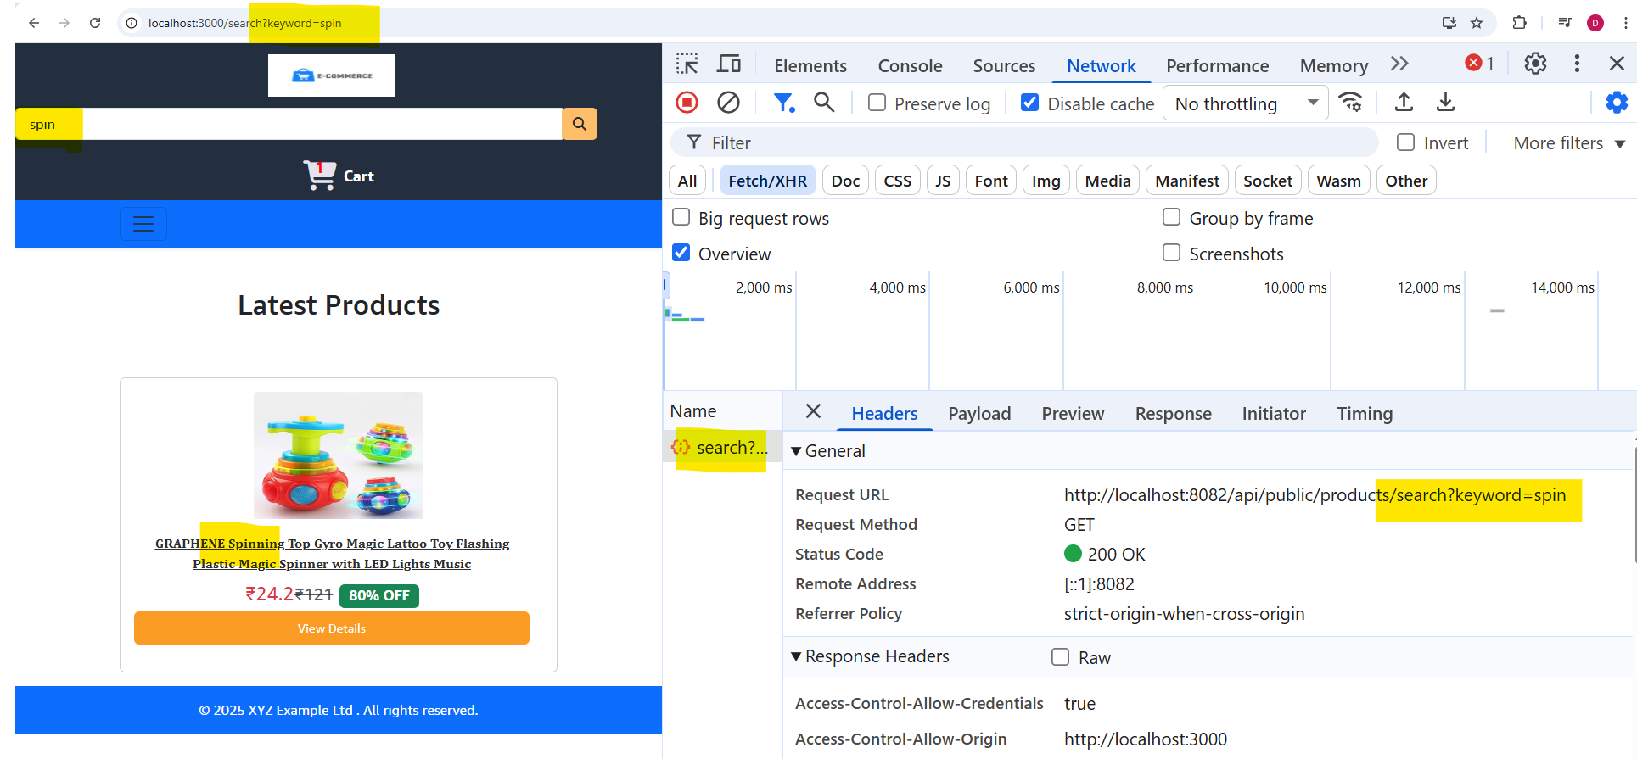

**After searching, When you click the logo, we need to be redirected to home page**

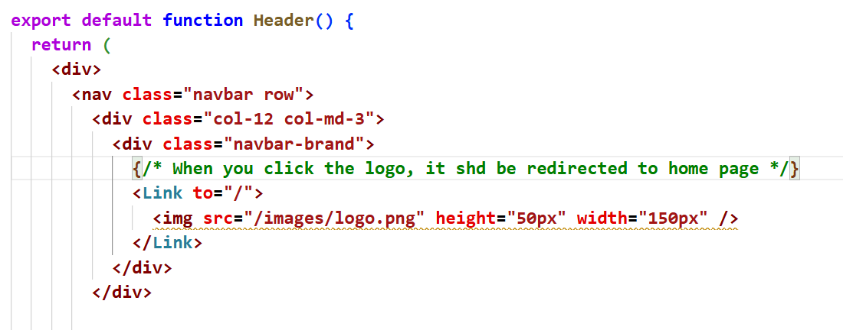

**Header.jsx**

|  |
| --- |
| **<Link to="/">**  **<img src="/images/logo.png" height="50px" width="150px" />**  **</Link>** |

**CLICK ON THE PRODUCT TO VIEW THE PRODUCTDETAILS PAGE**

**Create a ProductDetails.jsx in pages folder. Paste the template and create a path in App.js to check , after clicking the productdetails page should be opened**

**ProductDetails.jsx**

|  |
| --- |
| **export default function ProductDetails() {**  **return (**  **<div>**  **<div class="container container-fluid">**  **<div class="row f-flex justify-content-around">**  **<div class="col-12 col-lg-5 img-fluid" id="product_image">**  **<img src="/images/products/3.jpg" alt="sdf" height="500" width="500" />**  **</div>**  **<div class="col-12 col-lg-5 mt-5">**  **<h3>Dell Inspiron 3511 Laptop, Intel i3-1115G4, 8GB, 512GB</h3>**  **<p id="product_id">Product # 387874kkfjkf</p>**  **<hr />**  **<div class="rating-outer">**  **<div class="rating-inner"></div>**  **</div>**  **<hr />**  **<p id="product_price">$456.00</p>**  **<div class="stockCounter d-inline">**  **<span class="btn btn-danger minus">-</span>**  **<input type="number" class="form-control count d-inline" value="1" readOnly />**  **<span class="btn btn-primary plus">+</span>**  **</div>**  **<button type="button" id="cart_btn" class="btn btn-primary d-inline ml-4">**  **Add to Cart**  **</button>**  **<hr />**  **<p>**  **Status: <span id="stock_status">In Stock</span>**  **</p>**  **<hr />**  **<h4 class="mt-2">Description:</h4>**  **<p>**  **Processor: Intel i5-1235U (3.30 GHz up to 4.40 GHz), 10 Cores & 12MB Cache RAM & Storage: 8GB, 8Gx1, DDR4, 2666MHz Ach & 512GB**  **SSD Display & Graphics: 15.6" FHD WVA AG 120Hz 250 nits Narrow Border & Integrated Graphics**  **</p>**  **<hr />**  **<p id="product_seller mb-3">**  **Sold by: <strong>Amazon</strong>**  **</p>**  **<div class="rating w-50"></div>**  **</div>**  **</div>**  **</div>**  **</div>**  **);**  **}** |

**App.js**

|  |
| --- |
| **<Routes>**  **<Route path="/" element={<Home />} />**  **<Route path="/search" element={<Home />} />**  **<Route path="/product/:id" element={<ProductDetails />} />**  **</Routes>** |

**Now Routing in URL is enabled**

**In ProductDetails.jsx, fetch a particular product based on the id in the URL**

|  |
| --- |
| **import { useEffect, useState } from "react";**  **import { useParams } from "react-router-dom";**  **export default function ProductDetails() {**  **const [product, setProduct] = useState(null);**  **const { id } = useParams();**  **useEffect(() => {**  **fetch(process.env.REACT_APP_API_URL + "/products/" + id)**  **.then((res) => res.json())**  **.then((data) => setProduct(data))**  **.catch((err) => console.error(err));**  **}, [id]);**  **return ( ……….**  **);** |

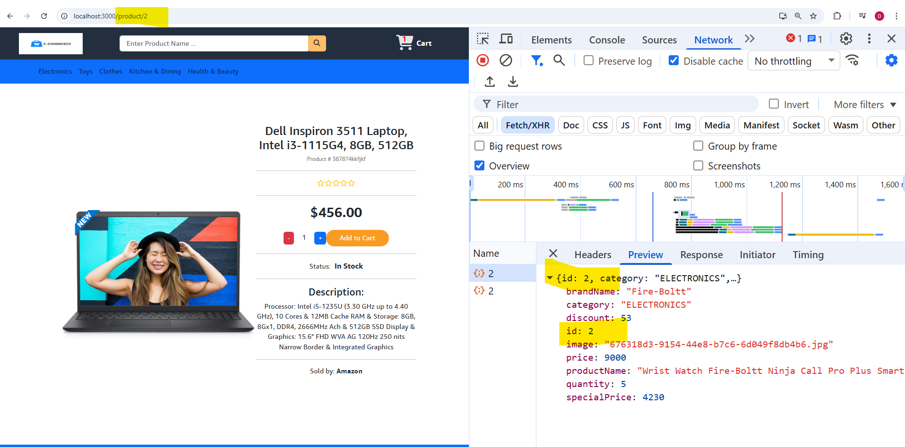

**Now map the values in the respective elements in the template**

**ProductDetails.jsx finally will be like this.**

|  |
| --- |
| **import { useEffect, useState } from "react";**  **import { useParams } from "react-router-dom";**  **export default function ProductDetails() {**  **const [product, setProduct] = useState(null);**  **const { id } = useParams();**  **useEffect(() => {**  **fetch(process.env.REACT_APP_API_URL + "/products/" + id)**  **.then((res) => res.json())**  **.then((data) => {**  **console.log(data);**  **setProduct(data);**  **})**  **.catch((err) => console.error(err));**  **}, [id]);**  **if (!product) {**  **return <h2 className="text-center mt-5">Loading...</h2>;**  **}**  **const imageUrl =**  **product.image && product.image.length > 0 ? `${process.env.REACT_APP_API_URL}/products/image/${product.image}` : "/images/noimage.jpg"; // fallback image**  **return (**  **<div>**  **<div class="container container-fluid">**  **<div class="row f-flex justify-content-around">**  **<div class="col-12 col-lg-5 img-fluid" id="product_image">**  **<img src={imageUrl} alt="/images/noimage.jpg" height="500" width="500" />**  **</div>**  **<div class="col-12 col-lg-5 mt-5">**  **<h3>{product.productName}</h3>**  **<p id="product_id">Product # {product.id}</p>**  **<hr />**  **<p class="card-text mb-1">**  **<span id="product_price" class="card-text text-danger font-weight-bold">**  **₹{product.specialPrice}**  **</span>**  **<small class="text-muted">**  **<del>₹{product.price}</del>**  **</small>**  **<span class="badge bg-success ms-2">{product.discount}% OFF</span>**  **</p>**  **<div class="stockCounter d-inline">**  **<span class="btn btn-danger minus">-</span>**  **<input type="number" class="form-control count d-inline" value="1" readOnly />**  **<span class="btn btn-primary plus">+</span>**  **</div>**  **<button type="button" id="cart_btn" class="btn btn-primary d-inline ml-4">**  **Add to Cart**  **</button>**  **<hr />**  **<p>**  **Status: <span id="stock_status">In Stock</span>**  **</p>**  **<hr />**  **<h4 class="mt-2">Description:</h4>**  **<p>**  **Lorem ipsum dolor sit amet, consectetur adipiscing elit. Vestibulum id enim non justo hendrerit maximus ac nec sem.**  **Pellentesque feugiat ante at neque tristique, eget pulvinar ex ornare. Nulla facilisi. Integer cursus congue enim ut commodo.**  **Donec aliquam mattis velit, sit amet bibendum justo egestas interdum. Duis volutpat dolor est, sit amet sagittis libero**  **interdum eleifend.**  **</p>**  **<hr />**  **<p id="product_seller mb-3">**  **Sold by: <strong>Amazon</strong>**  **</p>**  **<div class="rating w-50"></div>**  **</div>**  **</div>**  **</div>**  **</div>**  **);**  **}** |

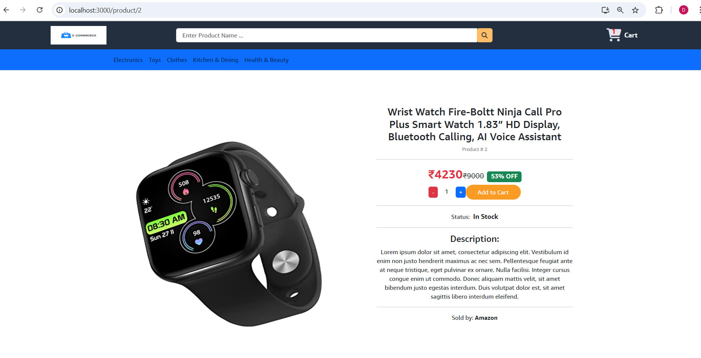

**Now focus on Stock status. InStock or Out of Stock**

**ProductDetails.jsx**

|  |
| --- |
| **<p>**  **Status:{" "}**  **<span id="stock_status" class={product.quantity > 0 ? "text-success" : "text-danger"}>**  **{product.quantity > 0 ? "In Stock" : "Out of Stock"}**  **</span>**  **</p>** |

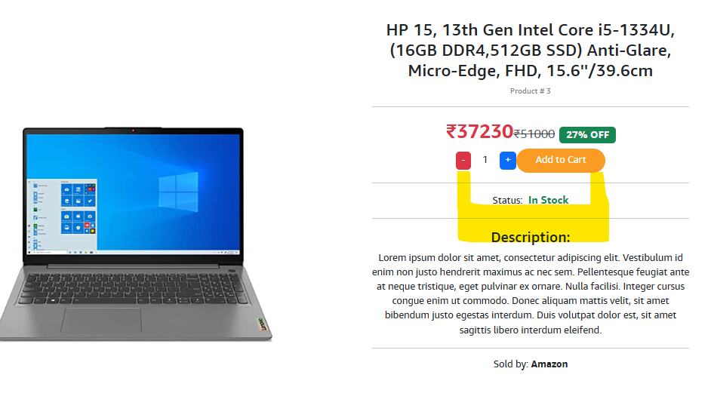 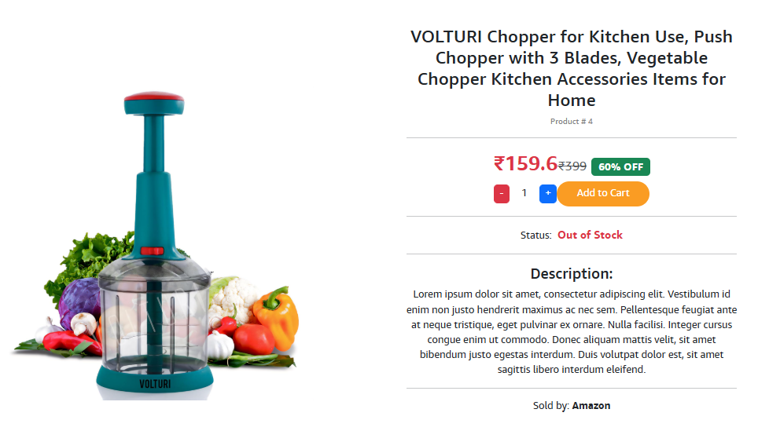

**ADD TO CART FUNCTIONALITY**

**Go to App.js, this is the page where all the components are loaded. So this plays a major role in Add to Cart functionality.**

**Create a state here using useState();**

**We need to send the cartitems to header component , where cart is displayed. So send the cartItems as props to the Header component.**

**App.js**

|  |
| --- |
| **function App() {**  **const [cartItems, setCartItems] = useState([]);**  **return (**  **<div className="App">**  **<Router>**  **<div>**  **<Header cartItems={cartItems} />**  **<Routes>**  **<Route path="/" element={<Home />} />**  **<Route path="/search" element={<Home />} />**  **<Route path="/product/:id" element={<ProductDetails />} />**  **</Routes>**  **</div>**  **</Router>**  **<Footer />**  **</div>**  **);**  **}** |

**In Header.jsx, pass the props and change the static data in span tag. Get the length of cartItems array, which is 0 by default. Observe in the cart**

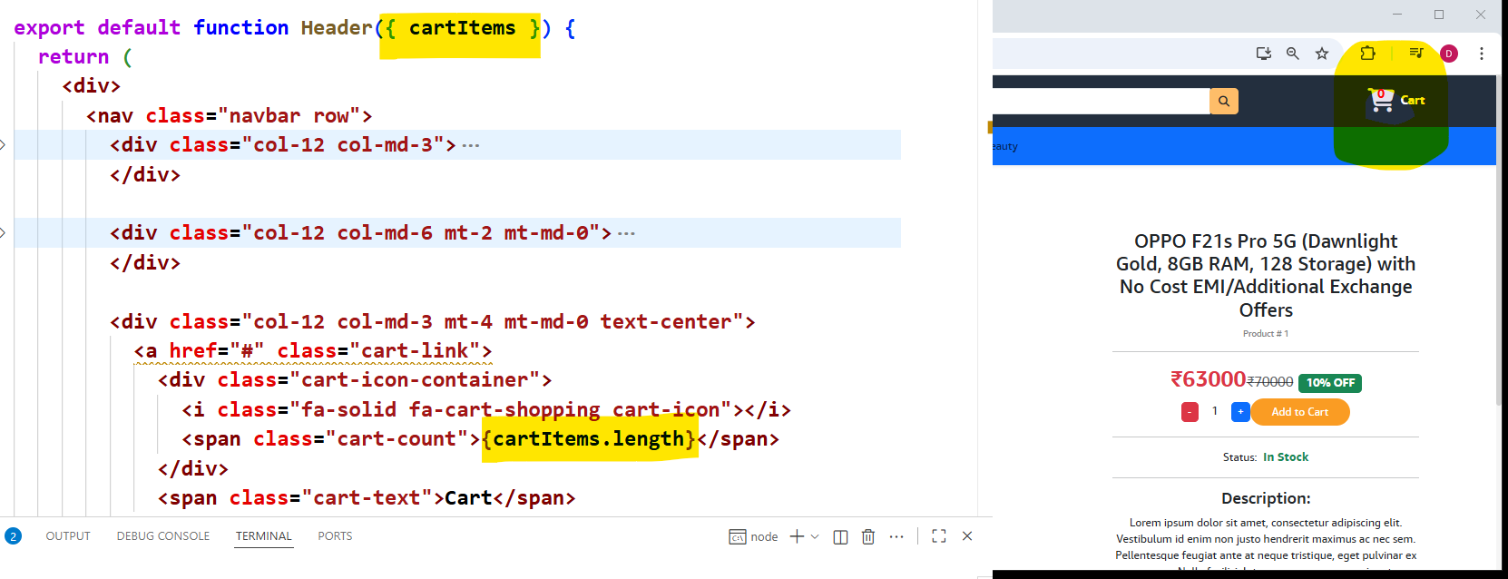

**We actually change the cartItems in the ProductDetails page. So pass the cartItems and setCartItems in the ProductDetails in App.js**

|  |
| --- |
| **<Routes>**  **<Route path="/" element={<Home />} />**  **<Route path="/search" element={<Home />} />**  **<Route path="/product/:id" element={<ProductDetails cartItems={cartItems} setCartItems={setCartItems} />} />**  **</Routes>** |

**ProductDetails.jsx**

1. **In AddToCart button, create a handler function**
2. **Create that function addToCart**
3. **Create the props cartItems, setCartItems in ProductDetails.**
4. **Create a state for qty and assign it in the template**
5. **In addToCart(), set the cartItems using setCartItems. Get the previous state, along with that add the new item.** When clicking **Add to Cart**, the product should be added only once—if it already exists in the cart, only its quantity should increase instead of creating duplicate entries.
6. **So add a if condition and restrict it, so that the product added only once, if it already exists. Use find function in JS to find the items existence in the cart**

|  |
| --- |
| **import { useEffect, useState } from "react";**  **import { useParams } from "react-router-dom";**  **export default function ProductDetails({ cartItems, setCartItems }) {**  **const [product, setProduct] = useState(null);**  **const [qty, setQty] = useState(1);**  **const { id } = useParams();**  **useEffect(() => {**  **fetch(process.env.REACT_APP_API_URL + "/products/" + id)**  **.then((res) => res.json())**  **.then((data) => {**  **console.log(data);**  **setProduct(data);**  **})**  **.catch((err) => console.error(err));**  **}, [id]);**  **if (!product) {**  **return <h2 className="text-center mt-5">Loading...</h2>;**  **}**  **const imageUrl =**  **product.image && product.image.length > 0 ? `${process.env.REACT_APP_API_URL}/products/image/${product.image}` : "/images/noimage.jpg"; // fallback image**  **function addToCart() {**  **const newItem = { product, qty };**  **setCartItems((state) => […state , newItem]);**  **}**  **return (**  **<div>**  **<div class="container container-fluid">**  **<div class="row f-flex justify-content-around">**  **<div class="col-12 col-lg-5 img-fluid" id="product_image">**  **<img src={imageUrl} alt="/images/noimage.jpg" height="500" width="500" />**  **</div>**  **<div class="col-12 col-lg-5 mt-5">**  **<h3>{product.productName}</h3>**  **<p id="product_id">Product # {product.id}</p>**  **<hr />**  **<p class="card-text mb-1">**  **<span id="product_price" class="card-text text-danger font-weight-bold">**  **₹{product.specialPrice}**  **</span>**  **<small class="text-muted">**  **<del>₹{product.price}</del>**  **</small>**  **<span class="badge bg-success ms-2">{product.discount}% OFF</span>**  **</p>**  **<div class="stockCounter d-inline">**  **<span class="btn btn-danger minus">-</span>**  **<input type="number" class="form-control count d-inline" value={qty} readOnly />**  **<span class="btn btn-primary plus">+</span>**  **</div>**  **<button onClick={addToCart} type="button" id="cart_btn" class="btn btn-primary d-inline ml-4">**  **Add to Cart**  **</button>**  **<hr />**  **<p>**  **Status:**  **<span id="stock_status" class={product.quantity > 0 ? "text-success" : "text-danger"}>**  **{product.quantity > 0 ? "In Stock" : "Out of Stock"}**  **</span>**  **</p>**  **<hr />**  **<h4 class="mt-2">Description:</h4>**  **<p>**  **Lorem ipsum dolor sit amet, consectetur adipiscing elit. Vestibulum id enim non justo hendrerit maximus ac nec sem.**  **Pellentesque feugiat ante at neque tristique, eget pulvinar ex ornare. Nulla facilisi. Integer cursus congue enim ut commodo.**  **Donec aliquam mattis velit, sit amet bibendum justo egestas interdum. Duis volutpat dolor est, sit amet sagittis libero**  **interdum eleifend.**  **</p>**  **<hr />**  **<p id="product_seller mb-3">**  **Sold by: <strong>Amazon</strong>**  **</p>**  **<div class="rating w-50"></div>**  **</div>**  **</div>**  **</div>**  **</div>**  **);**  **}** |

**Check for the existence of product in the cart and restrict it. C**

|  |
| --- |
| **function addToCart() {**  **const itemsExists = cartItems.find((item) => item.product.id == product.id);**  **if (!itemsExists) {**  **const newItem = { product, qty };**  **setCartItems((state) => [...state, newItem]);**  **}**  **}** |

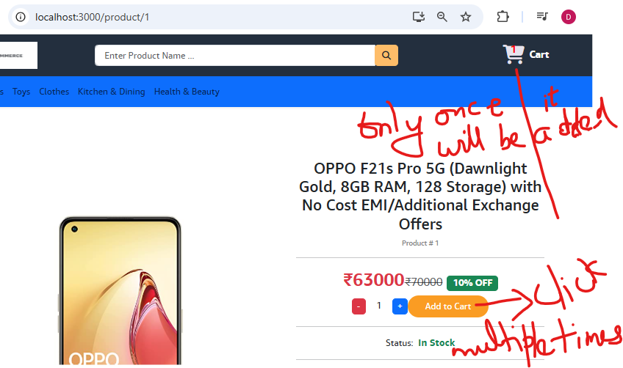 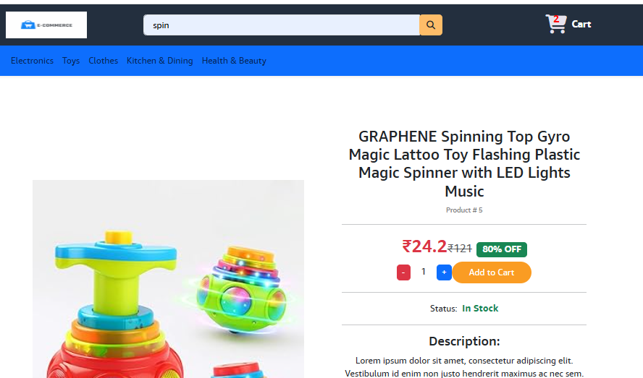

**Add once more product from different page and check , it will be added.**

**Showing TOAST message. (instead of looking at the cart)**

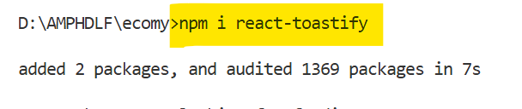

[**https://fkhadra.github.io/react-toastify/introduction/**](https://fkhadra.github.io/react-toastify/introduction/) **=🡺 Documentation for Code**

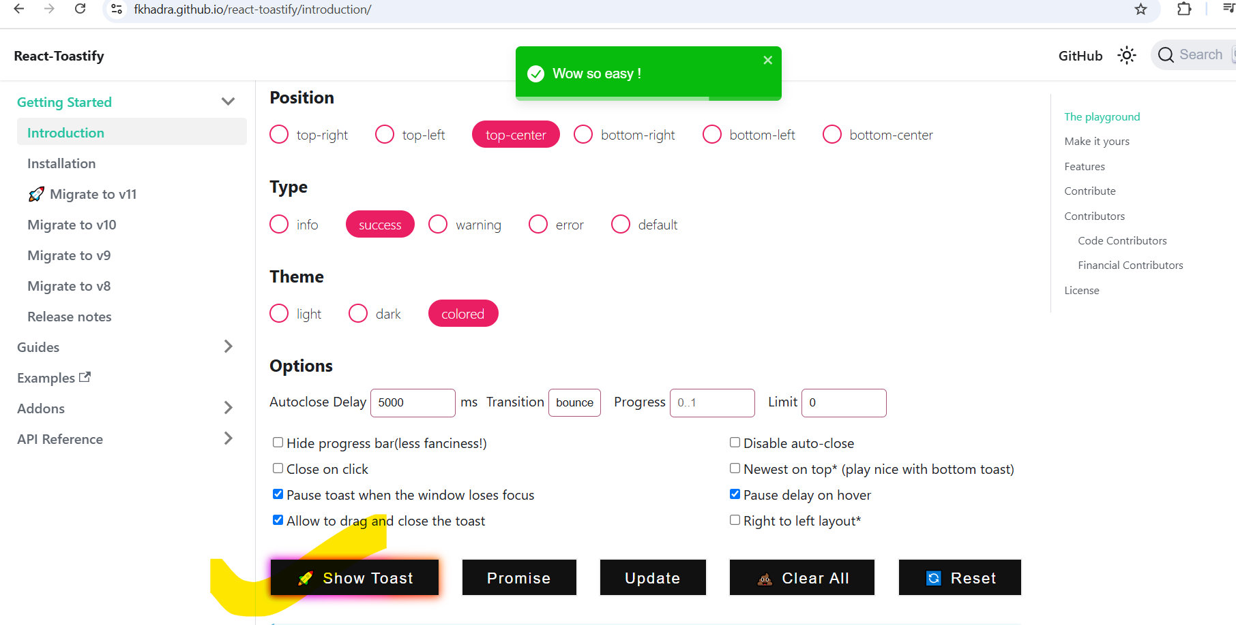

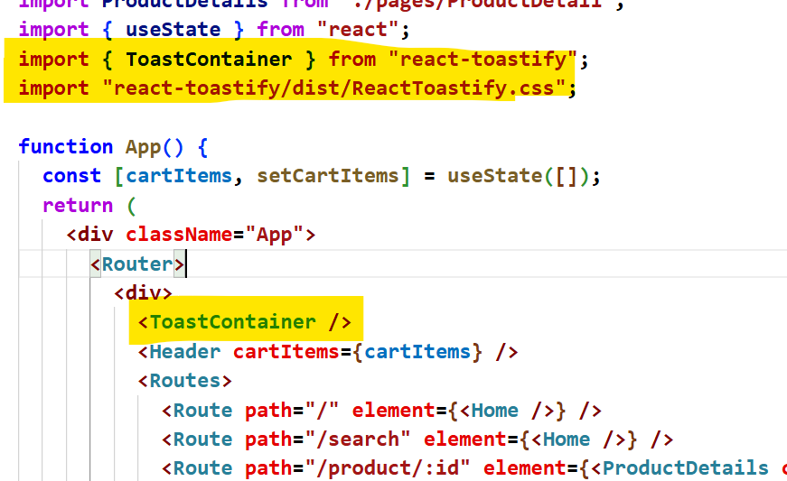

**ProductDetails.jsx**

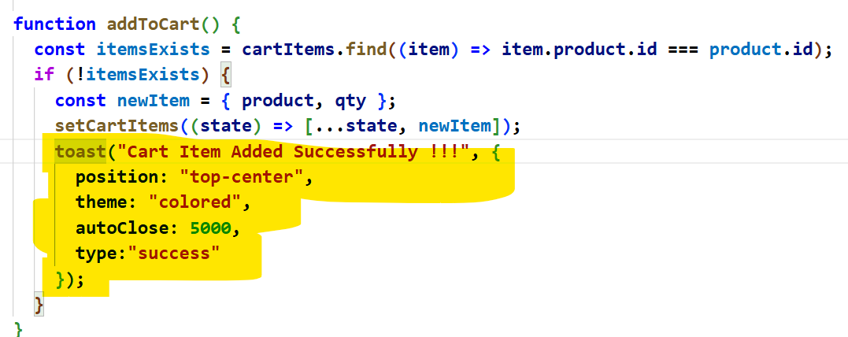

|  |
| --- |
| **function addToCart() {**  **const itemsExists = cartItems.find((item) => item.product.id === product.id);**  **if (!itemsExists) {**  **const newItem = { product, qty };**  **setCartItems((state) => [...state, newItem]);**  **toast("Cart Item Added Successfully !!!", {**  **position: "top-center",**  **theme: "colored",**  **autoClose: 5000,**  **type:"success"**  **});**  **}**  **}** |

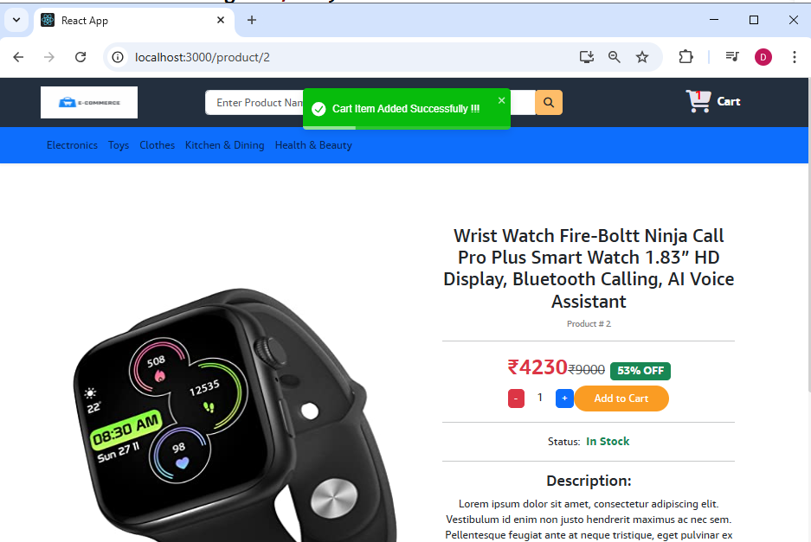

**INCREASE AND DECREASE CART ITEMS**

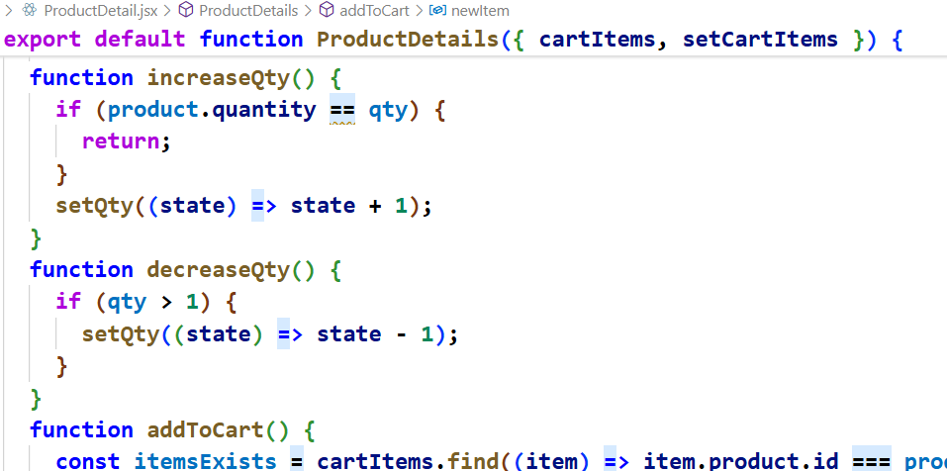

**ProductDetails.jsx**

|  |
| --- |
| **function increaseQty() {**  **if (product.quantity == qty) {**  **return;**  **}**  **setQty((state) => state + 1);**  **}**  **function decreaseQty() {**  **if (qty > 1) {**  **setQty((state) => state - 1);**  **}**  **}**  **……**  **<div class="stockCounter d-inline">**  **<span class="btn btn-danger minus" onClick={decreaseQty}>**  **-**  **</span>**  **{/* <input type="number" class="form-control count d-inline" value="1" readOnly /> */}**  **<input type="number" class="form-control count d-inline" value={qty} readOnly />**  **<span class="btn btn-primary plus" onClick={increaseQty}>**  **+**  **</span>**  **</div>** |

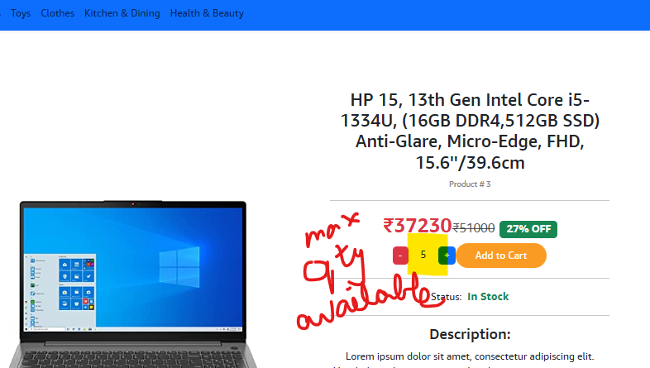

**DISABLE THE ADD TO CART BUTTON IF THE PRODUCT IS OUT OF STOCK**

**ProductDetails.jsx**

|  |
| --- |
| **<button onClick={addToCart} disabled={product.quantity == 0} type="button" id="cart_btn" class="btn btn-primary d-inline ml-4">**  **Add to Cart**  **</button>** |

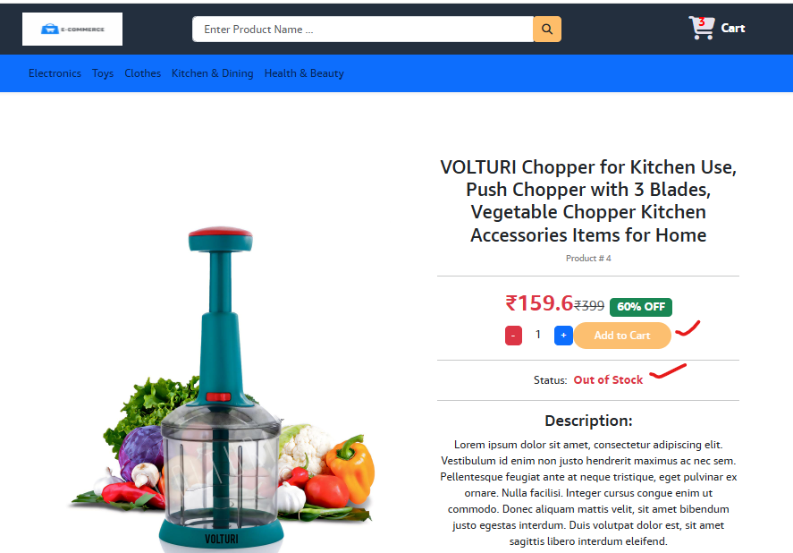

**CREATING CART PAGE**

1. **Create a new Component Cart.jsx in pages folder. (template available)**
2. **Create a route in App.jsx**
3. **Create a <Link> in Header.jsx**

**Cart.jsx**

|  |
| --- |
| **export default function Cart() {**  **return (**  **<div class="container container-fluid">**  **<h2 class="mt-5">**  **Your Cart: <b>2 items</b>**  **</h2>**  **<div class="row d-flex justify-content-between">**  **<div class="col-12 col-lg-8">**  **<hr />**  **<div class="cart-item">**  **<div class="row">**  **<div class="col-4 col-lg-3">**  **<img src="/images/products/1.jpg" alt="Laptop" height="90" width="115" />**  **</div>**  **<div class="col-5 col-lg-3">**  **<a href="#">OPPO F21s Pro 5G (Dawnlight Gold, 8GB RAM, 128 Storage) with No Cost EMI/Additional Exchange Offers</a>**  **</div>**  **<div class="col-4 col-lg-2 mt-4 mt-lg-0">**  **<p id="card_item_price">$245.67</p>**  **</div>**  **<div class="col-4 col-lg-3 mt-4 mt-lg-0">**  **<div class="stockCounter d-inline">**  **<span class="btn btn-danger minus">-</span>**  **<input type="number" class="form-control count d-inline" value="1" readOnly />**  **<span class="btn btn-primary plus">+</span>**  **</div>**  **</div>**  **<div class="col-4 col-lg-1 mt-4 mt-lg-0">**  **<i id="delete_cart_item" class="fa fa-trash btn btn-danger"></i>**  **</div>**  **</div>**  **</div>**  **<hr />**  **</div>**  **<div class="col-12 col-lg-3 my-4">**  **<div id="order_summary">**  **<h4>Order Summary</h4>**  **<hr />**  **<p>**  **Subtotal: <span class="order-summary-values">1 (Units)</span>**  **</p>**  **<p>**  **Est. total: <span class="order-summary-values">$245.67</span>**  **</p>**  **<hr />**  **<button id="checkout_btn" class="btn btn-primary btn-block">**  **Place Order**  **</button>**  **</div>**  **</div>**  **</div>**  **</div>**  **);**  **}** |

**App.jsx**

|  |
| --- |
| **<Routes>**  **<Route path="/" element={<Home />} />**  **<Route path="/search" element={<Home />} />**  **<Route path="/product/:id" element={<ProductDetails cartItems={cartItems} setCartItems={setCartItems} />} />**  **<Route path="/cart" element={<Cart cartItems={cartItems} setCartItems={setCartItems} />} />**  **</Routes>** |

**Header.jsx**

|  |
| --- |
| **<nav>**  **……..**  **<div class="col-12 col-md-3 mt-4 mt-md-0 text-center">**  **{/* <a href="#" "> */}**  **<Link to={"/cart"}>**  **<div class="cart-icon-container cart-link">**  **<i class="fa-solid fa-cart-shopping cart-icon"></i>**  **<span class="cart-count">{cartItems.length}</span>**  **</div>**  **<span class="cart-text">Cart</span>**  **</Link>**  **{/* </a> */}**  **</div>**  **</nav>** |

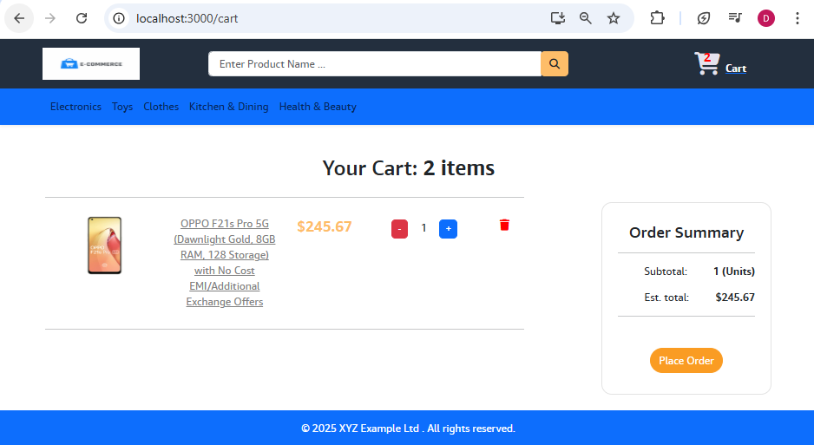

**When you click on the cart icon, it is redirected to Cart component Now. Render the values now**

**SHOWING CART LIST**

**In Cart.jsx, lookout for a div with class cart-items, make it available within a <Fragment> tag**

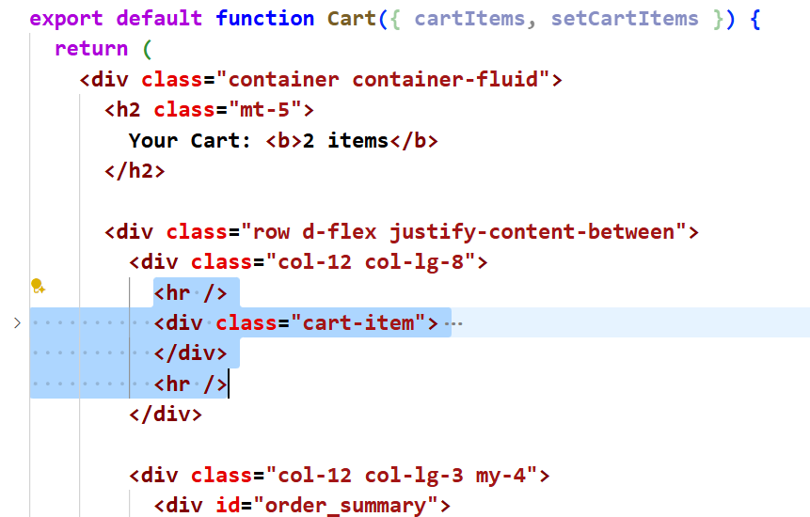 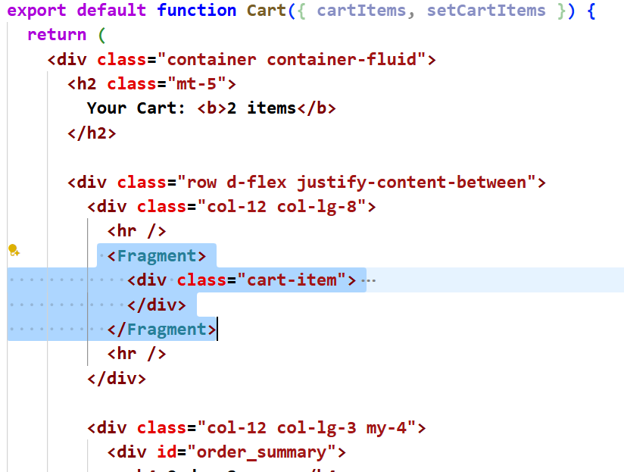

**Now Loop it through all the items,**

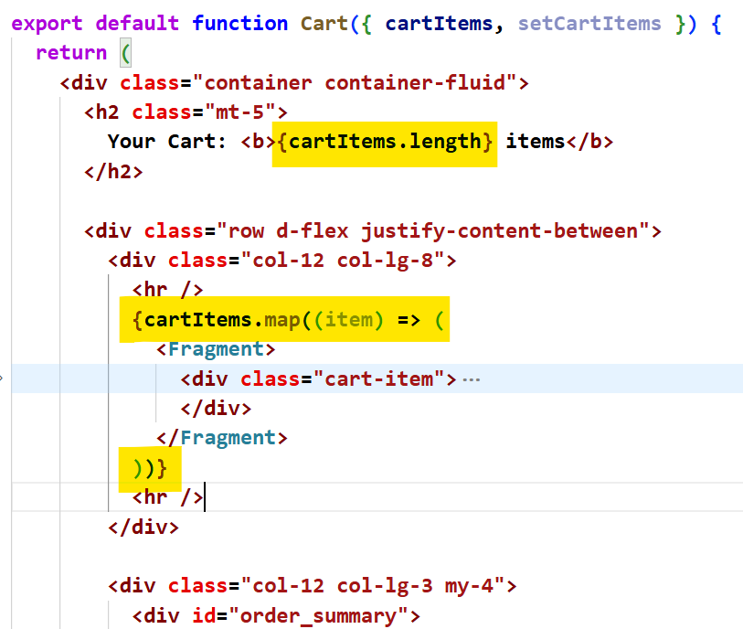

**{cartItems.map((item) => (**

**<Fragment>**

**<div class="cart-item">**

**….**

**</div>**

**</Fragment>**

**))}**

**Now make the data dynamic in the template.**

**Cart.jsx**

|  |
| --- |
| **import { Fragment } from "react";**  **import { Link } from "react-router-dom";**  **export default function Cart({ cartItems, setCartItems }) {**  **return (**  **<div className="container container-fluid">**  **<h2 className="mt-5">**  **Your Cart: <b>{cartItems.length} items</b>**  **</h2>**  **<div className="row d-flex justify-content-between">**  **<div className="col-12 col-lg-8">**  **<hr />**  **{cartItems.map((item) => {**  **const imageUrl =**  **item.product.image && item.product.image.length > 0**  **? `${process.env.REACT_APP_API_URL}/products/image/${item.product.image}`**  **: "/images/noimage.jpg"; // fallback image**  **return (**  **<Fragment>**  **<div className="cart-item">**  **<div className="row">**  **<div className="col-4 col-lg-3">**  **<img src={imageUrl} alt="/images/noimage.jpg" height="90" width="115" />**  **</div>**  **<div className="col-5 col-lg-3">**  **{/* <a href="#">{item.product.productName}</a> */}**  **<Link to={"/product/" + item.product.id}>{item.product.productName}</Link>**  **</div>**  **<div className="col-4 col-lg-2 mt-4 mt-lg-0">**  **<p id="card_item_price">₹{item.product.specialPrice}</p>**  **</div>**  **<div className="col-4 col-lg-3 mt-4 mt-lg-0">**  **<div className="stockCounter d-inline">**  **<span className="btn btn-danger minus">-</span>**  **<input type="number" className="form-control count d-inline" value={item.qty} readOnly />**  **<span className="btn btn-primary plus">+</span>**  **</div>**  **</div>**  **<div className="col-4 col-lg-1 mt-4 mt-lg-0">                      <i id="delete_cart_item" className="fa fa-trash btn btn-danger"></i>**  **</div>**  **</div>**  **</div>**  **</Fragment>**  **);**  **})}**  **<hr />**  **</div>**  **<div className="col-12 col-lg-3 my-4">**  **<div id="order_summary">**  **<h4>Order Summary</h4>**  **<hr />**  **<p>**  **Subtotal: <span className="order-summary-values">1 (Units)</span>**  **</p>**  **<p>**  **Est. total: <span className="order-summary-values">$245.67</span>**  **</p>**  **<hr />**  **<button id="checkout_btn" className="btn btn-primary btn-block">**  **Place Order**  **</button>**  **</div>**  **</div>**  **</div>**  **</div>**  **);**  **}** |

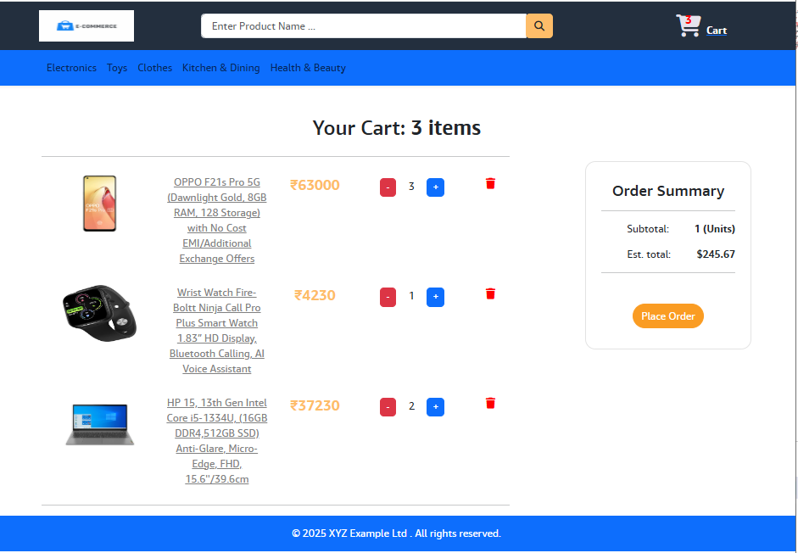

**Items in the cart displays properly. Now we need to focus on + and – operation, delete operation, order summary.**

**INCREASE AND DECREASE QUANTITY OF ITEMS IN THE CART PAGE**

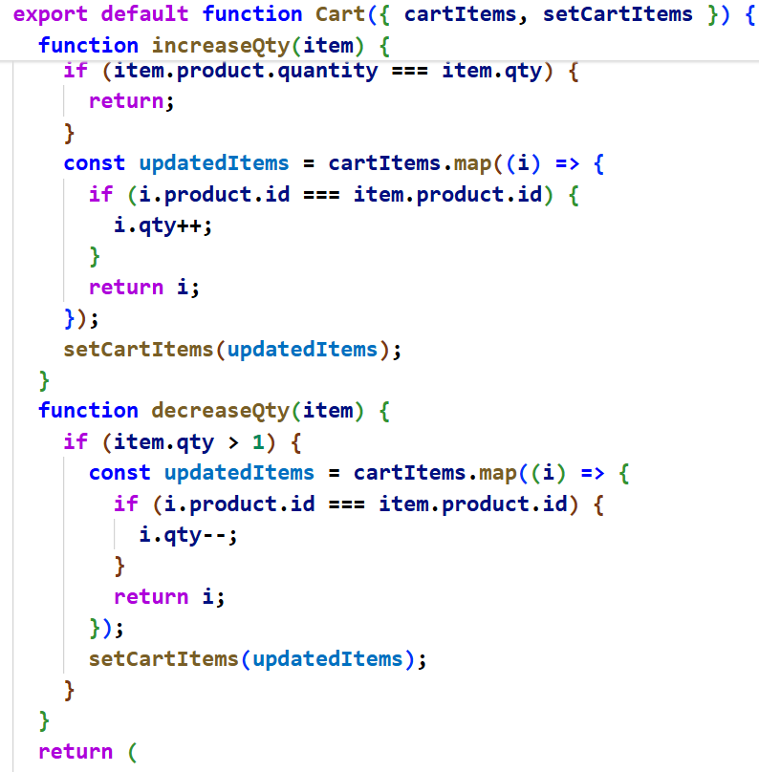

**Cart.jsx**

|  |
| --- |
| **function increaseQty(item) {**  **if (item.product.quantity === item.qty) {**  **return;**  **}**  **const updatedItems = cartItems.map((i) => {**  **if (i.product.id === item.product.id) {**  **i.qty++;**  **}**  **return i;**  **});**  **setCartItems(updatedItems);**  **}**  **function decreaseQty(item) {**  **if (item.qty > 1) {**  **const updatedItems = cartItems.map((i) => {**  **if (i.product.id === item.product.id) {**  **i.qty--;**  **}**  **return i;**  **});**  **setCartItems(updatedItems);**  **}**  **}**  **……**  **<div className="col-4 col-lg-3 mt-4 mt-lg-0">**  **<div className="stockCounter d-inline">**  **<span className="btn btn-danger minus" onClick={() => decreaseQty(item)}>**  **-**  **</span>**  **<input type="number" className="form-control count d-inline" value={item.qty} readOnly />**  **<span className="btn btn-primary plus" onClick={() => increaseQty(item)}>**  **+**  **</span>**  **</div>**  **</div>** |

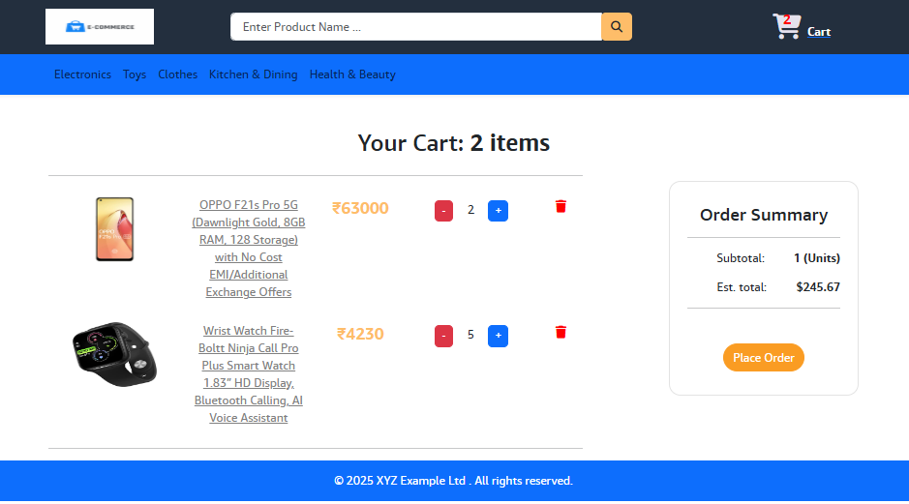

**REMOVE CART ITEMS**

**Add the following function in Cart.jsx**

|  |
| --- |
| **function removeItemFromCart(item) {**  **const updatedItems = cartItems.filter((i) => {**  **if (i.product.id !== item.product.id) {**  **return true;**  **}**  **});**  **setCartItems(updatedItems);**  **}**  **……….**  **<div className="col-4 col-lg-1 mt-4 mt-lg-0">**  **<i id="delete_cart_item" onClick={() => removeItemFromCart(item)}**  **className="fa fa-trash btn btn-danger"></i>**  **</div>** |

**If you have deleted all the items , it should not show**

**Cart has 0 items and Order Summary section. So put the div in a <Fragment> and use Ternary operator**

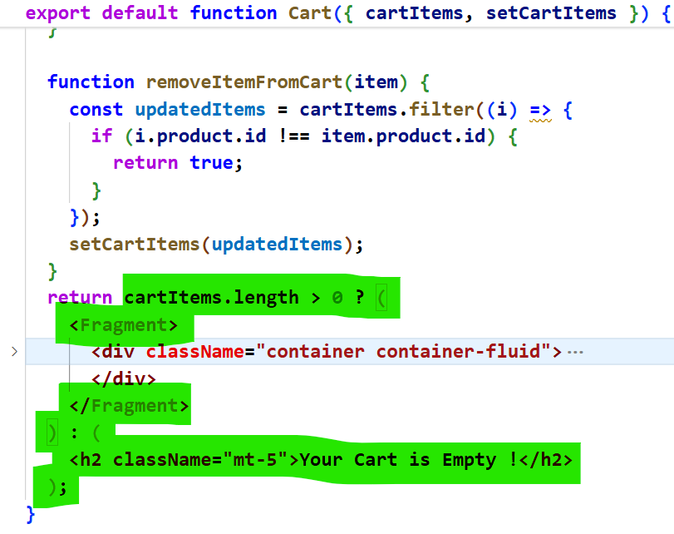

|  |
| --- |
| **return cartItems.length > 0 ? (**  **<Fragment>**  **<div className="container container-fluid">**  **………….**  **</div>**  **</Fragment>**  **) : (**  **<h2 className="mt-5">Your Cart is Empty !</h2>**  **);** |

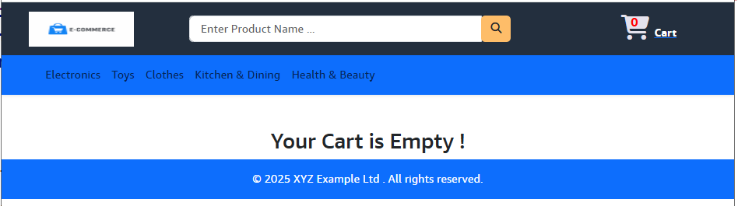

**CART SUMMARY**

**Cart.jsx**

|  |
| --- |
| **<div className="col-12 col-lg-3 my-4">**  **<div id="order_summary">**  **<h4>Order Summary</h4>**  **<hr />**  **<p>**  **<b> Subtotal: </b>**  **<span className="order-summary-values">{cartItems.reduce((acc, item) => acc + item.qty, 0)} (Items)</span>**  **</p>**  **<p>**  **<b>To Pay:</b>**  **<span className="order-summary-values">**  **{cartItems.reduce((acc, item) => acc + item.product.specialPrice * item.qty, 0)}**  **</span>**  **</p>**  **<hr />**  **<button id="checkout_btn" className="btn btn-primary btn-block">**  **Proceed to Buy {cartItems.reduce((acc, item) => acc + item.qty, 0)} Items**  **</button>**  **</div>**  **</div>** |

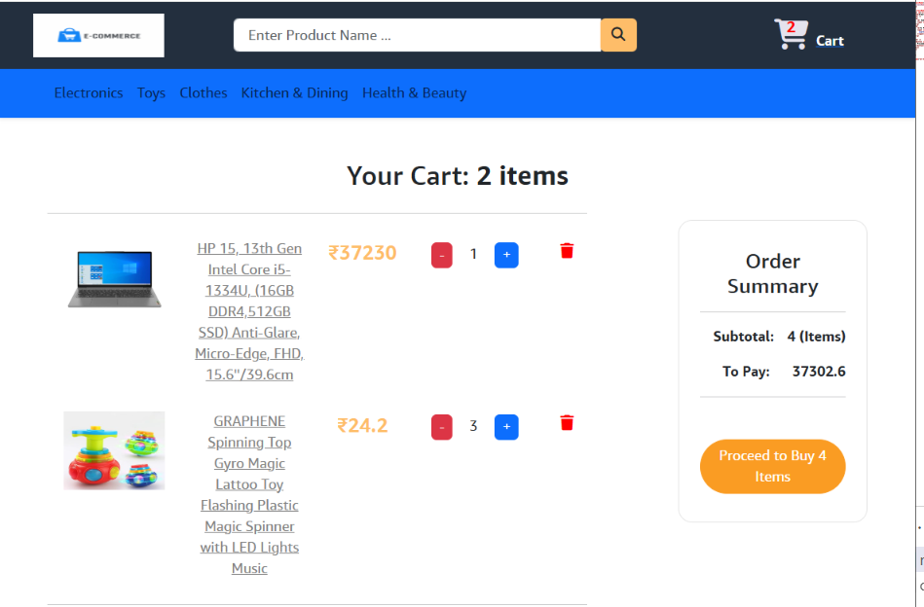

**REACT – REDUX**

**npm install axios redux react-redux redux-thunk @reduxjs/toolkit**

**npm uninstall redux**

**Store is a place where we store all the states. It is like a container which should be available through out our application. So that the state can be accessed through out our application**

**Reducer is sth which will change our state.**

**Middleware is sth which will make our actions asynchronous(we use thunk here). But by default actions are synchronous**

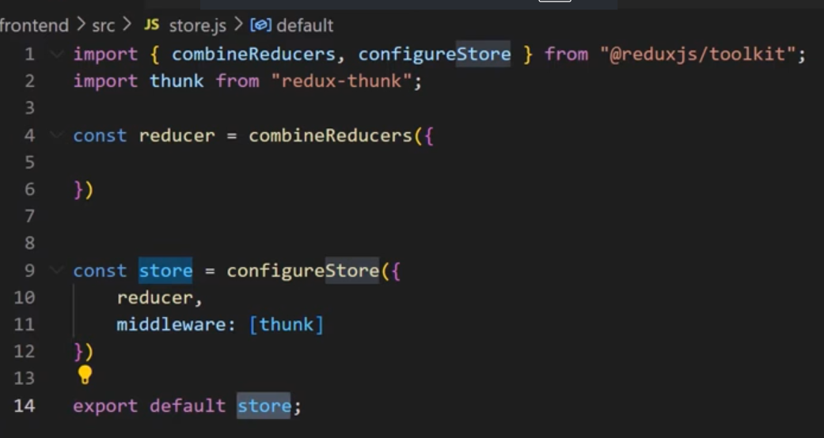

**Store.js**

|  |
| --- |
| **const { combineReducers, configureStore } = require("@reduxjs/toolkit");**  **const { thunk } = require("redux-thunk");**  **const reducer = combineReducers({});**  **//To create store**  **const store = configureStore({**  **reducer: reducer, // It will change our state**  **middleware: [thunk],**  **});**  **export default store;** |

**To make the store available through out our application, go to index.js and create a Provider and map store to it.**

|  |
| --- |
| **import React from "react";**  **import ReactDOM from "react-dom/client";**  **import "./index.css";**  **import App from "./App";**  **import { Provider } from "react-redux";**  **import store from "./store/store";**  **const root = ReactDOM.createRoot(document.getElementById("root"));**  **root.render(**  **<React.StrictMode>**  **<Provider store={store}>**  **<App />**  **</Provider>**  **</React.StrictMode>**  **);** |

**To check whether redux is working in our application, install redux devtools as the chrome extension . open browser**

 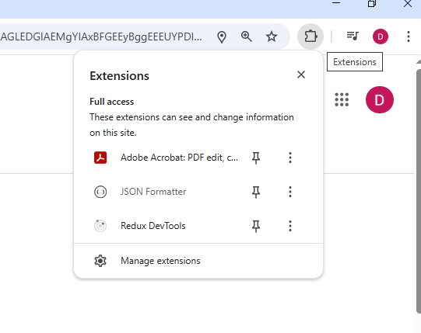

**Create a slice for products within slices folder. We are creating slices to create the reducers. The reducers will check the loading status. For the reducer object, everytime it will get state and action**

|  |
| --- |
| **import { createSlice } from "@reduxjs/toolkit";**  **const productSlice = createSlice({**  **name: "products",**  **initialState: {**  **loading: false,**  **},**  **reducers: {**  **productsRequest(state, action) { //This reducer will be called when the 1st request is triggered from browser. State param will give current state**  **return {**  **loading: true,**  **};**  **},**  **productsSuccess(state, action) { // this will when the api response is successfully fetched to frontend. Now loading is false. Becoz already loaded**  **return {**  **loading: false,**  **products: action.payload.products,**  **};**  **},**  **productsFail(state, action) {**  **return {**  **loading: false,**  **error: action.payload,**  **};**  **},**  **},**  **});** |

**Now you need to create ActionCreator which creates an action object and this Action Object is consumed by the reducer.**

|  |
| --- |
| **import { createSlice } from "@reduxjs/toolkit";**  **const productsSlice = createSlice({**  **name: "products",**  **initialState: {**  **loading: false,**  **},**  **reducers: {**  **productsRequest(state, action) {**  **return {**  **loading: true,**  **};**  **},**  **productsSuccess(state, action) {**  **return {**  **loading: false,**  **products: action.payload.products,**  **};**  **},**  **productsFail(state, action) {**  **return {**  **loading: false,**  **error: action.payload,**  **};**  **},**  **},**  **});**  **//To take out the actions from the slices**  **const { actions, reducer } = productsSlice;**  **export const { productsRequest, productsSuccess, productsFail } = actions;**  **export default reducer;** |

**After exposing the reducer from slice, bring it to store.js**

|  |
| --- |
| **import productsReducer from "../slices/productsSlice";**  **const { combineReducers, configureStore } = require("@reduxjs/toolkit");**  **//const { thunk } = require("redux-thunk");**  **const reducer = combineReducers({**  **productsState: productsReducer,**  **});**  **//To create store**  **const store = configureStore({**  **reducer: reducer, // It will change our state**  **//middleware: [thunk],**  **});**  **export default store;** |

**Create Login Components using Redux**

**Within slices folder create authSlice.jsx**

|  |
| --- |
| **import { createSlice } from "@reduxjs/toolkit";**  **const authSlice = createSlice({**  **name: "auth",**  **initialState: {**  **loading: false,**  **isAuthenticated: false,**  **user: null,**  **error: null,**  **},**  **reducers: {**  **loginRequest(state, action) {**  **return {**  **...state,**  **loading: true,**  **};**  **},**  **loginSuccess(state, action) {**  **return {**  **loading: false,**  **isAuthenticated: true,**  **user: action.payload.user,**  **};**  **},**  **loginFailed(state, action) {**  **return {**  **...state,**  **loading: false,**  **error: action.payload.error,**  **};**  **},**  **},**  **});**  **const { actions, reducer } = authSlice;**  **export const { loginRequest, loginSuccess, loginFailed } = actions;**  **export default reducer;** |

**Within store.js**

|  |
| --- |
| **import productsReducer from "../slices/productsSlice";**  **import authReducer from "../slices/authSlice";**  **const { combineReducers, configureStore } = require("@reduxjs/toolkit");**  **const reducer = combineReducers({**  **productsState: productsReducer,**  **authState: authReducer,**  **});**  **//To create store**  **const store = configureStore({**  **reducer // It will change our state**  **});**  **export default store;** |

**Create a folder actions within which create a file userActions.jsx**

|  |
| --- |
| **import axios from "axios";**  **import { loginFailed, loginRequest, loginSuccess } from "../slices/authSlice";**  **export const login = (userName, password) => async (dispatch) => {**  **try {**  **dispatch(loginRequest());**  **const { data } = await axios**  **.post(process.env.REACT_APP_API_URL + `/auth/signin`, { userName, password }, { withCredentials: true })**  **.then((response) => {**  **dispatch(loginSuccess({ user: response.data }));**  **});**  **} catch (error) {**  **//dispatch(loginFailed(error.response.data.message));**  **dispatch(loginFailed({ error: "Oyie !Invalid Credentials " }));**  **}**  **};** |

**Create a folder user, within which create Login.jsx, paste the template login.html, add <Fragment>**

**Change class to className, for to htmlFor**

**Create 2 states email, password using useState()**

|  |
| --- |
| **import { Fragment, useState } from "react";**  **import { login } from "../actions/userActions";**  **import { useDispatch } from "react-redux";**  **export default function Login() {**  **const [userName, setUserName] = useState("");**  **const [password, setPassword] = useState("");**  **const dispatch = useDispatch();**  **const submitHandler = (e) => {**  **e.preventDefault();**  **dispatch(login(userName, password));**  **};**  **return (**  **<Fragment>**  **<div className="row wrapper">**  **<div className="col-10 col-lg-5">**  **<form onSubmit={submitHandler} className="shadow-lg">**  **<h1 className="mb-3">Login</h1>**  **<div className="form-group">**  **<label htmlFor="email_field">Email</label>**  **<input type="email" id="email_ field" className="form-control"**  **value={userName}**  **onChange={(e) => setUserName(e.target.value)}**  **</div>**  **<div className="form-group">**  **<label htmlFor="password_field">Password</label>**  **<input**  **type="password"**  **id="password_field"**  **className="form-control"**  **value={password} onChange={(e) => setPassword(e.target.value)}**  **/>**  **</div>**  **<a href="#" className="float-right mb-4">**  **Forgot Password?**  **</a>**  **<button id="login_button" type="submit" className="btn btn-block py-2">**  **LOGIN**  **</button>**  **<a href="#" className="float-right mt-3">**  **New User?**  **</a>**  **</form>**  **</div>**  **</div>**  **</Fragment>**  **);**  **}** |

**App.js**

**Create a rotue for Login component and test**

|  |
| --- |
| **<Router>**  **<div>**  **<ToastContainer />**  **<Header cartItems={cartItems} />**  **<Routes>**  **<Route path="/" element={<Home />} />**  **<Route path="/search" element={<Home />} />**  **………………**  **<Route path="/login" element={<Login />} />**  **</Routes>** |

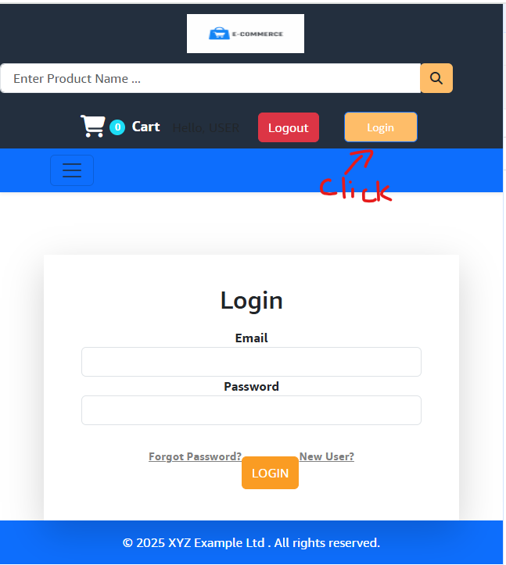

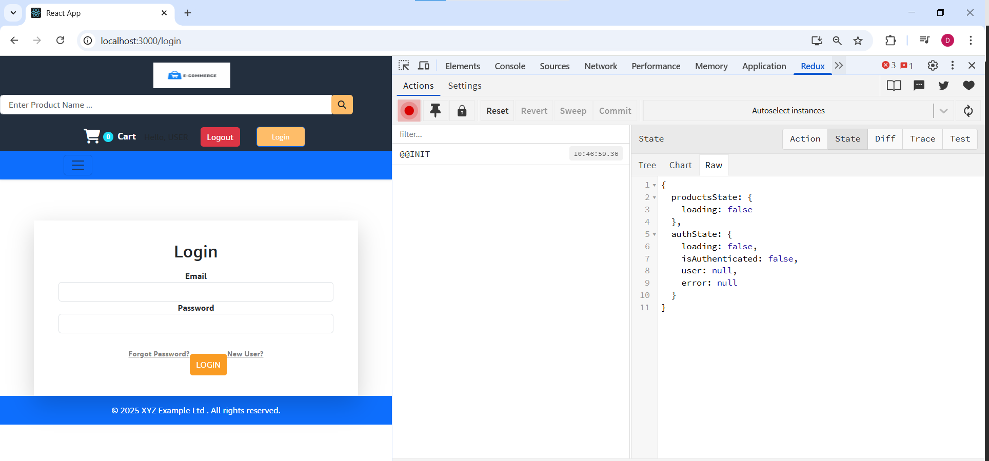



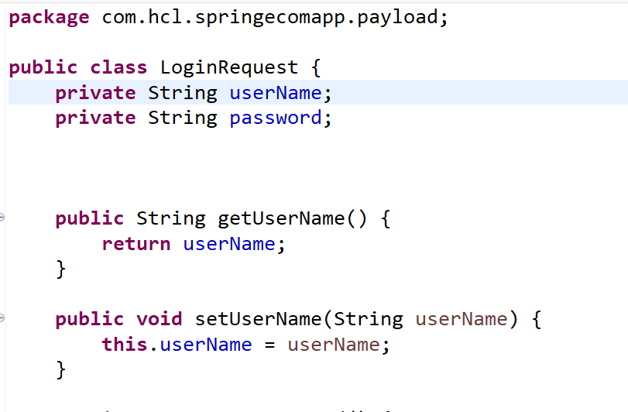 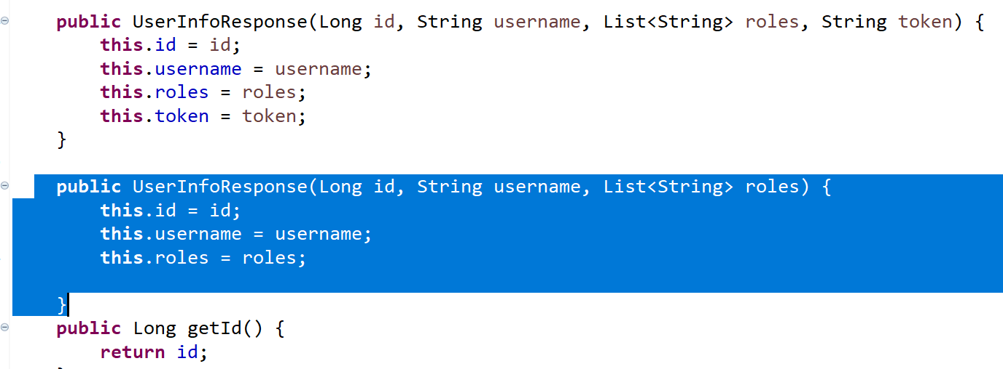

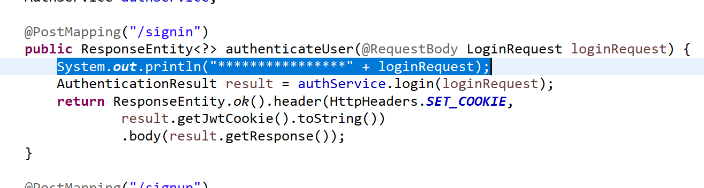

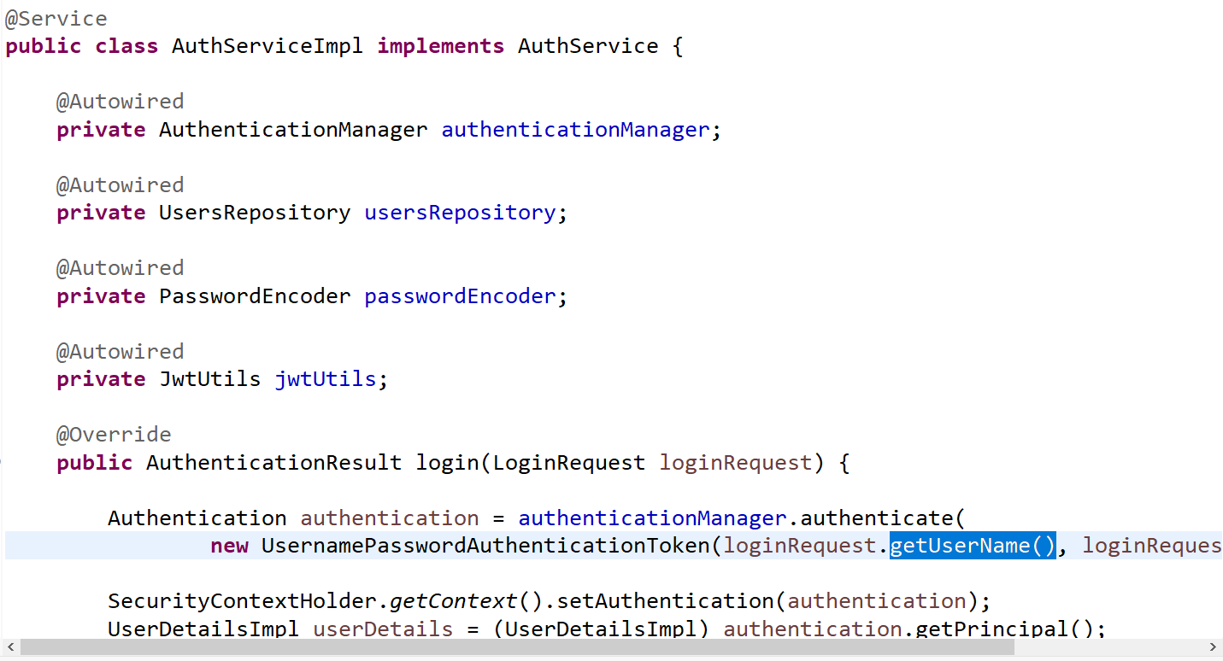

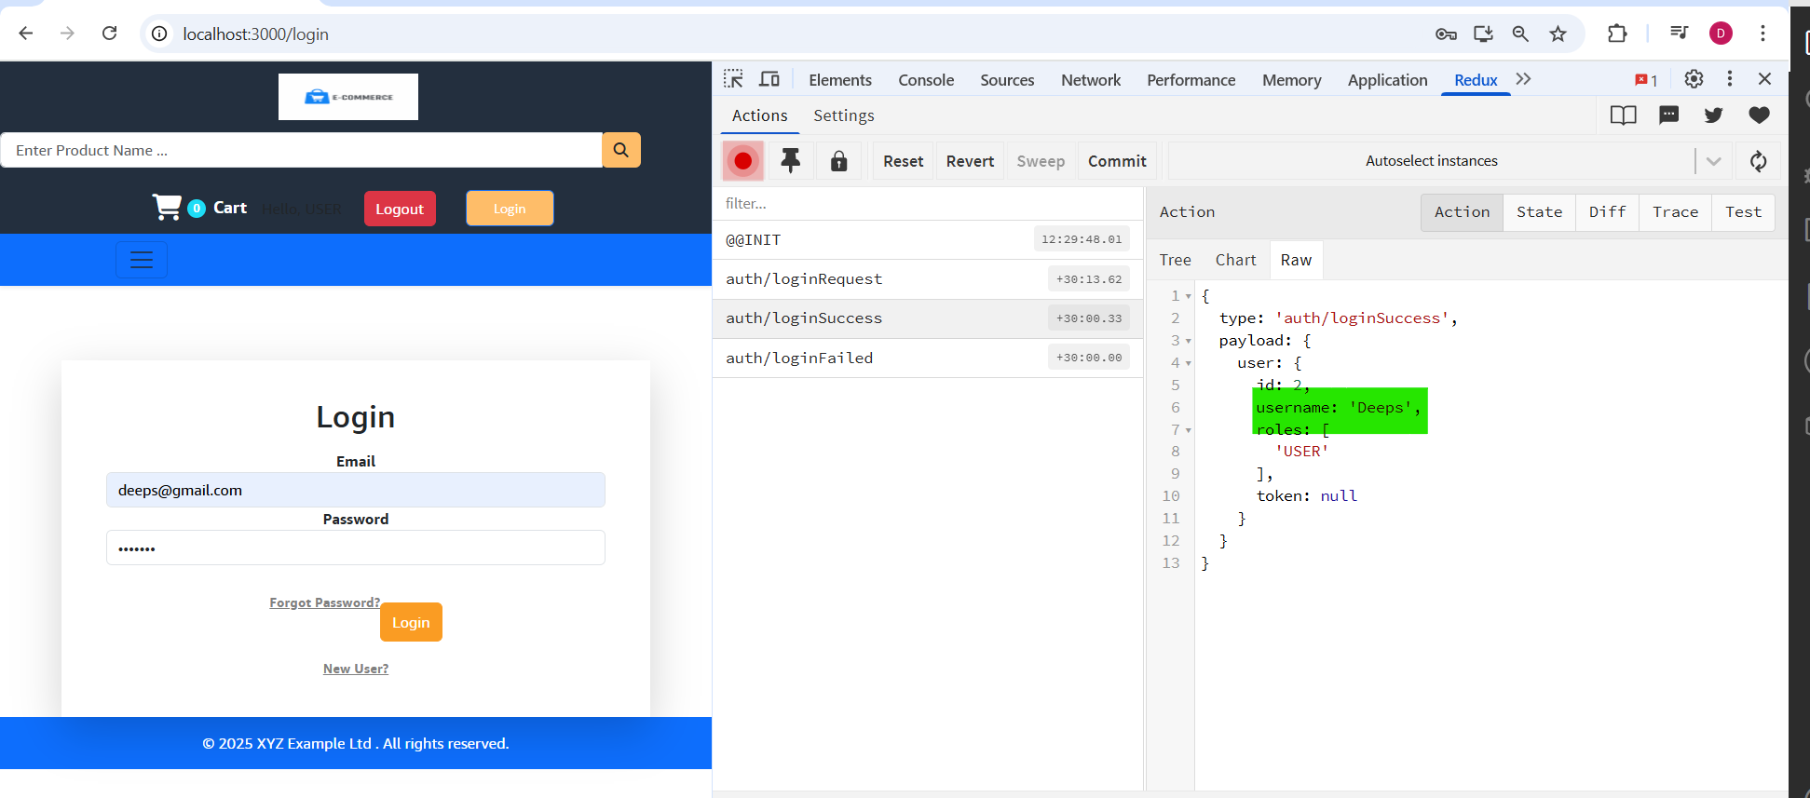

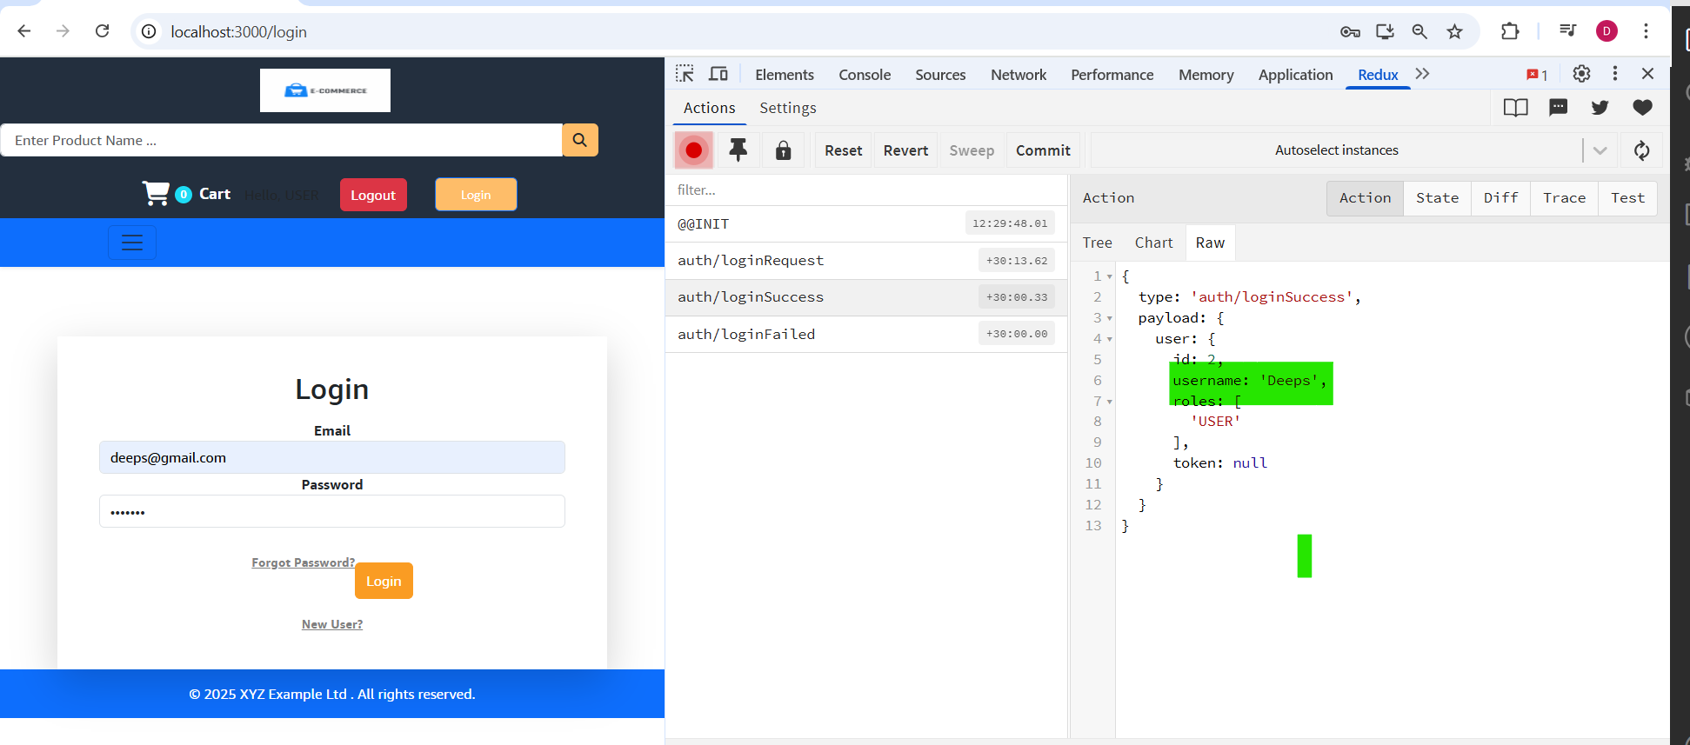

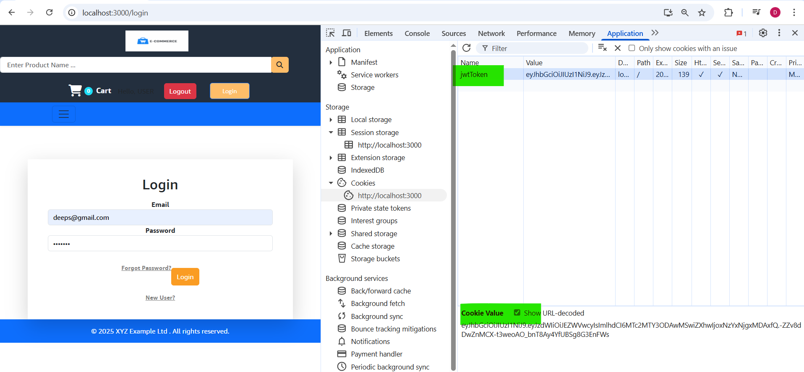

**Now the Authentication is successful.**

**Now redirect the request to the home page.**

**Login.jsx**

|  |
| --- |
| **import { Fragment, useEffect, useState } from "react";**  **import { login } from "../actions/userActions";**  **import { useDispatch, useSelector } from "react-redux";**  **import { toast } from "react-toastify";**  **import { useNavigate } from "react-router-dom";**  **export default function Login() {**  **//const [email, setEmail] = useState("");**  **const [userName, setUserName] = useState("");**  **const [password, setPassword] = useState("");**  **const dispatch = useDispatch();**  **const navigate = useNavigate();**  **const { loading, error, isAuthenticated } = useSelector((state) => state.authState);**  **const submitHandler = (e) => {**  **e.preventDefault();**  **dispatch(login(userName, password));**  **};**  **useEffect(() => {**  **if (isAuthenticated) {**  **navigate("/");**  **}**  **if (error) {**  **toast.error(error, {**  **position: "bottom-center",**  **});**  **}**  **}, [error]);**  **return (**  **<Fragment>**  **<div className="row wrapper">**  **<div className="col-10 col-lg-5">**  **<form onSubmit={submitHandler} className="shadow-lg">**  **<h1 className="mb-3">Login</h1>**  **<div className="form-group">**  **<label htmlFor="email_field">Email</label>**  **<input**  **type="email"**  **id="email_ field"**  **className="form-control"**  **value={userName}**  **onChange={(e) => setUserName(e.target.value)}**  **/>**  **</div>**  **<div className="form-group">**  **<label htmlFor="password_field">Password</label>**  **<input**  **type="password"**  **id="password_field"**  **className="form-control"**  **value={password}**  **onChange={(e) => setPassword(e.target.value)}**  **/>**  **</div>**  **<a href="#" className="float-right mb-4">**  **Forgot Password?**  **</a>**  **<button type="submit" className="btn btn-block py-2" disabled={loading}>**  **{loading ? "Signing in..." : "Login"}**  **</button>**  **{error && <p style={{ color: "red" }}>{error.message}</p>}**  **<a href="#" className="float-right mt-3">**  **New User?**  **</a>**  **</form>**  **</div>**  **</div>**  **</Fragment>**  **);**  **}** |

**Now do login and check the field isAuthenticated:true in Redux devtools, and check after clicking the login button it should be redirected to home page**

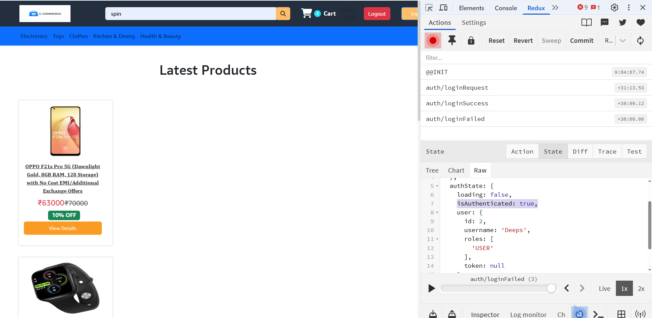

**Clear the error message**

**Login.jsx**

|  |
| --- |
| **export default function Login() {**  **//const [email, setEmail] = useState("");**  **const [userName, setUserName] = useState("");**  **const [password, setPassword] = useState("");**  **const dispatch = useDispatch();**  **const navigate = useNavigate();**  **const { loading, error, isAuthenticated } = useSelector((state) => state.authState);**  **const submitHandler = (e) => {**  **e.preventDefault();**  **dispatch(login(userName, password));**  **};**  **useEffect(() => {**  **if (isAuthenticated) {**  **navigate("/");**  **}**  **if (error) {**  **toast(error, {**  **position: "bottom-center",**  **type: "error",**  **onOpen: () => {**  **dispatch(clearAuthError);**  **},**  **});**  **return;**  **}**  **}, [error, isAuthenticated, dispatch]);**  **return (**  **<Fragment>** |
|  |

**authSlice.jsx**

|  |
| --- |
| **import { createSlice } from "@reduxjs/toolkit";**  **const authSlice = createSlice({**  **name: "auth",**  **initialState: {**  **loading: false,**  **isAuthenticated: false,**  **user: null,**  **error: null,**  **},**  **reducers: {**  **loginRequest(state, action) {**  **return {**  **...state,**  **loading: true,**  **};**  **},**  **loginSuccess(state, action) {**  **return {**  **loading: false,**  **isAuthenticated: true,**  **user: action.payload.user,**  **};**  **},**  **loginFailed(state, action) {**  **return {**  **...state,**  **loading: false,**  **error: action.payload.error,**  **};**  **},**  **clearError(state, action) {**  **return {**  **...state,**  **error: null,**  **};**  **},**  **},**  **});**  **const { actions, reducer } = authSlice;**  **export const { loginRequest, loginSuccess, loginFailed, clearError} = actions;**  **export default reducer;** |

**userActions.jsx**

|  |
| --- |
| **import axios from "axios";**  **import { clearError, loginFailed, loginRequest, loginSuccess, registerFailed, registerRequest, registerSuccess } from "../slices/authSlice";**  **export const login = (userName, password) => async (dispatch) => {**  **try {**  **dispatch(loginRequest());**  **const { data } = await axios**  **.post(process.env.REACT_APP_API_URL + `/auth/signin`, { userName, password }, { withCredentials: true })**  **.then((response) => {**  **dispatch(loginSuccess({ user: response.data }));**  **});**  **} catch (error) {**  **//dispatch(loginFailed(error.response.data.message));**  **dispatch(loginFailed({ error: "Oyie !Invalid Credentials " }));**  **}**  **};**  **export const clearAuthError = (dispatch) => {**  **dispatch(clearError());**  **};** |

**NOW CREATE REGISTRATION PAGE LOGIC**

**authSlice.jsx**

|  |
| --- |
| **registerRequest(state, action) {**  **return {**  **...state,**  **loading: true,**  **};**  **},**  **registerSuccess(state, action) {**  **return {**  **loading: false,**  **isAuthenticated: true,**  **user: action.payload.user,**  **};**  **},**  **registerFailed(state, action) {**  **return {**  **...state,**  **loading: false,**  **error: action.payload.error,**  **};**  **},**  **export const { loginRequest, loginSuccess, loginFailed, clearError,**  **registerRequest, registerSuccess, registerFailed } = actions;** |

**userActions.jsx**

|  |
| --- |
| **export const register = (userData) => async (dispatch) => {**  **try {**  **dispatch(registerRequest());**  **const { data } = await axios**  **.post(process.env.REACT_APP_API_URL + `/auth/signup`, { userData }, { withCredentials: true })**  **.then((response) => {**  **dispatch(registerSuccess(data));**  **});**  **} catch (error) {**  **//dispatch(loginFailed(error.response.data.message));**  **dispatch(registerFailed(error.response.data.message));**  **}**  **};** |

**NOW CREATE REGISTER PAGE/COMPONENT(template)**

**Register.jsx**

|  |
| --- |
| **export default function Register() {**  **return (**  **<div className="container container-fluid">**  **<div className="row wrapper">**  **<div className="col-10 col-lg-5">**  **<form className="shadow-lg" enctype="multipart/form-data">**  **<h1 className="mb-3">Register</h1>**  **<div className="form-group">**  **<label htmlFor="name_field">Name</label>**  **<input type="name" id="name_field" className="form-control" value="" />**  **</div>**  **<div className="form-group">**  **<label htmlFor="email_field">Email</label>**  **<input type="email" id="email_field" className="form-control" value="" />**  **</div>**  **<div className="form-group">**  **<label htmlFor="password_field">Password</label>**  **<input type="password" id="password_field" className="form-control" value="" />**  **</div>**  **<button id="register_button" type="submit" className="btn btn-block py-3">**  **REGISTER**  **</button>**  **</form>**  **</div>**  **</div>**  **</div>**  **);**  **}** |

**App.js**

**Create a Route**

|  |
| --- |
| **<Route path="/register" element={<Register />} />** |

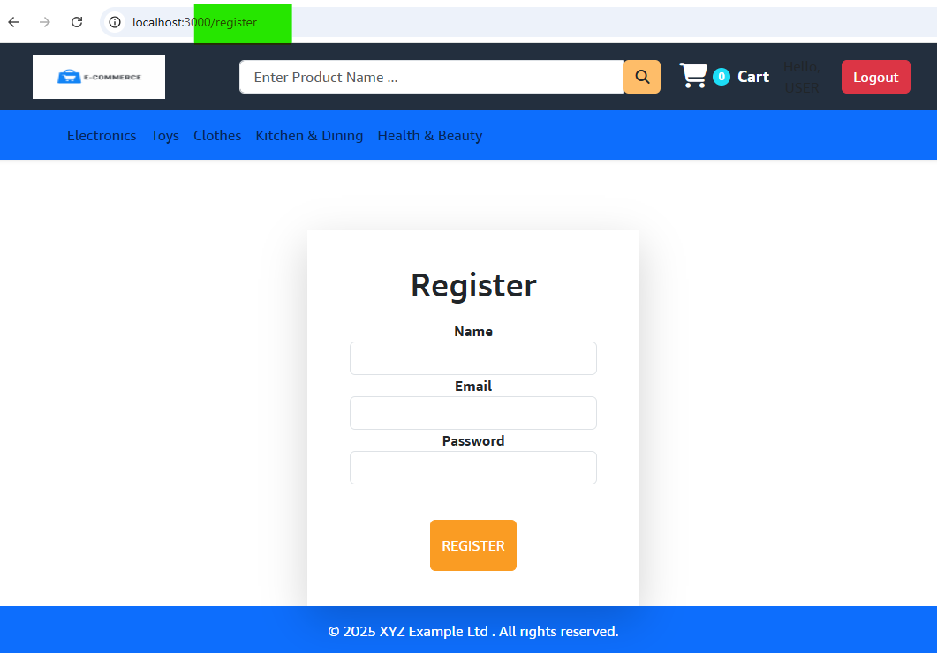

**Update the fields in Register.jsx, remove value=”” from the template, else you cant enter any data**

|  |
| --- |
| **import { useState } from "react";**  **import { useDispatch, useSelector } from "react-redux";**  **import { register } from "../actions/userActions";**  **export default function Register() {**  **const [userData, setUserData] = useState({**  **userName: "",**  **email: "",**  **password: "",**  **});**  **const dispatch = useDispatch();**  **const { loading } = useSelector((state) => state.authState);**  **const onChangeHandler = (e) => {**  **setUserData({ ...userData, [e.target.name]: e.target.value });**  **};**  **const submitHandler = (e) => {**  **e.preventDefault();**  **const formData = new FormData();**  **formData.append("userName", userData.userName);**  **formData.append("email", userData.email);**  **formData.append("password", userData.password);**  **dispatch(register(formData));**  **};**  **return (**  **<div className="container container-fluid">**  **<div className="row wrapper">**  **<div className="col-10 col-lg-5">**  **<form onSubmit={submitHandler}>**  **<h1 className="mb-3">Register</h1>**  **<div className="form-group">**  **<label htmlFor="name_field">Name</label>**  **<input type="text" name="userName" onChange={onChangeHandler} id="name_field" className="form-control" />**  **</div>**  **<div className="form-group">**  **<label htmlFor="email_field">Email</label>**  **<input type="email" name="email" onChange={onChangeHandler} id="email_field" className="form-control" />**  **</div>**  **<div className="form-group">**  **<label htmlFor="password_field">Password</label>**  **<input type="password" name="password" onChange={onChangeHandler} id="password_field" className="form-control" />**  **</div>**  **<button id="register_button" disabled={loading} type="submit" className="btn btn-block py-3">**  **REGISTER**  **</button>**  **</form>**  **</div>**  **</div>**  **</div>**  **);**  **}** |
|  |
|  |
|  |
|  |

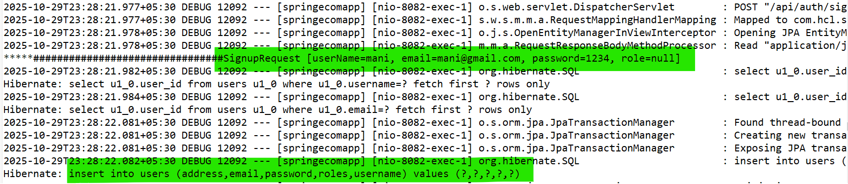

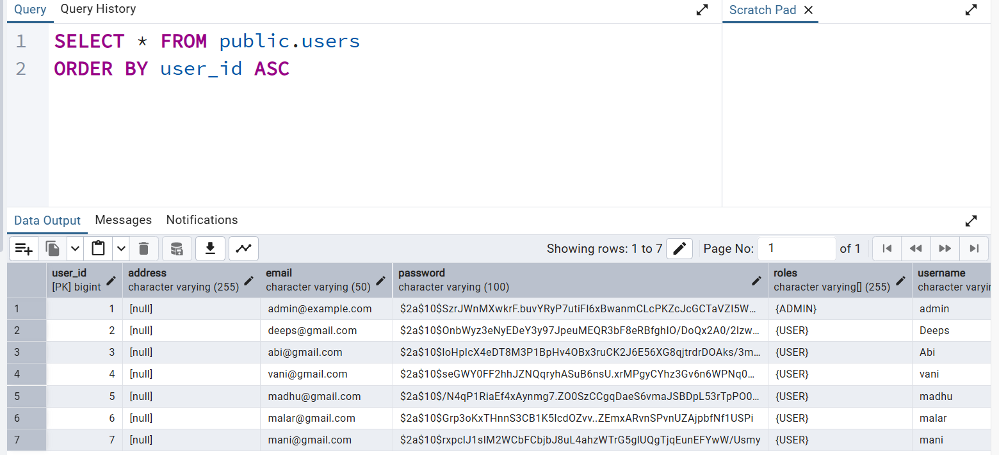

**After Registration, navigate to login**

|  |
| --- |
| **import { useEffect, useState } from "react";**  **import { useDispatch, useSelector } from "react-redux";**  **import { register } from "../actions/userActions";**  **import { useNavigate } from "react-router-dom";**  **import { toast } from "react-toastify";**  **export default function Register() {**  **const [userData, setUserData] = useState({**  **userName: "",**  **email: "",**  **password: "",**  **});**  **const dispatch = useDispatch();**  **const navigate = useNavigate();**  **const { loading, isAuthenticated, error } = useSelector((state) => state.authState);**  **const onChangeHandler = (e) => {**  **setUserData({ ...userData, [e.target.name]: e.target.value });**  **};**  **const submitHandler = (e) => {**  **e.preventDefault();**  **const formData = new FormData();**  **formData.append("userName", userData.userName);**  **formData.append("email", userData.email);**  **formData.append("password", userData.password);**  **dispatch(register(formData));**  **};**  **useEffect(() => {**  **if (isAuthenticated) {**  **// ✅ Redirect to login after successful registration**  **toast.success("Registration successful! Please login.");**  **setTimeout(() => navigate("/login"), 500);**  **}**  **}, [isAuthenticated, navigate]);**  **return (**  **<div className="container container-fluid">**  **<div className="row wrapper">**  **<div className="col-10 col-lg-5">**  **<form onSubmit={submitHandler}>**  **<h1 className="mb-3">Register</h1>**  **<div className="form-group">**  **<label htmlFor="name_field">Name</label>**  **<input type="text" name="userName" onChange={onChangeHandler} id="name_field" className="form-control" />**  **</div>**  **<div className="form-group">**  **<label htmlFor="email_field">Email</label>**  **<input type="email" name="email" onChange={onChangeHandler} id="email_field" className="form-control" />**  **</div>**  **<div className="form-group">**  **<label htmlFor="password_field">Password</label>**  **<input type="password" name="password" onChange={onChangeHandler} id="password_field" className="form-control" />**  **</div>**  **<button id="register_button" disabled={loading} type="submit" className="btn btn-block py-3">**  **REGISTER**  **</button>**  **</form>**  **</div>**  **</div>**  **</div>**  **);**  **}** |

**Now Click Login button and check the jwtToken created in cookies In browser**

**Header.jsx**

**Create if authenticated, jwtToken will be in cookies. Now create a logout component**

|  |
| --- |
| **import { Link, useNavigate } from "react-router-dom";**  **import CategoryNavbar from "./CategoryNavbar";**  **import Search from "./Search";**  **import { DropdownButton, Dropdown, Image } from "react-bootstrap";**  **import { useDispatch, useSelector } from "react-redux";**  **export default function Header({ cartItems }) {**  **const { isAuthenticated, user } = useSelector((state) => state.authState);**  **const dispatch = useDispatch();**  **const navigate = useNavigate();**  **const logoutHandler = () => {**  **//dispatch(logout);**  **};**  **return (**  **<div>**  **<nav className="navbar row">**  **{/* Logo */}**  **<div className="col-12 col-md-3">**  **<div className="navbar-brand">**  **<Link to="/">**  **<img src="/images/logo.png" height="50px" width="150px" alt="LOGO" />**  **</Link>**  **</div>**  **</div>**  **{/* Search bar */}**  **<div className="col-12 col-md-6 mt-2 mt-md-0">**  **<Search />**  **</div>**  **{/* Login / Logout + Cart */}**  **<div className="col-12 col-md-3 mt-4 mt-md-0 d-flex justify-content-center align-items-center gap-3">**  **{/* Conditionally show buttons based on authentication */}**  **{isAuthenticated ? (**  **<Dropdown className="d-inline">**  **<Dropdown.Toggle variant="default text-white pr-5" id="dropdown-basic">**  **<figure className="avatar avatar-nav">**  **<Image width="50px" src={user.avatar ?? "./images/profilepic.jpg"} />**  **</figure>**  **<span className="me-2">{user.name}</span>**  **</Dropdown.Toggle>**  **<Dropdown.Menu>**  **<Dropdown.Item onClick={logoutHandler} className="text-danger">**  **Logout**  **</Dropdown.Item>**  **</Dropdown.Menu>**  **</Dropdown>**  **) : (**  **<Link to="/login" className="btn btn-success me-3">**  **Login**  **</Link>**  **)}**  **<Link to={"/cart"} className="cart-link text-decoration-none text-light position-relative ms-3">**  **<div className="d-flex align-items-center">**  **<i className="fa-solid fa-cart-shopping cart-icon"></i>**  **<span className="cart-count">{cartItems.length}</span>**  **</div>**  **<span className="cart-text ms-2">Cart</span>**  **</Link>**  **</div>**  **</nav>**  **<CategoryNavbar />**  **</div>**  **);**  **}** |

**LOAD LOGGED USER DATA**

**Now login into the site, check the isAuthentication field in redux-devtools. isAuthentication will be true. Now referesh the browser, isAuthentication will be false. You need to login again.**

**But notice, jwtToken will be available in cookies, even if you refersh. It will be available till it expires.**

**Use this token and get the userinfo**

**authSlice.jsx**

|  |
| --- |
| **import { createSlice } from "@reduxjs/toolkit";**  **const authSlice = createSlice({**  **name: "auth",**  **initialState: {**  **loading: false,**  **isAuthenticated: false,**  **user: null,**  **error: null,**  **},**  **reducers: {**  **…..**  **loadUserRequest(state, action) {**  **return {**  **...state,**  **loading: true,**  **isAuthenticated: false,**  **};**  **},**  **loadUserSuccess(state, action) {**  **return {**  **loading: false,**  **isAuthenticated: true,**  **user: action.payload.user,**  **};**  **},**  **loadUserFailed(state, action) {**  **return {**  **...state,**  **loading: false,**  **error: action.payload.error,**  **};**  **},**  **},**  **});**  **const { actions, reducer } = authSlice;**  **export const {**  **loginRequest,**  **loginSuccess,**  **loginFailed,**  **clearError,**  **registerRequest,**  **registerSuccess,**  **registerFailed,**  **loadUserRequest,**  **loadUserSuccess,**  **loadUserFailed,**  **} = actions;**  **export default reducer;** |

**userActions.jsx**

|  |
| --- |
| **export const loadUser = async (dispatch) => {**  **try {**  **dispatch(loadUserRequest());**  **const { data } = await axios.get(process.env.REACT_APP_API_URL + `/auth/user`, {**  **withCredentials: true,**  **headers: { "Content-Type": "application/json" },**  **});**  **dispatch(loadUserSuccess(data));**  **} catch (error) {**  **//dispatch(loginFailed(error.response.data.message));**  **dispatch(loadUserFailed(error.response?.data?.message || "Load user Failed"));**  **}**  **};** |

